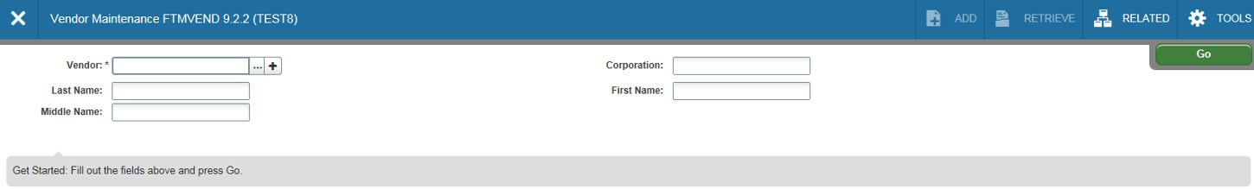It is often necessary to see if a vendor has been entered into the Banner system. The easiest
way to do this is to use FTMVEND (Vendor Maintenance) and Banner’s built in search
tools. From the Welcome page, Go to page FTMVEND and click on the drop down arrow next
to the Vendor field.

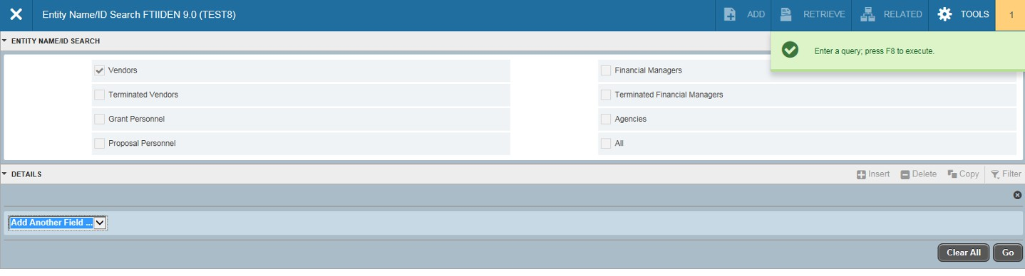FTMVEND (continued)-Click in the shaded line and select the search criteria. Enter F8 to execute query, or select the Go icon .

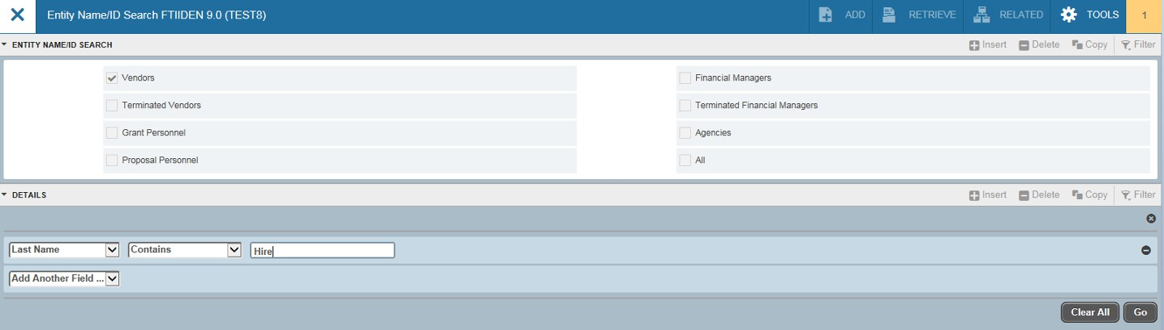FTMVEND (continued)-Click in the shaded line in the Last Name field and type in part of the vendor’s name. Enter F8 to execute query, or select the Go icon .

Type in part of the name. Click on Go icon.

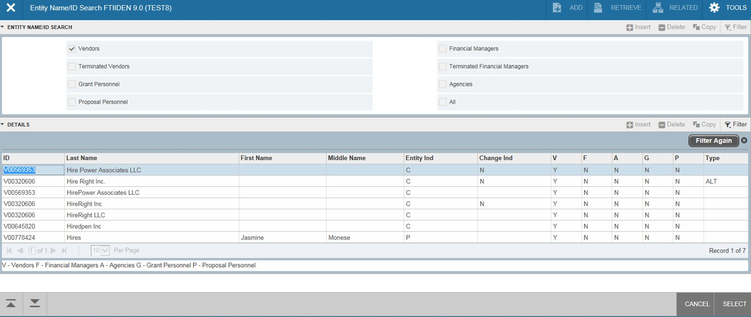FTMVEND (continued)- The page will return the closest matches to your query. To view more specific information about the vendor, double click on the vendor
name.
Double click on the desired line.

