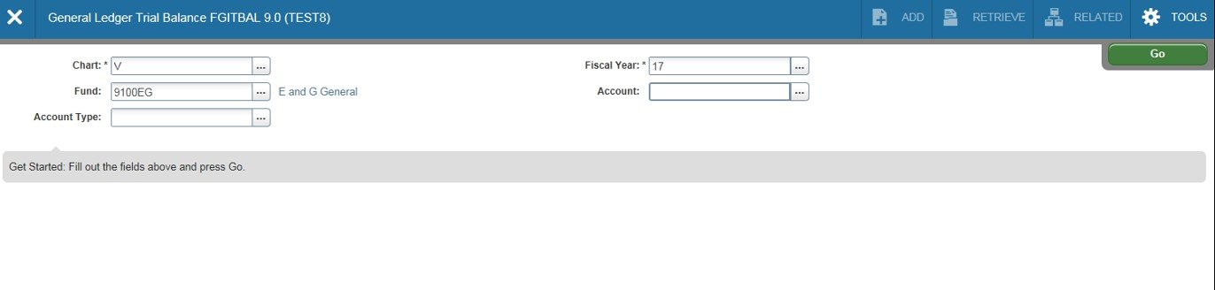With Grant funds it is often necessary to look at fund (general ledger) information. Remember, Indexes
roll up to Funds which can be a one-to-one or many-to-one relationship. Banner pages for Funds provide general ledger information such as assets (cash) and liabilities (payables) associated with their
subordinate indexes. Let’s look at Banner page FGITBAL(Trial Balance). From the Welcome page type in
FGITBAL; type in a Fund code. Press the tab key. You can also select which types of accounts you want to
view by using the drop down menu next to Account Type. To view all accounts, leave this field blank.
Click on the Go icon.

Select Go after
entering pertinent
information

Enter Fund, select Account or leave blank for all accounts.

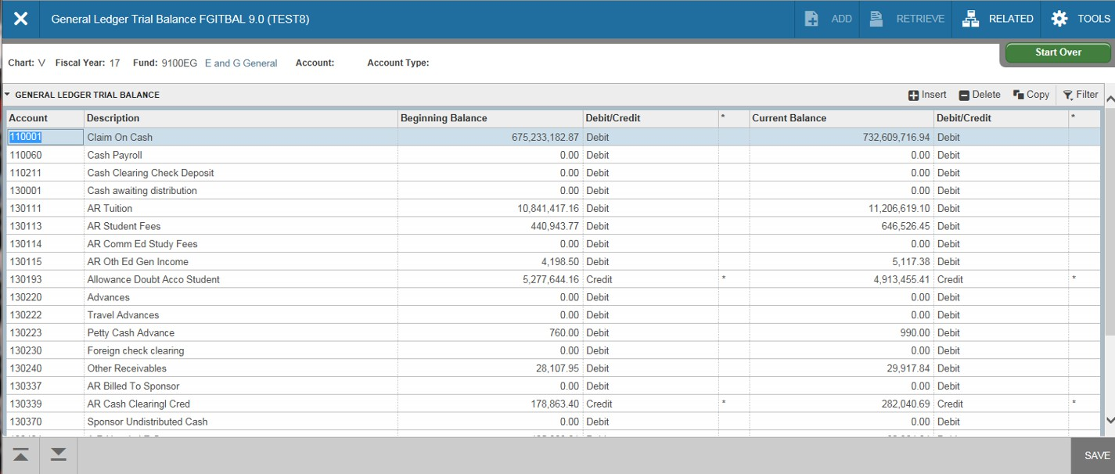FGITBAL (continued). On this page you’ll notice that current account balances are shown as
debits and credits. Cash should be a debit balance. A credit cash balance indicates a deficit situation. Any accounts that show a credit or debit balance out of the ordinary will have an asterisk
next to the field.

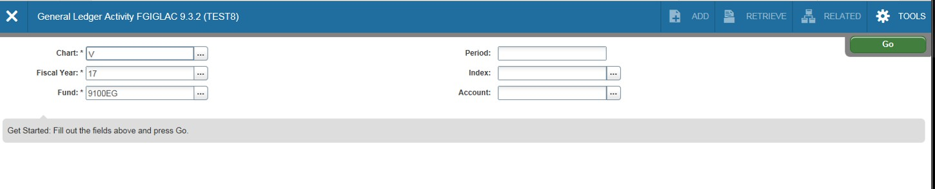Another general ledger page, FGIGLAC (General Ledger Activity), shows detailed transaction activity
for each account. You can access FGIGLAC from the main Welcome page. Select the fund, period, index,
and account.

Select Fund, Period, Index, and Account.

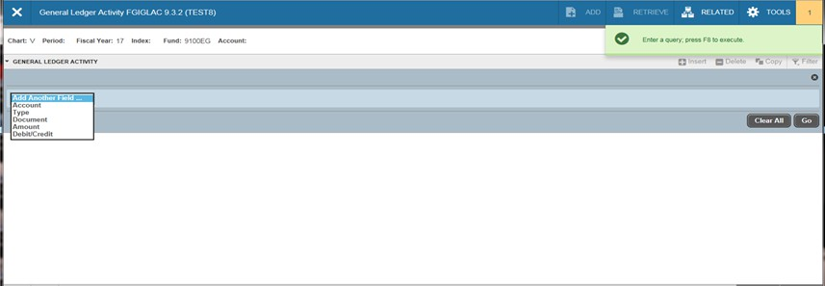FGIGLAC (continued)-The FGIGLAC page will open and prompt you for field search criteria
(account, type, amount, etc). Enter desired search criteria information, hit F8 on your keyboard
or select the Go icon.

Enter search criteria (account, type,
amount, etc). Hit F8 on keyboard, or
select Go icon.

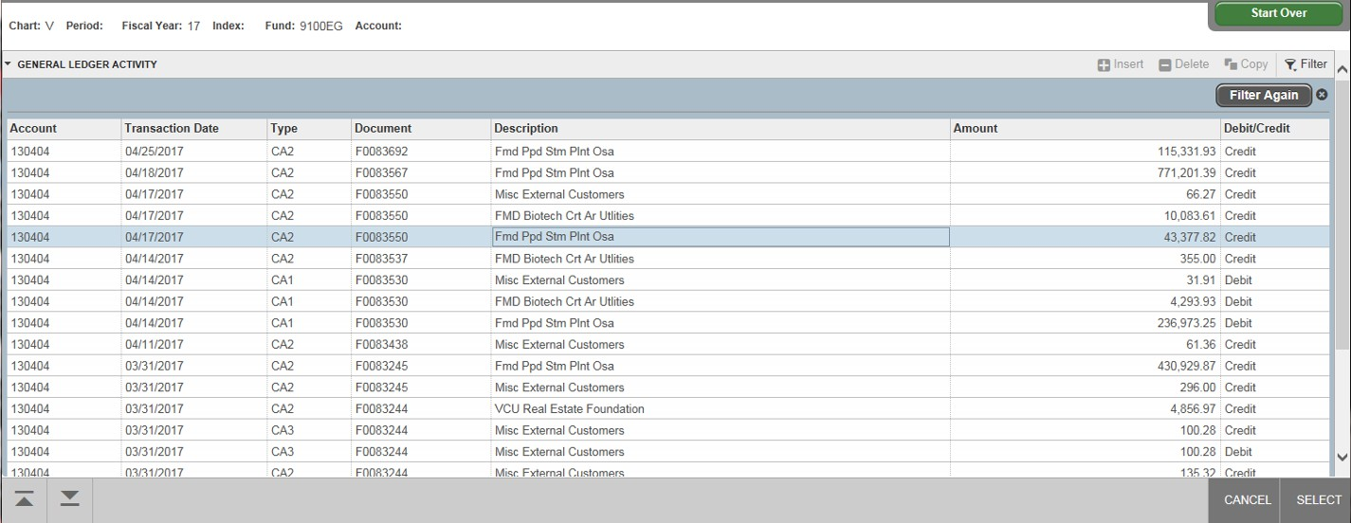FGIGLAC (continued)-The FGIGLAC page will open showing all transactions that posted to the
account. To see the detail of any of the transactions, you would “filter again” using other search
criteria such as Document number.

Select Filter Again, and enter
additional/new search criteria such as
document number. Hit F8 on keyboard, or select Go icon.

