Budget Forms

There are summary and detailed budget information forms available in Banner Finance. Let's look at a few. Type
FGIBSUM in the Go To box on the Banner main menu and press the Enter key.

FGIBSUM

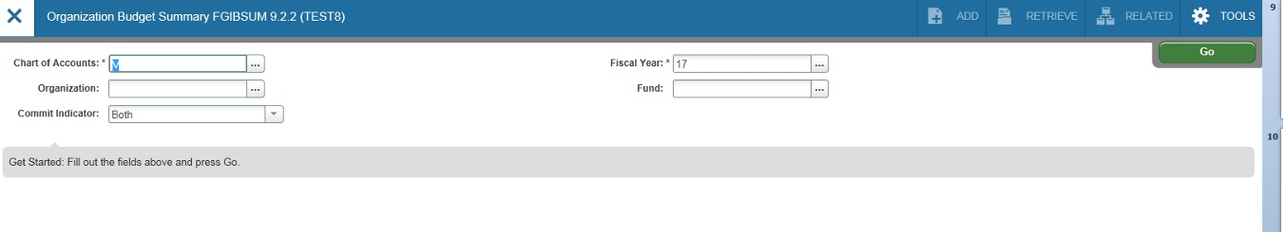FGIBSUM-Organization Budget Summary Page
(Acronym=Finance, General Ledger, Inquiry, Budget Summary)
FGIBSUM displays summarized budget information for a selected organization. Adjusted Budget
(Current Budget), year-to-date activity (transactions), commitments (encumbrances) and available
balance are summarized on this page by major category type. In the key block area (top of the page)
enter the org (organization or index number) and press the tab key on your keyboard. You can also
change the Fiscal Year by using the drop down box or manually changing it. Ignore the Commit Indicator.
VCU does not use this field. Click on the “GO” icon.

You can change the Fiscal

Ignore

Enter your Org (Index Code) here, then press the Tab key.
Year here.

Select “Go” icon to see page results.

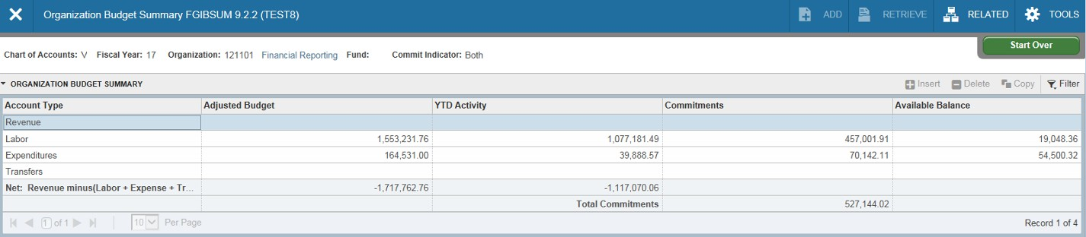FGIBSUM (continued)-The activity on the page is summarized by Type: Revenue Labor, Expenditures
and Transfers. You’ll notice that this particular org has budget and activity in labor(personnel expenses)
and expenditures, but no revenues. Since the Banner default is to assume revenues and subtract
expenditures, you may find the negative numbers in the Net Total fields to be misleading. This is
something you’ll have to keep in mind for orgs with expenditure budget only. The Available Balances
shown are correct, but they include any Commitments (encumbrances).

The Net Totals will appear as negative The Available Balance appears
if the Org does not earn revenues. correctly, but includes Commitments.

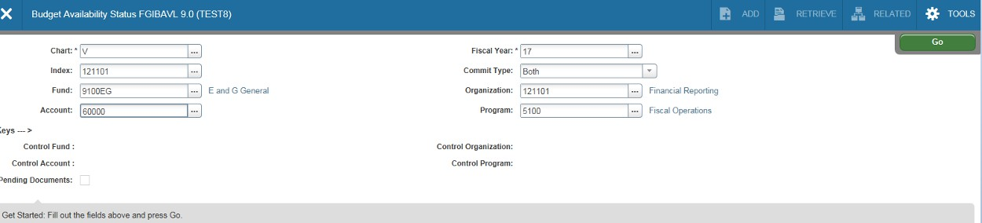FGIBAVL-Budget Availability Status
(Acronym=Finance, General Ledger, Inquiry, Budget Availability)
FGIBAVL provides an overview of your department’s budget by budget pool (a summarized expense category). The
page summarizes the current budget and expenditures in major categories with available balances given for each
pool. Tab to the Index field and enter your Index code. Press the tab key. This page requires you enter an Account
code as well. For example, to view all pools and expenditures, enter 50000 in the Account field. To view all non-
salary related expenditure budget pools, enter 60000 in the Account field. Leave the Commit Type indicator set to Both. VCU does not use this particular feature. Click the “Go” icon when ready to view the results.

3. Click on the “Go” icon.
2. Enter the budget pool account in the
account field. All subsequent budget pools will 4. If you do not enter an account
display. Here we’ve chosen non-labor code before clicking on the “Go”
1. Enter the Index. Press tab key. expenses. icon, you will receive this notice.

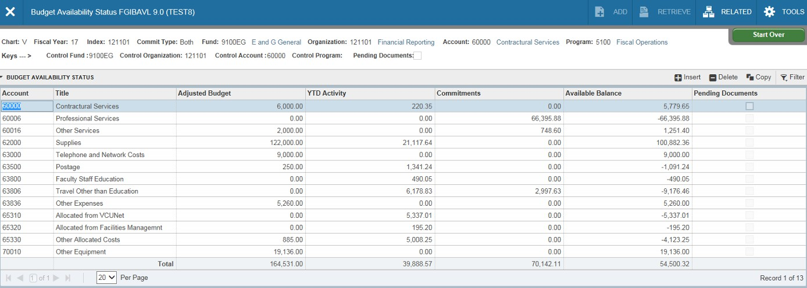FGIBAVL(continued)-a budget pool is a 5 digit summary account used for budgeting purposes only.
For instance, telephone and network costs are budgeted in account pool 63000. Transactions for
telephone and network costs will post to the more specific 6 digit accounts that fall under this budget
pool.

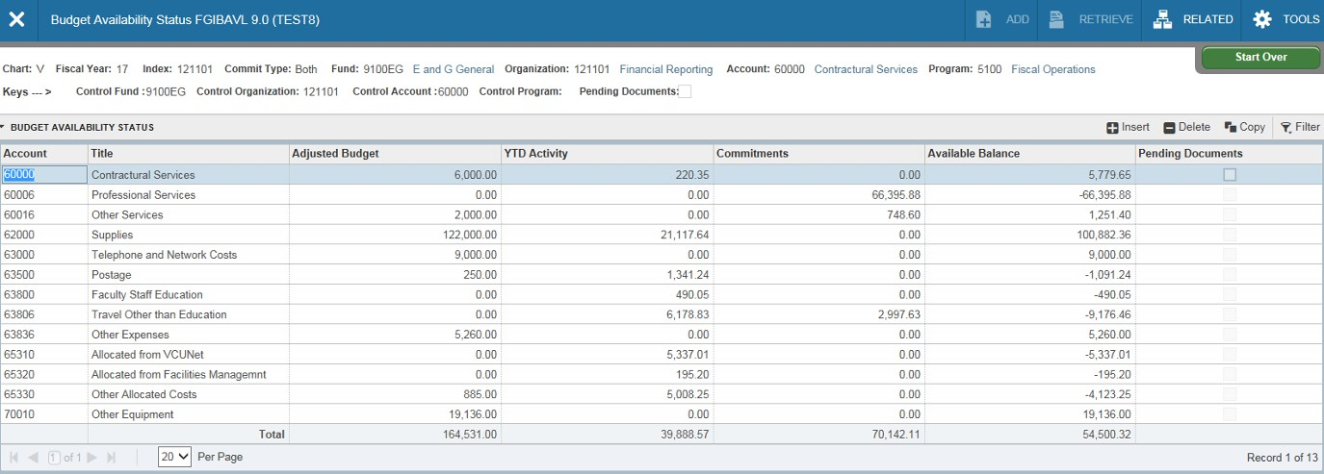FGIBAVL(continued)-Current budget*, year-to-date expenditures, commitments and available balance are shown
for each major budget category (budget pool), excluding salaries. You’ll notice on this page that the totals are
positive numbers as this page does not include revenues. This particular page will not return results for accounts
beginning with 4 (revenue accounts).
*Permanent Budget is not shown on Banner pages, only Adjusted Budget (which is your Current Budget). To see
Permanent Budget you can either query all permanent budget transactions (see pages 27-28 of this module) or use
the permanent budget reports available in Banner Self-Service (eServices).

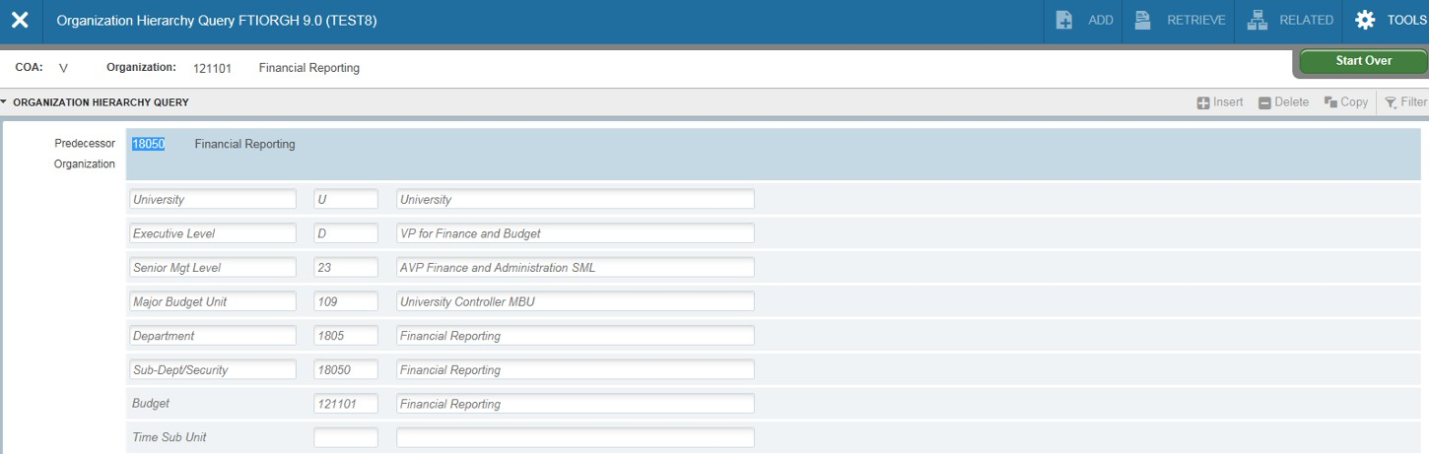FGIBDSR-Executive Summary
(acronym=Finance, General Ledger, Inquiry, Budget Summary)
This page provides more specific information than the previous two, as the accounts are not summarized. The
main advantage of this page is the ability to view financial data that is rolled up to higher organizational levels. In
Banner, individual indexes roll up to sub-departments, sub-departments roll up to departments, departments roll
up to major budget units and MBUs roll up to Senior Management Levels, etc. Too see this relationship, go to
Banner page FTIORGH (example below) and enter an index code in the organization box. Click the “Go” icon. You’ll notice the numeric value is smaller as the organizational hierarchy is increased. This is useful for department
managers who want to view summarized financial data for an entire department or school.

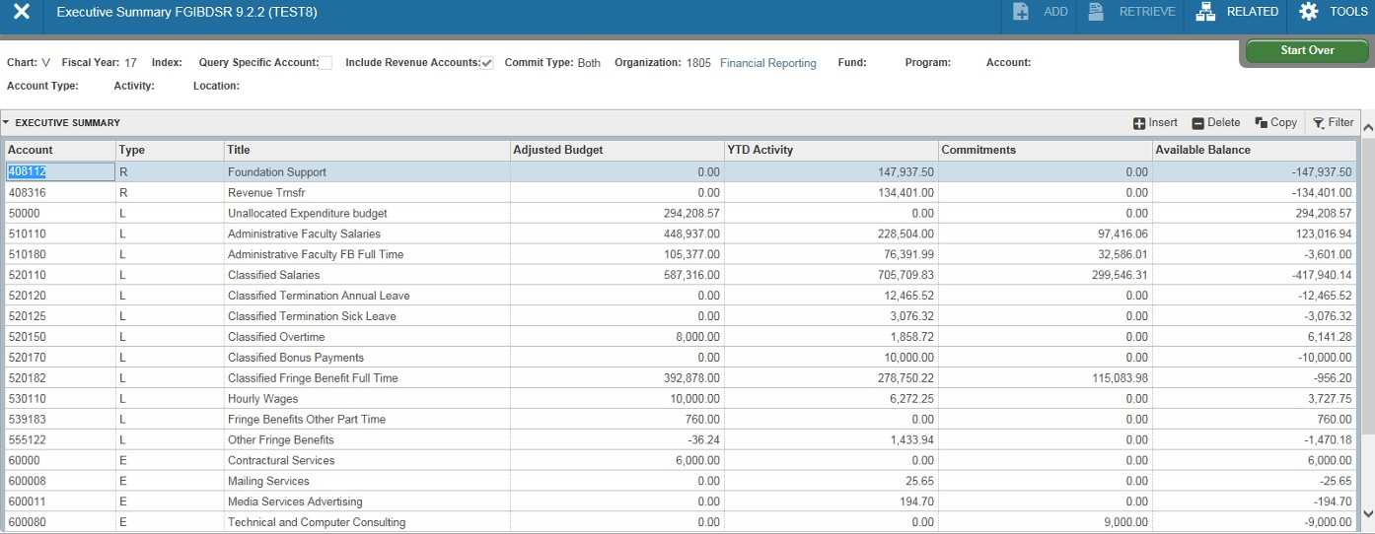FGIBDSR (continued)- From the main Banner page, type FGIBDSR. Let’s enter a value for a department level rather
than a single index in the Organization field. This is a four digit code rather than six. Press the tab key on your
keyboard. Click on the “Go” icon. The financial data shown is for all indexes that roll up to this department. If you
want to restrict the view to department indexes with a particular fund source, enter a fund in the Fund field (i.e.,
9100EG for E&G funds). You’ll notice the Net Totals are returned as negative numbers. By default, Banner assumes
offsetting revenues. To view expenditures only, click on the Start Over icon and uncheck Include Revenue Accounts.
Then click on the “Go” icon.

Start Over icon to enter new criteria

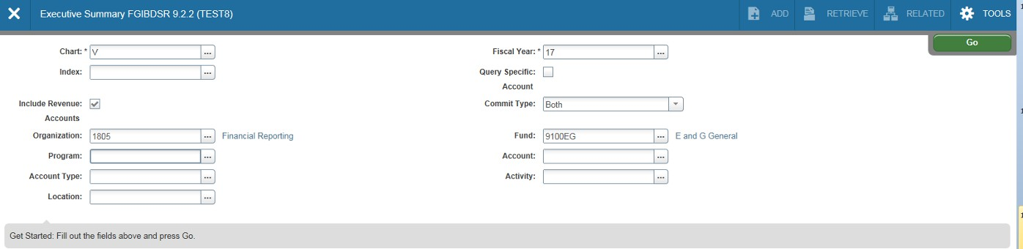FGIBDSR (continued)

Department Code Uncheck Include Revenue Accounts “Go” icon

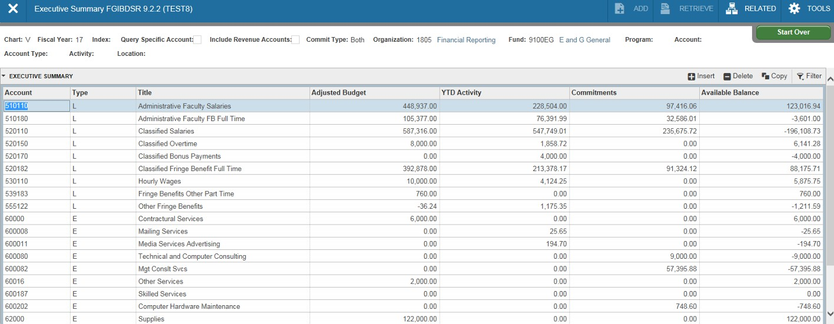FGIBDSR (continued)

Include Revenue Accounts unchecked

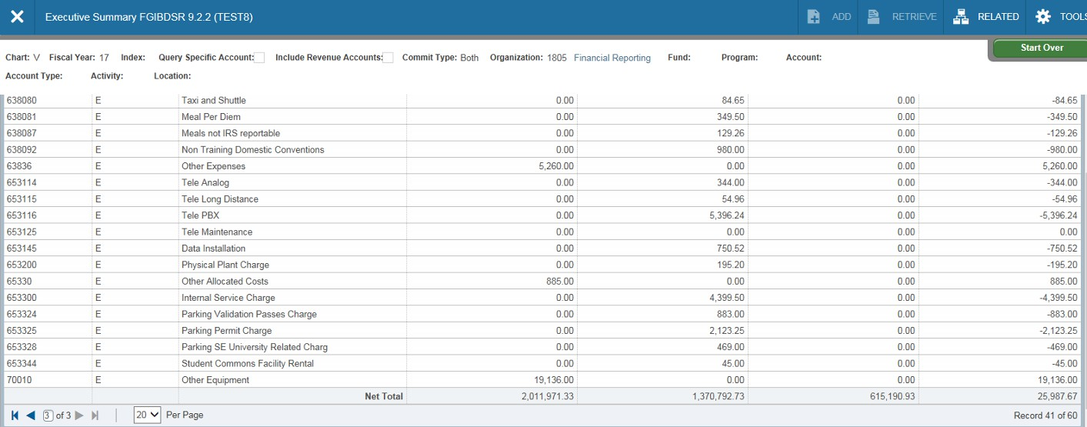FGIBDSR (continued)-The financial data shown is expenditure activity for the entire department. You’ll notice the Net Totals are now positive numbers.

Fund is empty, so all fund sources.

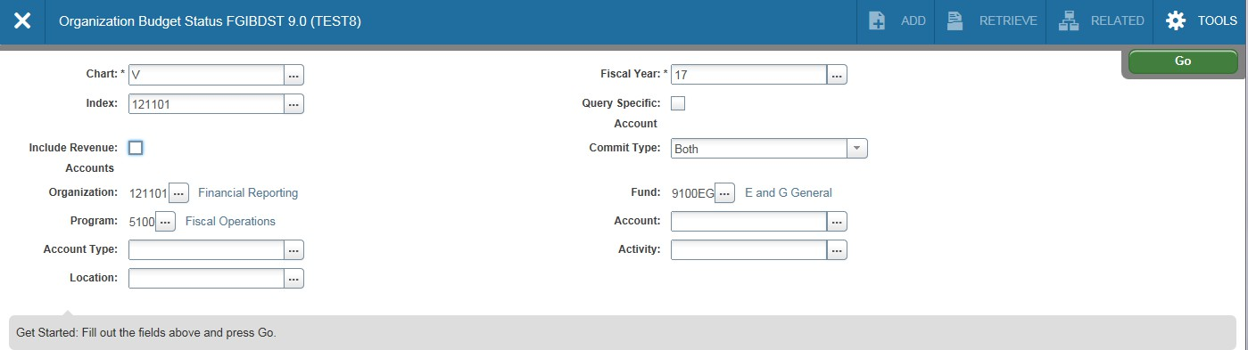FGIBDST-Organization Budget Status
(acronym=Finance, General Ledger, Inquiry, Budget Status)
This page is probably one of the most useful pages in Banner. It provides up to date information on adjusted
budgets, year-to-date expenditures, open commitments and available balances. In the key block area, select
your fiscal year (if other than current) and type in your Index code. Press the tab key on your keyboard. If you
want to view all financial data for this index, leave the Account field blank. If this particular index does not earn
revenues, remember to uncheck Include Revenue Accounts or your Net Totals will be returned as negative
values. Leave the Commit Type Indicator set to Both. VCU does not use this feature. Click on the “Go” icon to
see the results.

Enter Index code

Uncheck Include Revenue Accounts if Leave Commit Type as Both. VCU
Index does not earn revenues. does not use this feature.

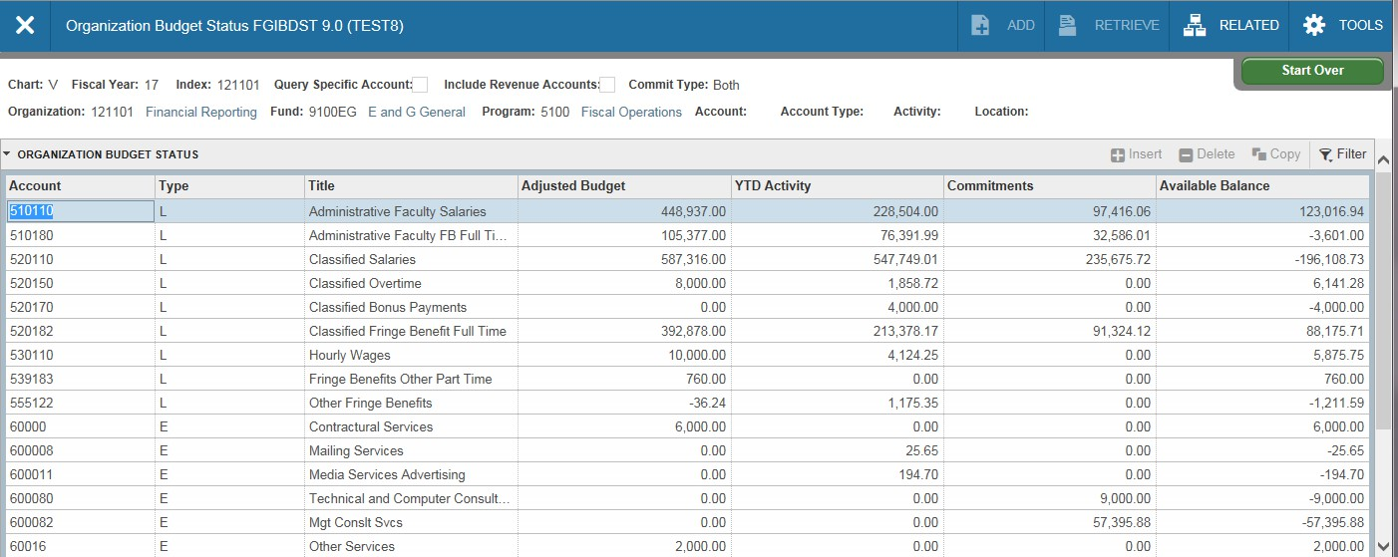FGIBDST (continued)-You’ll need to use the scroll bar to view all the accounts returned on this
page. The Adjusted Budget shown is your Current Budget. YTD Activity is year-to-date expenditures
through today. Commitments are your encumbrances (outstanding purchase orders, etc.). The Available Balance field includes your commitments (deducts from your balance).

Use the Scroll Bar to move
through the page.

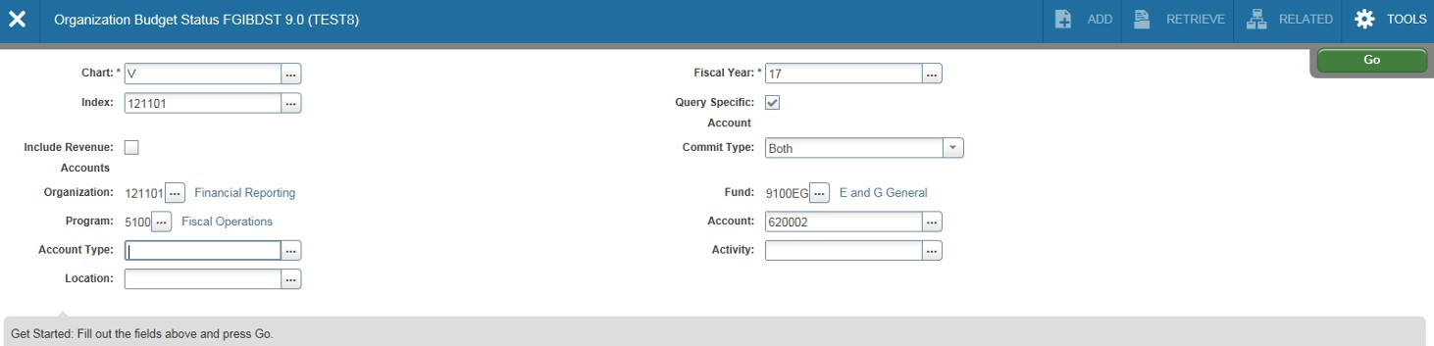FGIBDST(continued)-To view detailed transactions that make up your year-to-date activity, you can
enter the Account you wish to view in the account field; be sure the “Query Specific Account” box is
selected; then select the “GO” icon; highlight the specific account from the account list. This will give
you a list of all transactions (budget, expenses and commitments) that posted to that account code.

Check the Query Specific Account
box

Enter account.

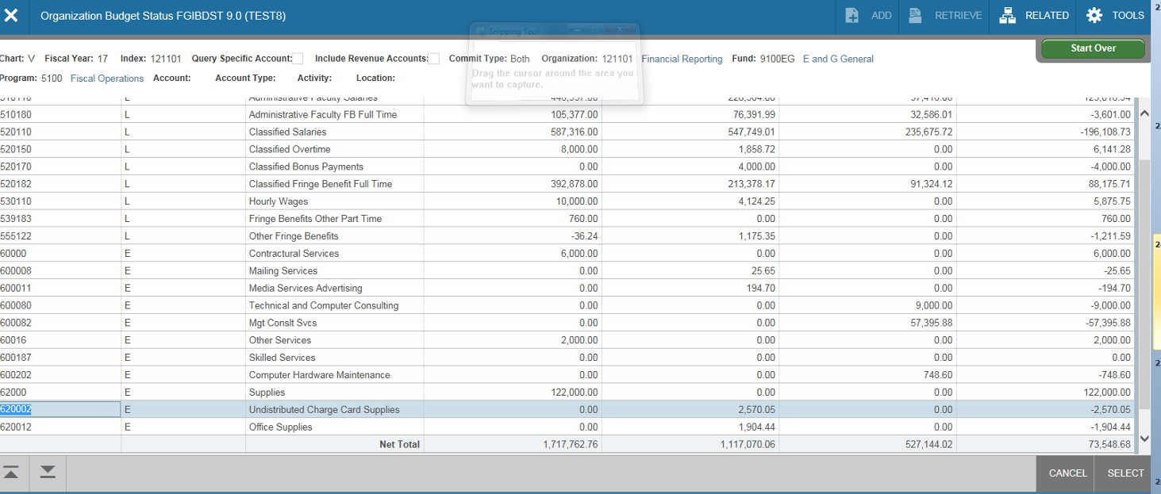FGIBDST(continued) click once in the field for the transactions you want to view (for the specific
account you wish to investigate). In this case, year to date activity for Undistributed Charge Card
Supplies. Then, press the F3 key on your keyboard. This brings up page FGITRND.

Click into the box you wish to see
a more detail listing of activity, hit
F3

