Banner Finance Approval Processes
Approving Budget Entries, Journal Vouchers and Cash Receipts
Controller’s Office

Banner Approvals

• What are they?
- Electronic Approvals provide a paperless process for documents to move
through the approval process in Banner.

• Which documents?
- All Banner journal entries, budget reallocations and cash receipts must be
approved in Banner before they will be posted.
2

Banner Approval Rules and Policies
• The document “running” total (total of all transactions) will determine how many
approvals, and what administrative levels, are necessary for Banner documents
(budget entries and journal entries):
- Fiscal Administrators $100,000 or less
– Dean/Director $100,001 - $500,000
– Vice President $500,001 - $999,999
– President $1,000,000 and over
– The Controller’s Office will approve journal entry transactions of $1,000,000 or
more.

• Cash receipt entries only require a Fiscal Administrator approval.
3

Banner Approval Responsibilities

• “Explicit” approvals implemented
- The person who keys the entry cannot approve their own document.

• Please review documents waiting for approval in a timely manner. All Banner
Finance documents must be approved or rejected within 5 business days.
- When you access any finance form, you will receive a message in Banner
notifying you that documents are waiting for your approval.
4

Banner Approval Forms
Forms used for approvals:
FOIAINP Approval Notification
- Lists the types and number of documents awaiting your approval. FOAUAPP User Approval
- This form enables you to approve or disapprove a document, view the
document's detail and view all of the queues/levels responsible for approving
the document.
FOAAINP Document Approval
- This form can be used when you know the specific document and document
number you need to approve.
FOIAPPH Document Approval History
- This form displays the document approval history and status of a specific
document.
- The queue ID displays “DENY” if a document has been disapproved.
5

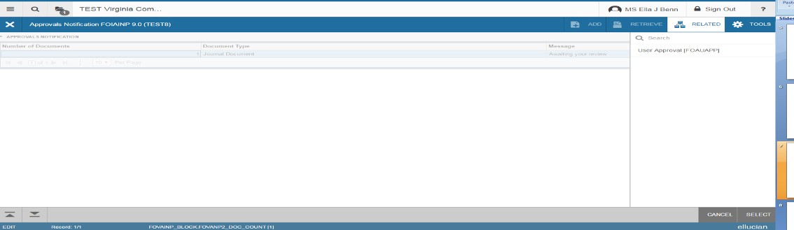Banner Approval Procedures
To access the Approval Notification form:
• In FOIAINP, click Related>FOAUAPP to proceed to the User Approval form.

• Or click (exit) to close the FOIAINP form and enter FOAUAPP directly in the
Search box.
6

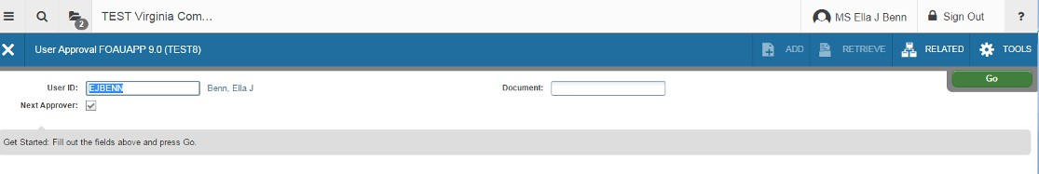Banner FOAUAPP Approval Procedures
• Your user ID will default into the FOAUAPP form
• To see ONLY your approval queue, leave the box checked.
• If you approve at Dean/Director authority or higher and the Fiscal Administrator
level has not approved the document, remove the check mark from the Next
Approver box on the right of the screen to view other approval levels.

• Click Go, to show documents to approve.
• Document information block on the form and view any waiting documents.
7

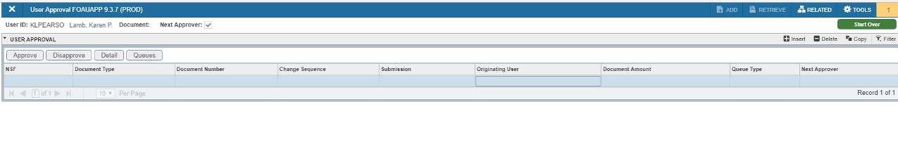Banner Approval Procedures

approve, disapprove, view detail or view queue information.
- To review the detail of the entry, click Detail to open FOQJVCD
- Click (exit) to close FOQJVCD and return to FOUAUPP.
8

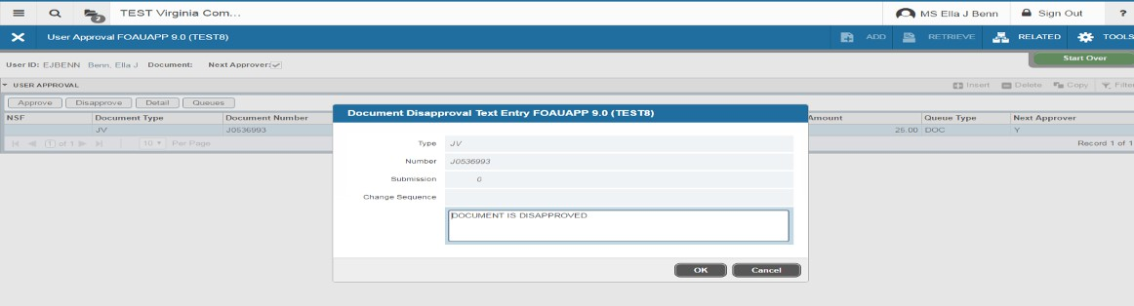If you disapprove a document…

• A pop up window will display the message stating that the document was
disapproved. Text can be entered why the document was disapproved.
- Click OK and OK again in the confirmation window.
• The document can be edited on the Journal Voucher Mass Entry Form
FGAJVCM by the originator and it will be rerouted for approval again.
- The document will post once all necessary approvals have been
completed.
9

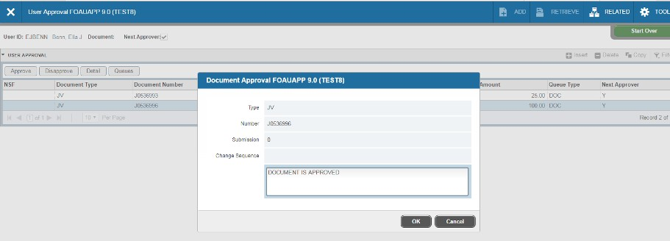If you approve a document…

• A pop up window will appear with the message stating that the
document is approved
• Click OK and OK again in the confirmation window.
10

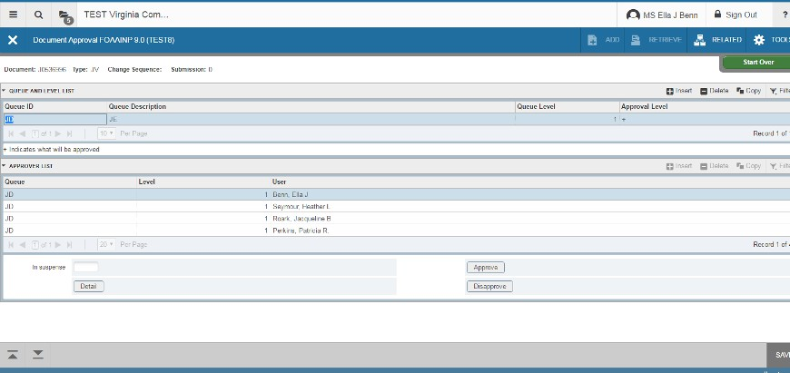FOAAINP Document Approval

• Used to display the document approval history and status of
documents. You may approve or disapprove documents on this form as well.
• Enter FOAAINP in the Search box.
• Click GO to display the documents.
11

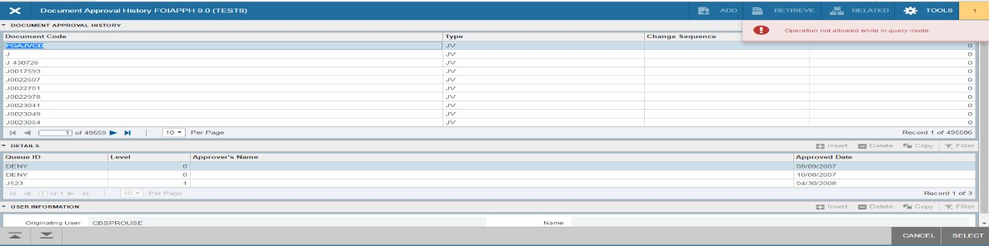FOIAPPH Approval History

• Used to display the document approval history and status of
documents.
• Enter FOIAPPH in the Search box.
- For a list of documents, enter specific search criteria, click GO. To see
all results, click GO.
• The Queue ID states DENY if any document was disapproved.
12

