Removing a PO Encumbrance
in Self-Service

Controller’s Office

Removing a PO Encumbrance in Self-Service
There are instances where a Purchase Order encumbrance needs to be removed manually. First, you will need to find out some specific information about the encumbrance you want to remove. Go to Banner form FGIENCD and enter the PO document number. Click on Go.
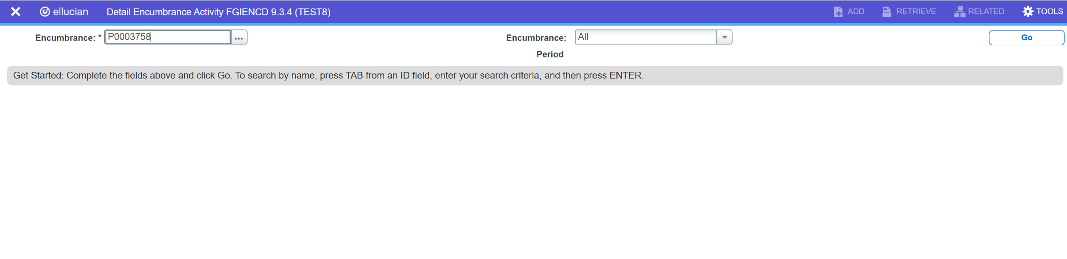

Alternative: The information found on FGIENCD can also be found in the VCU Reporting Center, Finance Folder, Report entitled “Open Encumbrances.” This report can be run by MBU, Department, Subdepartment, and Organization code.

Removing a PO Encumbrance in Self-Service
From FGIENCD, note the item number, sequence number, index, account, and balance. You will need this information to enter the encumbrance removal in Self-Service.
This must be done for each line of the encumbrance, if there are multiple items/sequence numbers. To get this information, check the bottom of the “Encumbrance Detail” section, and hit the right arrow button to view the next record(s).
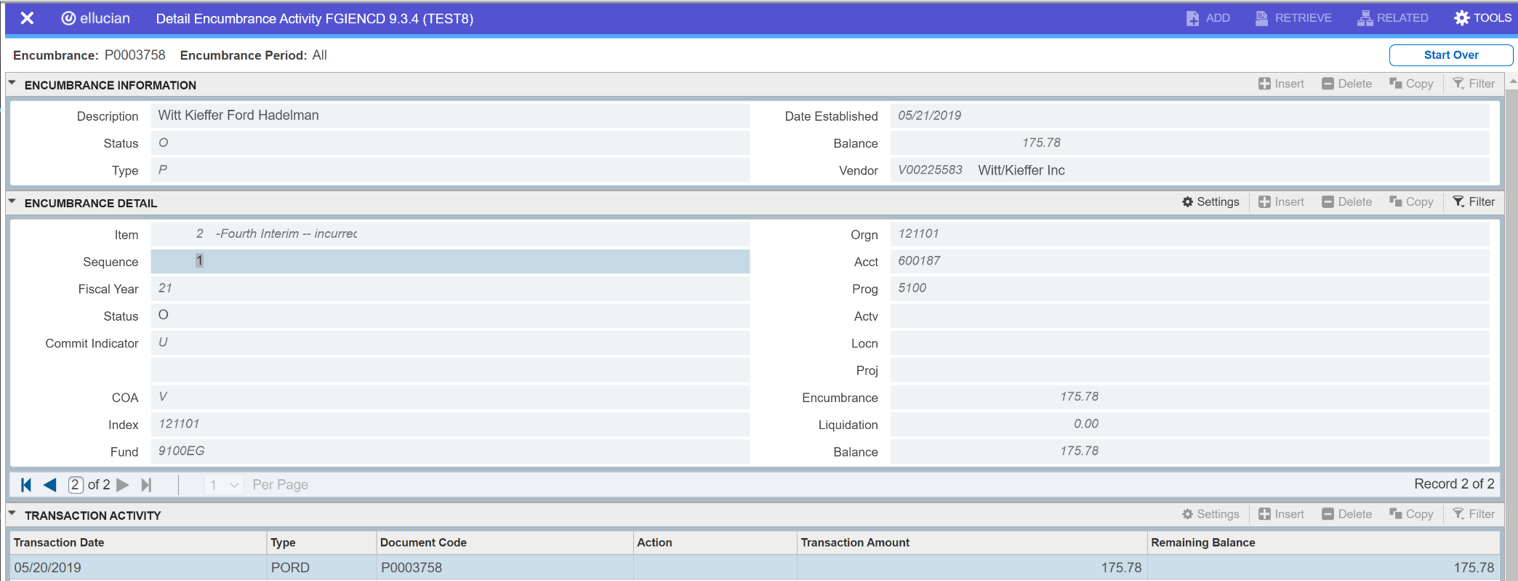

Removing a PO Encumbrance in Self-Service
After logging into VCU Self-Service, navigate to the Finance Landing Page. From the Finance Landing Page, click on My Journals.
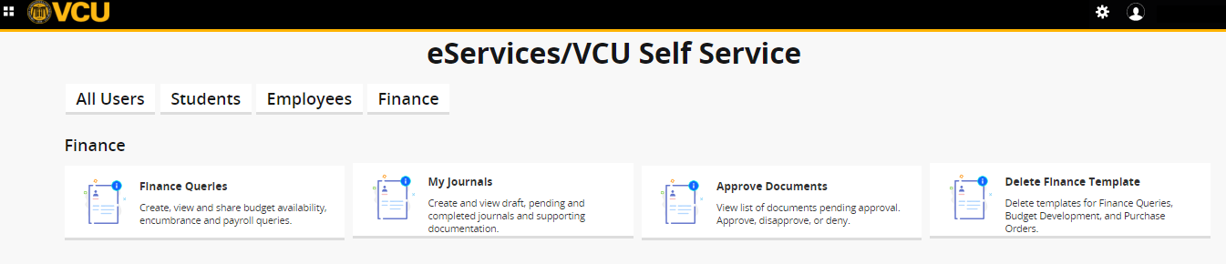

Removing a PO Encumbrance in Self-Service
From the My Journals page, click on Create Journal. The Create Journal screen will open.

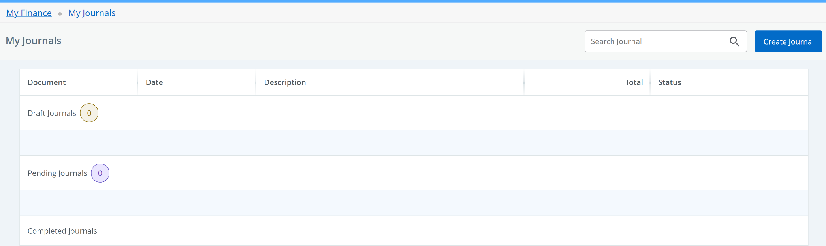

Removing a PO Encumbrance in Self-Service
On the Create Journal screen, enter the following data:
Transaction Date: will auto-populate to today’s date
Distribution Total: enter the PO encumbrance balance
Journal Type: E020
Description: enter vendor’s name
Bank Code: DB
After entering the data, click CREATE.
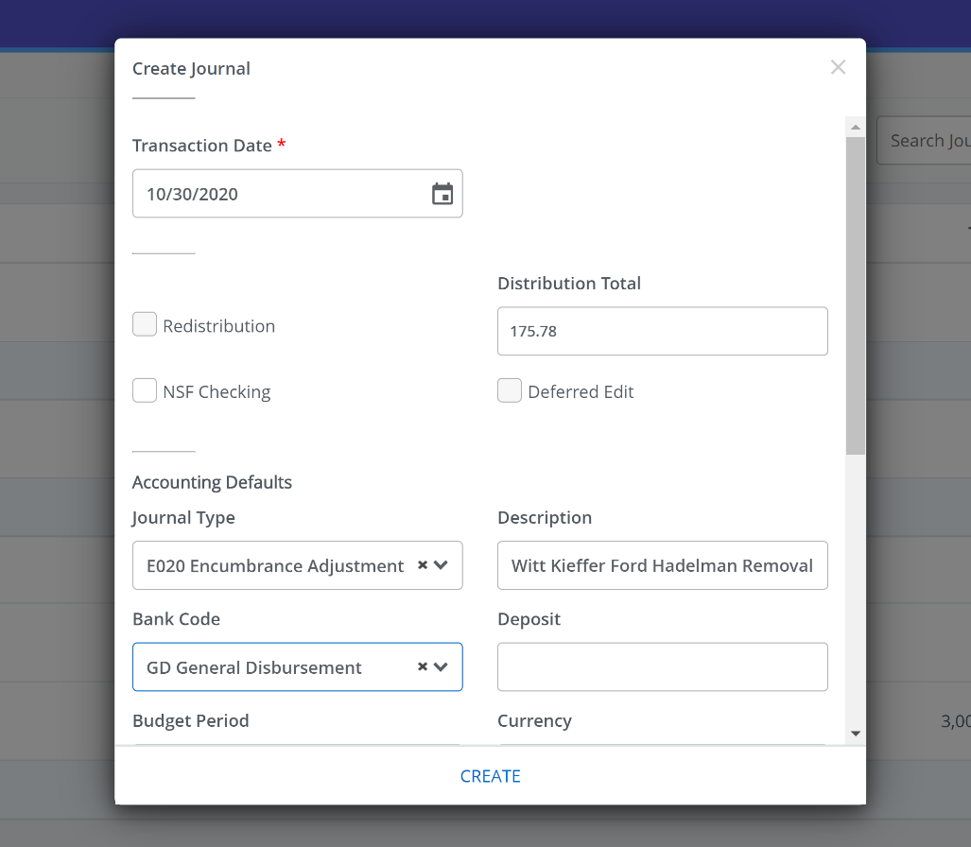
DB BoA Disbursement

Removing a PO Encumbrance in Self-Service
After clicking CREATE, the Add Accounting screen will open. Use the information noted from Banner FGIENCD to enter the accounting information.
Journal Type: E020
Chart: V
Index: enter PO index (fund and org will self-populate)
Account: enter PO account code
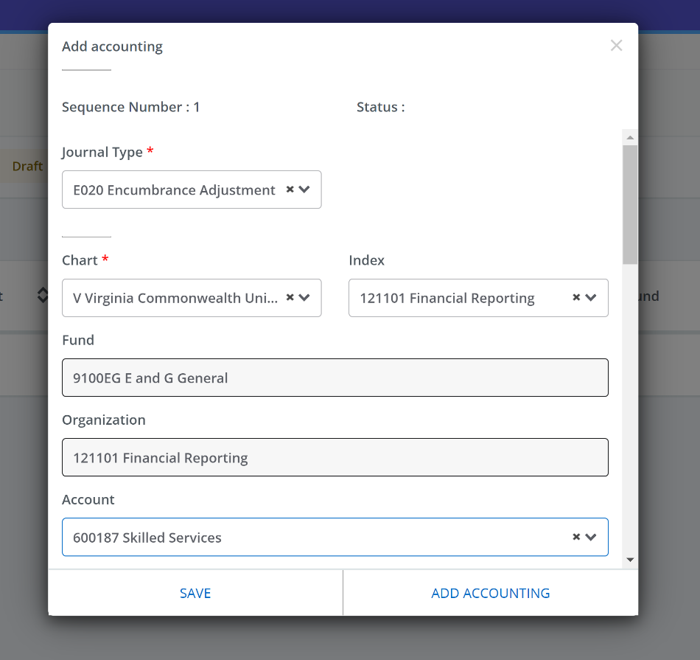

Removing a PO Encumbrance in Self-Service
Scroll down on the Add Accounting screen to continue entering the following accounting information.
Amount: enter encumbrance balance
Debit/Credit: - Minus
Description: enter vendor’s name
Bank Code: DB
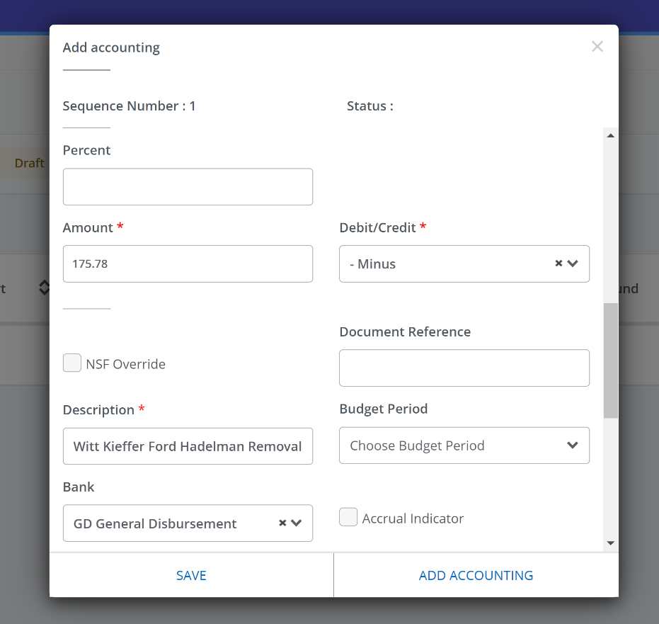

DB BoA Disbursement

Removing a PO Encumbrance in Self-Service
Scroll down on the Add Accounting screen to continue entering the following accounting information.
Encumbrance Number: enter PO number
Item Number: enter PO item number
Sequence: enter PO sequence number
Once you are finished entering the accounting information, click SAVE. Or if you need to add another line, such as for additional encumbrances or items/sequences for the same encumbrance, click ADD ACCOUNTING and complete the steps to enter the accounting information for the next line.
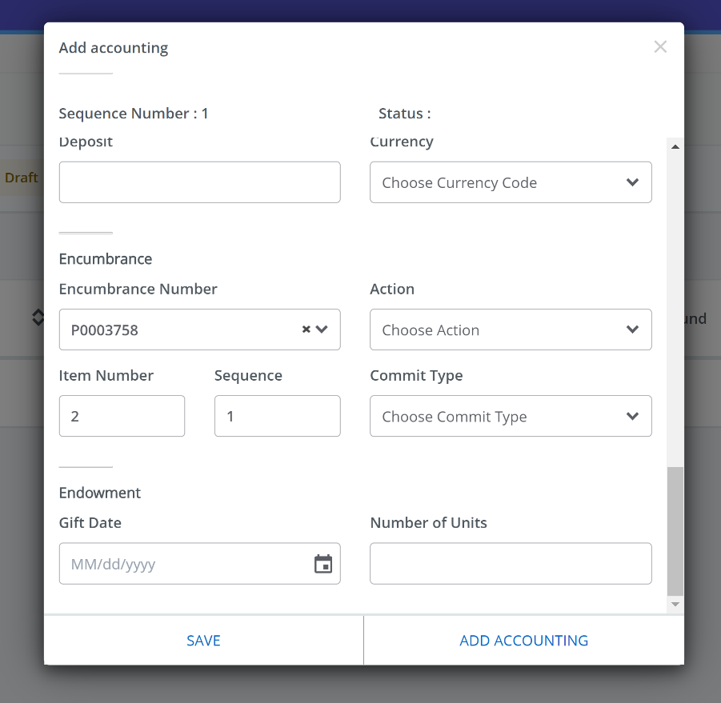
OR

Removing a PO Encumbrance in Self-Service
After clicking SAVE on the Add Accounting screen, the journal voucher draft will be displayed. The assigned document number will be listed in the top left of the screen. After reviewing the draft, click Submit Journal to submit the journal voucher.
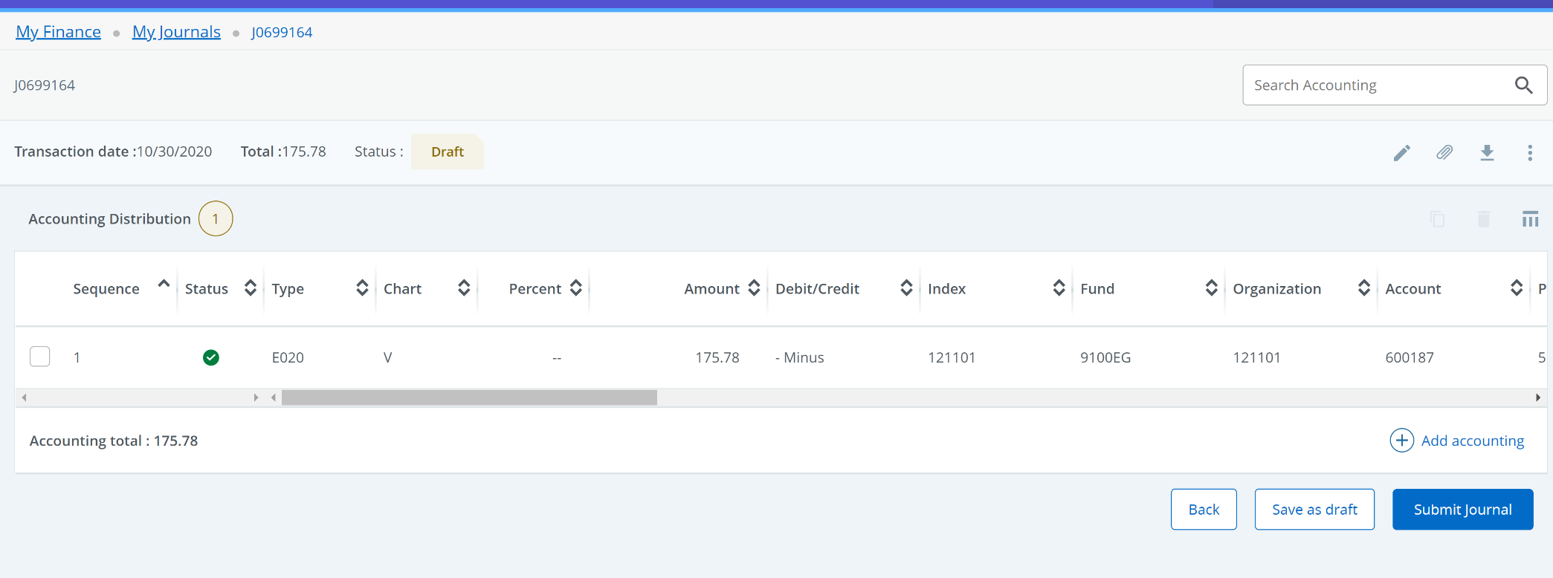

Removing a PO Encumbrance in Self-Service
After clicking on Submit Journal, a pop-up will appear “Do you want to submit journal Jxxxxxxx?”. Click YES.

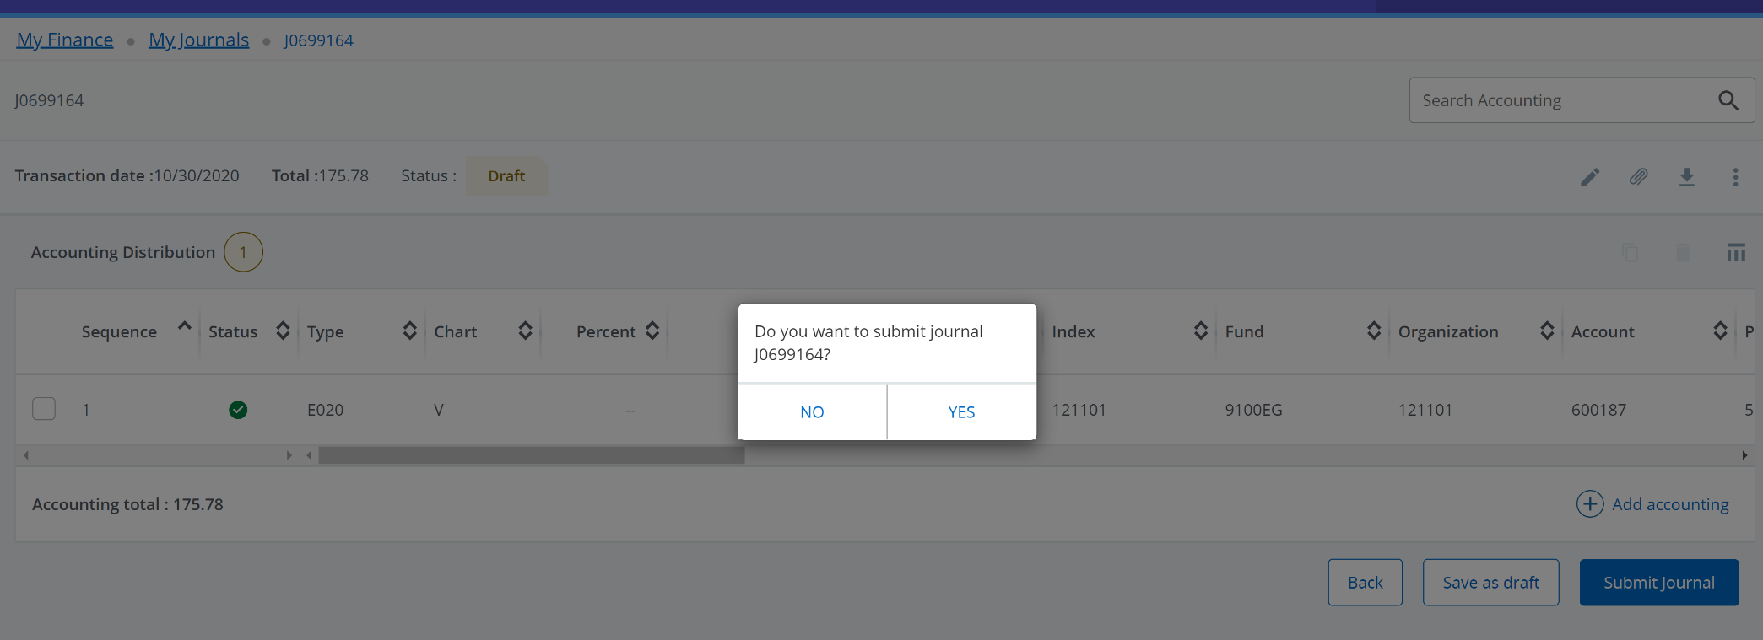

Removing a PO Encumbrance in Self-Service
After clicking YES, a green message box will appear, “Document Jxxxxxxx completed and forwarded to the approval process. The submitted journal voucher will also show in the Pending Journals section with a status of In Approval. After the document has been approved, check Banner form FGIENCD to ensure the PO balance has been removed.
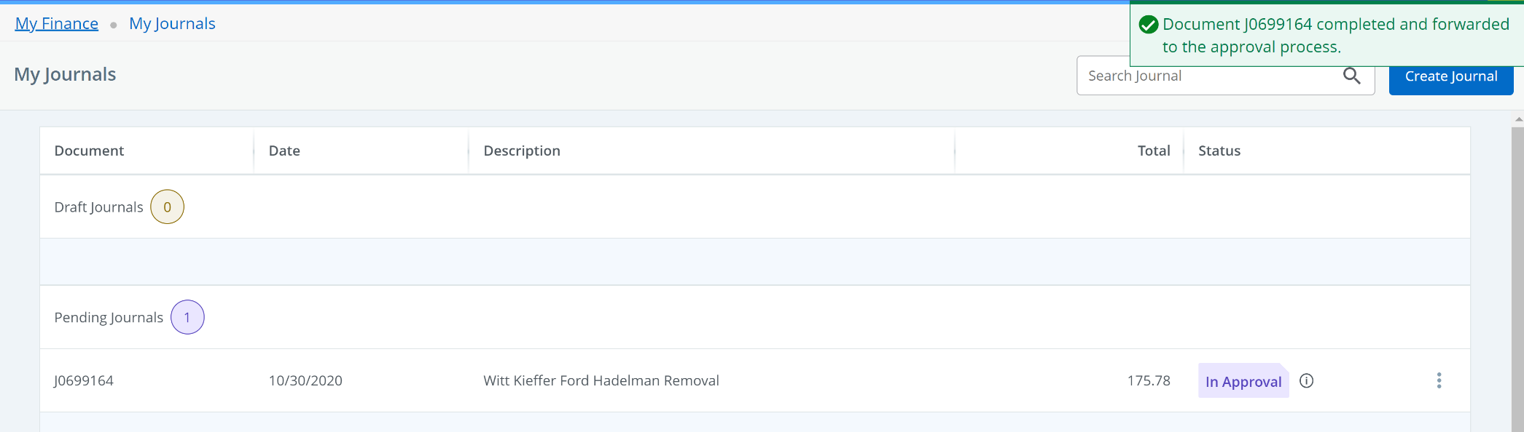

Removing a PO Encumbrance in Self-Service
After the document has been approved, check Banner form FGIENCD to ensure the PO balance has been removed.

