Journal Voucher Rule Classes
▪ X01 -Journal Entry for Revenue Transfer: For the transfer of revenue from one account to another
account. Not for expense or non-mandatory transfers. Restricted to accounts in the 400000 to 499999
range. Must use current fiscal year. Use DB in the Bank field. Budget Period field should be blank. An increase in revenue is a credit entry. A decrease to revenue is a debit entry.

▪ XEX -Journal Entry for Expense Transfer: For transfer of expenses within orgs and accounts. Not for non-
mandatory transfers or internal service charges. Restricted to accounts in the 600000 to 649999 and
700000 to 799999 ranges. Accounts from 650000 to 699999 can not be used. Must use current fiscal year. Use DB in the Bank field. Budget Period field should be blank. An increase to expense is a debit entry. A decrease to expense is a credit entry.

▪ XIC -Journal Entry for Internal Charge: For original charge or transfers of internal service charges from one
unit to another (i.e, Animal Resources, Telecommunications, Physical Plant, Mail Services, etc.). All original charges must be supported by detail work papers that document the actual costs and do not include indirect costs when charged to sponsored programs. Restricted to accounts in the 650000 to 699999 range. Must use current fiscal year. Use DB in the Bank field. Budget Period field should be blank. A charge to a department is a debit entry. A reimbursement to the service department is a credit entry.
▪ XLF -Journal Entry for Non-Mandatory Transfer: For non-mandatory transfers between local funds.
Restricted to accounts in 980035 through 980060, with the exception of 980050, which can not be used
for non-mandatory transfers. The organization must be a local organization (index) from 350000 through
699999. XLF can not be used for organizations in the 500000 to 599999 range, for sponsored programs.
Use DB in the Bank field. Budget Period field should be blank. A transfer to increase the cash available in a local org is a credit entry. A transfer to decrease the cash in a local org is a debit entry.

University Polices for Journal Vouchers
▪ University policy prohibits using a journal voucher to debit a sponsored program
organization (orgs in the 5xxxxx range) for an expense that posted to Banner more than 60 days from the month end of the original posting.

▪ University policy prohibits debiting a state organization and crediting a local organization. For
this purpose, local organizations are considered to be orgs in the 400000 to 499999, 600000
to 699999 ranges. All others are considered state organizations. The exception to this policy is the original charges of approved service centers and administrative division units (XIC
entry) providing support services to organizations. Expense transfers are allowed that debit a local organization and credit a state organization.

▪ Charges to sponsored programs (organizations in the 500000 to 599999 range) must be
supported by either approved authorized service center rates or documentation to support
actual costs. Charges, other than approved authorized service center rates, may only include
direct costs that are allowable on the sponsored project if they have been directly charged
and may not include any facility, administrative, overhead or processing fee costs or profit.

▪ No revenue may be transferred to or from organizations in the 200000 to 299999 range from
other organizations (ex: can’t move revenue from 1 ledgers to 2 ledgers, or vice versa).
Revenue may be transferred between organizations in that range but should also be
accompanied by the appropriate budget entries to transfer revenue and expense budget
within the 200000-299999. These organizations also may not be utilized for revolving or clearing accounts.

▪ Violation of University policies related to journal entries may result in the loss of access to
the journal voucher process regardless of job function.

Entering Journal Vouchers
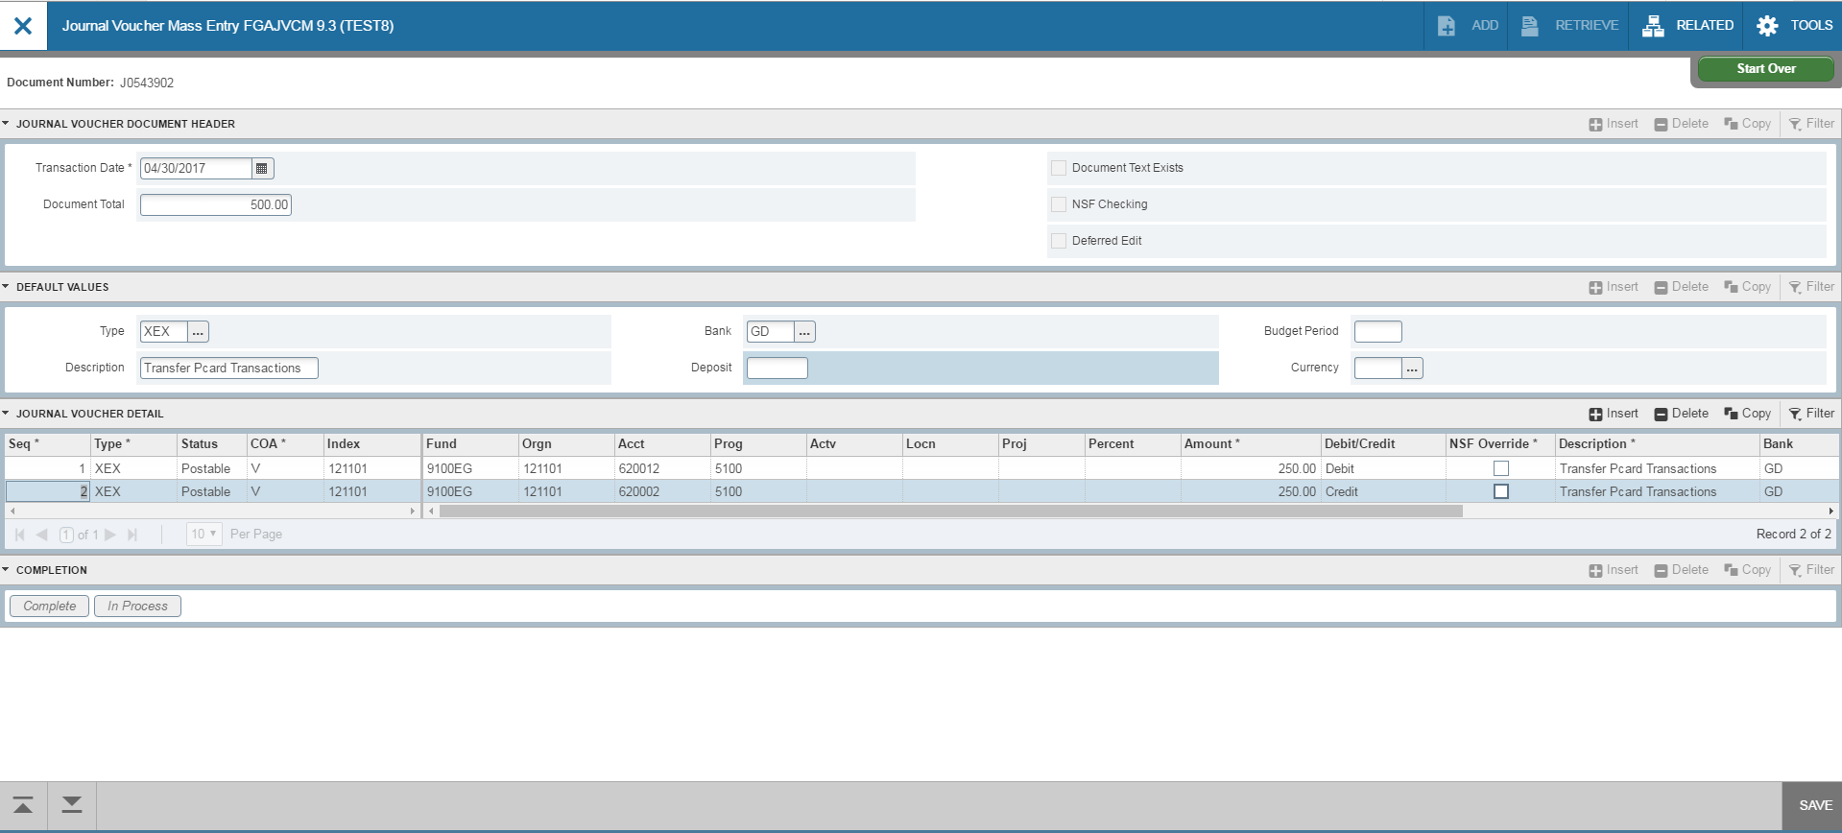
5
6
2
3
4

2

3

5

4

1. Go to Banner form FGAJVCM. Click on Go.
2. Transaction Date will auto-fill. Enter the Document Total. This is the total of all the transaction lines. For
example, if you move 250.00 from one account to another, the total is 500.00.
3. Type in your Rule Class Type: X01, XEX, XIC or XLF. Bank is DB. Type in your description. Budget period is
blank.
4. Click on Next Section down arrow.
5. Tab to Index and enter the index. Tab to Acct and enter account. Tab to Amount and enter amount.
6. For journal vouchers, use the Debit/Credit indicators. Tab through the rest of the fields on the line.
7. To add the next line, click the down arrow on your keyboard or click insert. A new line will appear.
Follow steps 4-6 to enter information for the new line.

Entering Journal Vouchers
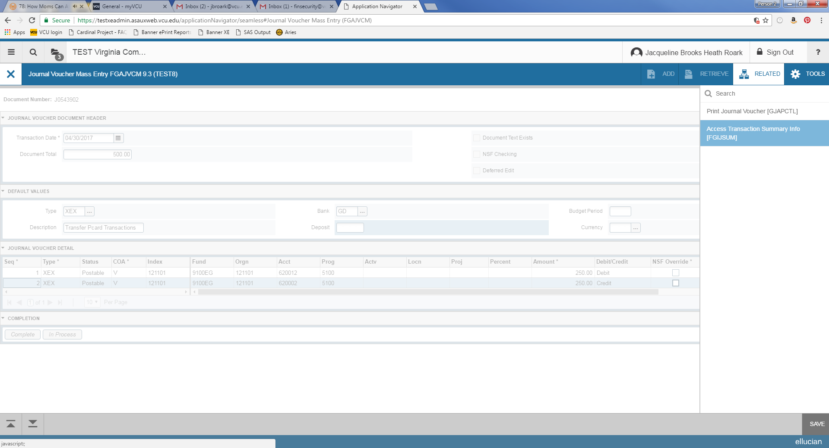

- After entering all lines, click Save at the bottom right of the screen. Make sure the status on all lines updates to “Postable”. If any lines show the status as “Error”, you will need to resolve the error before moving forward.
- Select Related>Access Transaction Summary Info from the toolbar.

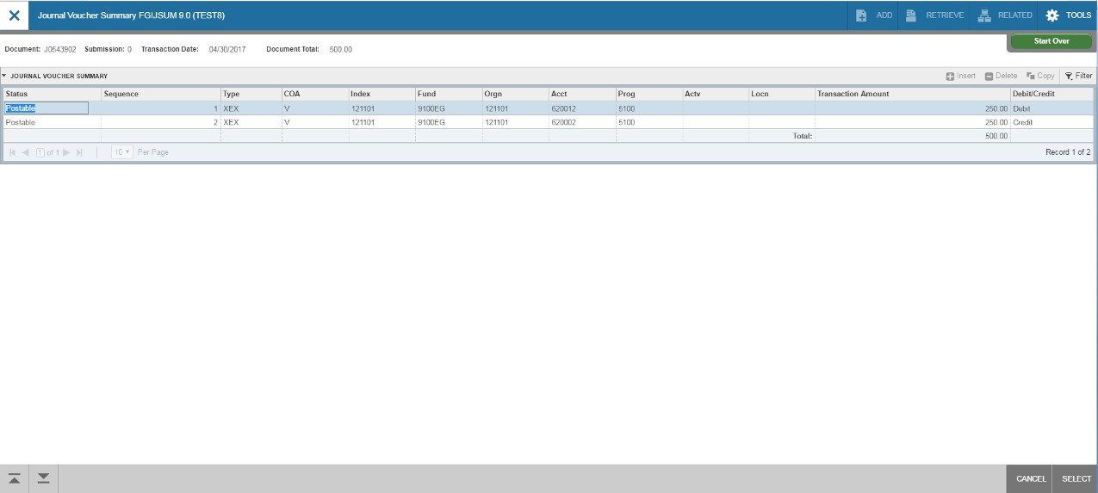Entering Journal Vouchers

1

1

2

- Review your entry on this form. Make sure the Document Total equals the total of all lines you entered.
2. Make sure that all lines of the transaction appear and that each has a status of Postable.
3. Click on Cancel at the bottom of the page to exit this form and return to FGAJVCM.

Entering Journal Vouchers

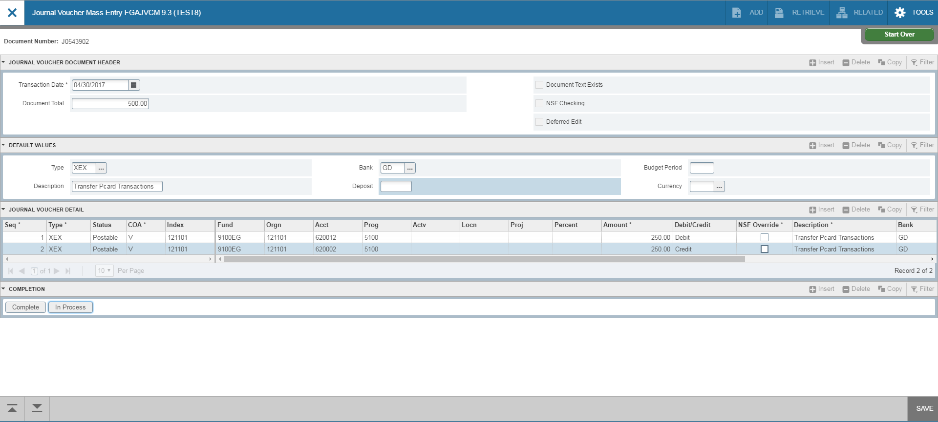
2
1

2

- On FGAJVCM, click on the Save icon on the toolbar. If you are ready to submit the document for approval , click on Next Section down arrow.
2. Click on Complete to submit the entry.

