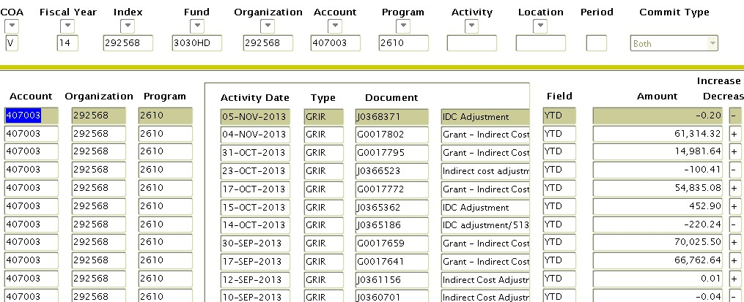How is FACR recorded in Banner Finance?

Some FACR revenue is processed in Banner automatically and   
will post several times a month in 2 ledger Banner orgs using   
account 407003.

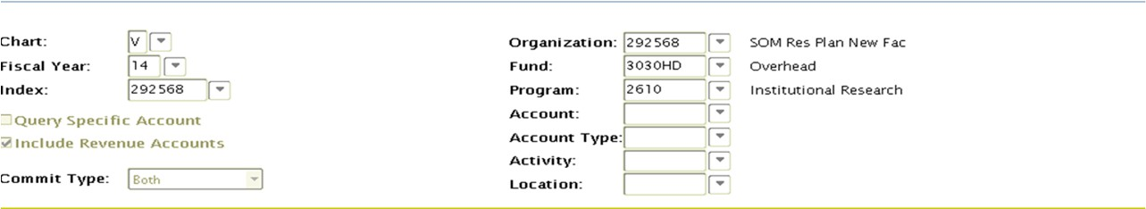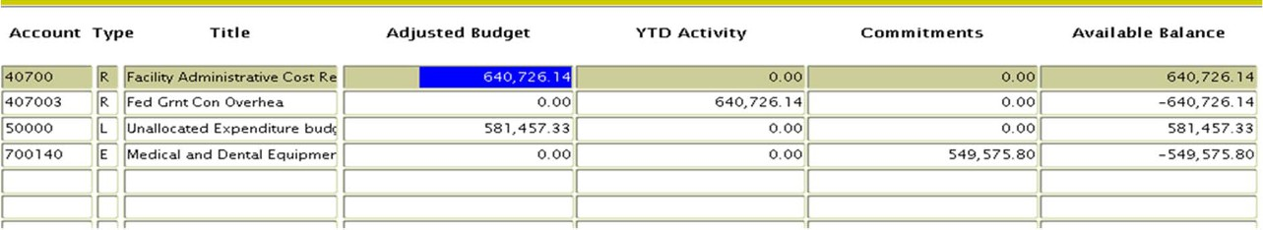How is FACR recorded in Banner Finance?

This creates revenue and expenditure budget entries   
as well as year to date actual revenue.

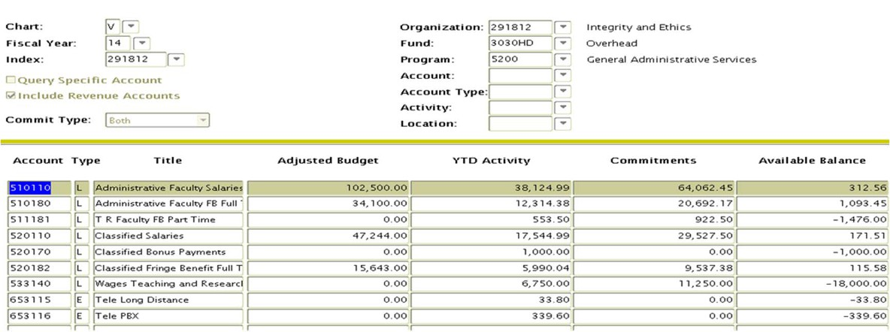How is FACR recorded in Banner Finance?

Other FACR revenue is budgeted similar to

Educational & General Funds (E&G) with only an   
expenditure budget. These orgs are generally for a   
specific project.

Departmental FACR funds

FACR orgs (indexes) are treated the same as E&G   
and grant funds. The same State rules apply. State   
funds may not be used for expenditures such as   
gifts, alcohol or social memberships.

It is critical to stay within the adjusted budget.

Unexpended budget balances may carry over to the   
next fiscal year, but only at the discretion of the   
executive level Vice President.

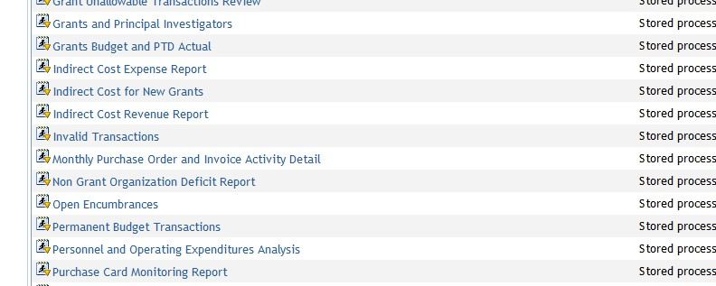Departmental FACR/Indirect Cost   
 Information

3 reports on VCU Reporting Center deal with   
Indirect Cost and/or FACR revenue.

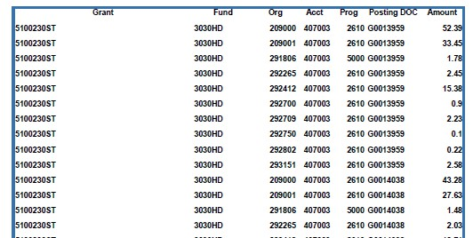Indirect Cost Expense Report

Provides information on the automatic entries for indirect   
cost. Includes the associated grants and expenditures used   
for the calculation as well as the orgs used to recover FACR   
revenues. Runs by department or sub-department.

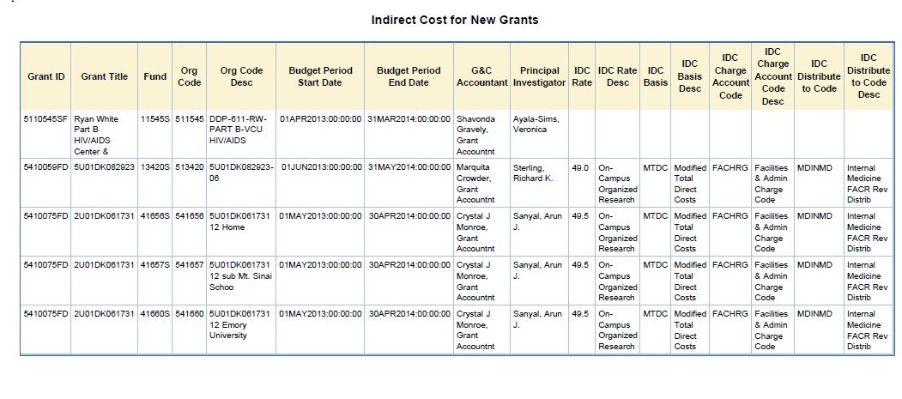Indirect Cost for New Grants Report

Identifies indirect cost information associated with   
new grants. Includes PI and indirect cost rates. Runs   
by MBU, department or sub-department.

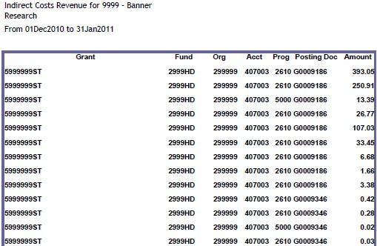Indirect Cost Revenue Report

Report provides the revenue generated through

indirect cost by grant ID. Does not include expense   
detail. Runs by department and sub-department.

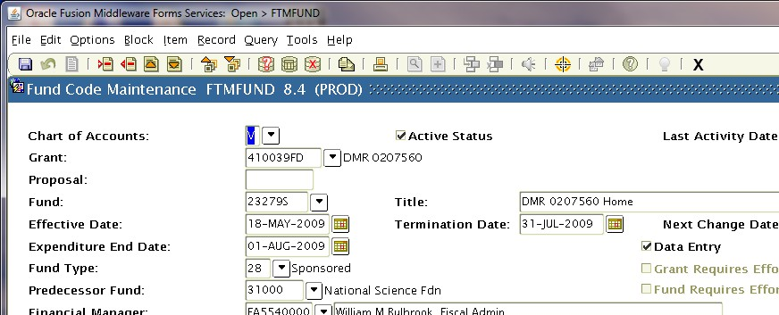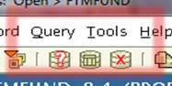Indirect cost information in Banner

For specific grant information, go to Banner form   
FTMFUND. Click on the Enter Query icon on the   
toolbar. Type in the Grant number. Click on the   
Execute Query icon on the toolbar. Details of grant   
will display.

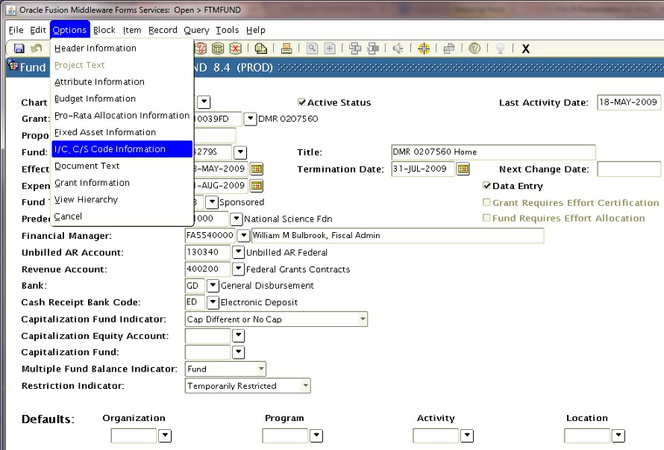Indirect cost information in Banner

Navigate to FRMFUND by Options>I/C C/S Code Information   
on the toolbar.

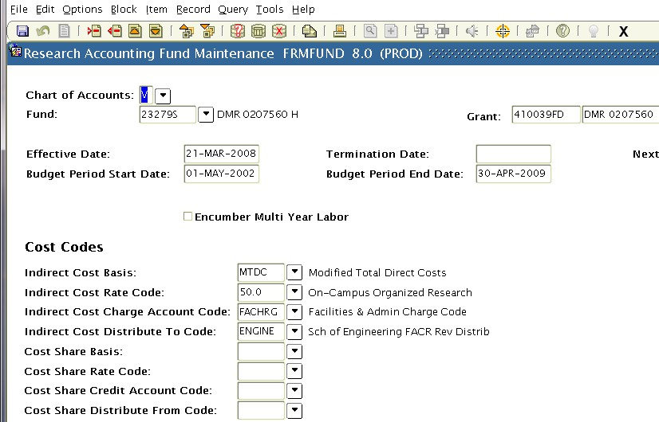Indirect cost Information in Banner

Displays the budget period and indirect cost setup for the specific grant.

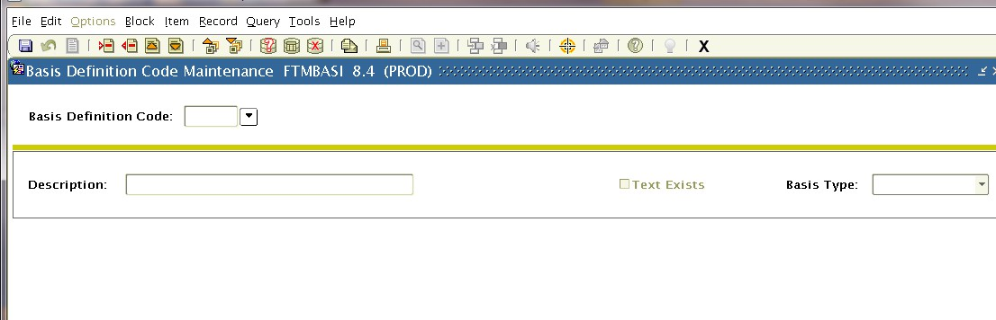Indirect cost information in Banner

FTMBASI-explains which accounts are used to

determine the indirect cost basis for modified total   
direct costs (MTDC). Use the search arrow at the   
beginning of form to view the list of codes and   
effective dates.

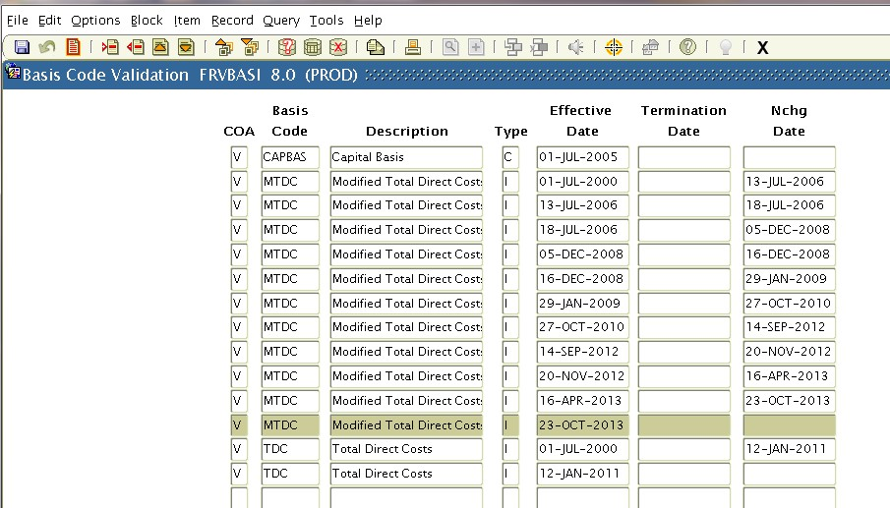Indirect cost information in Banner

Double click on the basis code you would like to   
view. Click on the next block icon.

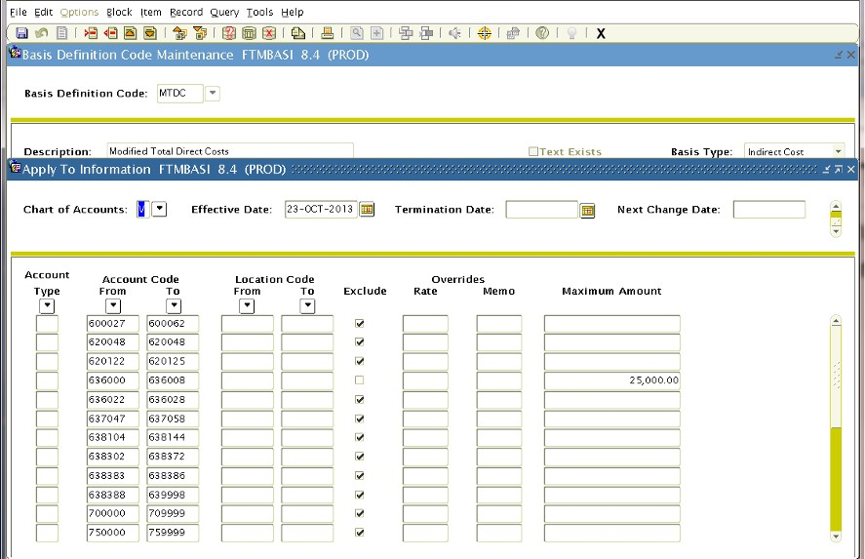Indirect cost information in Banner

Form displays which accounts are included or   
excluded from this definition (MTDC).

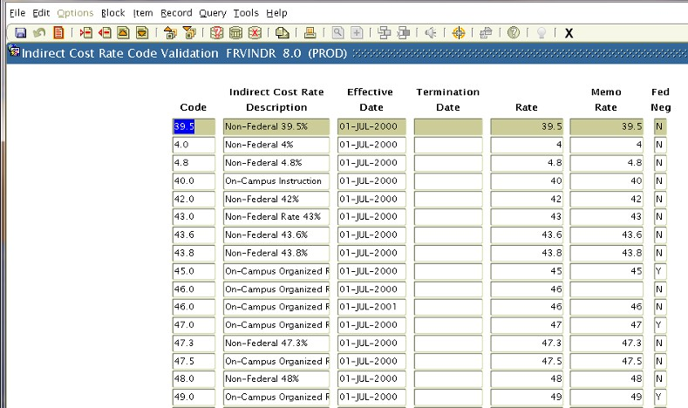Indirect cost information in Banner

FTMINDR-information on indirect costs rates,

percentages, effective dates and whether rate was   
federally negotiated. Navigate the same as FTMBASI:   
search arrow, double click rate, next block icon.

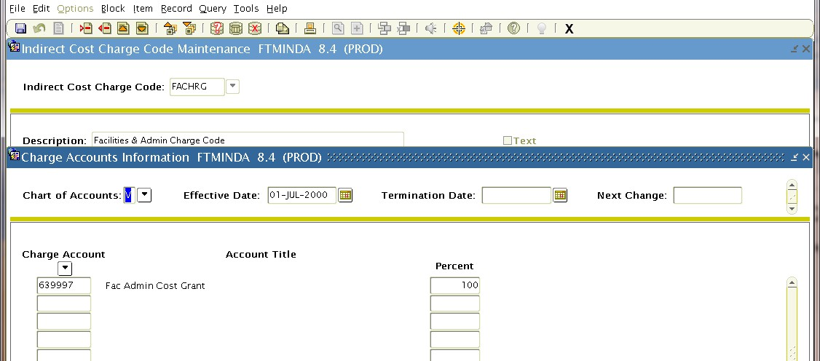Indirect cost information in Banner

FTMINDA-list of Banner accounts used to charge

indirect cost to orgs (indexes). Search arrow>double   
click on code>next block icon.

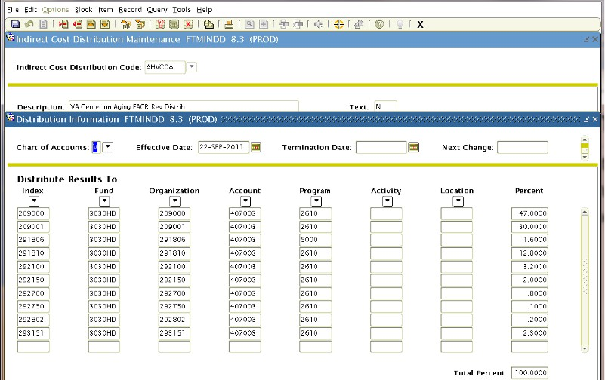Indirect cost information in Banner

FTMINDD-provides information on Banner orgs   
used for indirect cost distribution (FACR revenue).   
Search arrow>double click on code/date>next block   
icon.

Research Dashboard

Research Dashboard provides investigators and   
administrators direct access to financial and   
administrative information related to sponsored   
awards.

Data in the Dashboard updates nightly and includes   
integrated data from Banner Finance, Banner HR and   
InfoEd.

Login to the Dashboard through the VCU Reporting   
Center.

My VCU>VCU Reporting Center>Research Dashboard   
tab.