Banner Finance Approval Processes
Approving Budget Entries, Journal Vouchers, and Cash Receipts
Controller’s Office

Banner Approvals

- What are they?
- Electronic approvals provide a paperless process for documents to move through the approval process in Banner.

- Which documents?
- All Banner journal entries, budget reallocations, and cash receipts must be approved in Banner before they will be posted.

Banner Approval Rules and Policies

- The document “running” total (total of all transactions) will determine how many approvals, and what administrative levels, are necessary for Banner documents (budget entries and journal entries):
- Fiscal Administrators $100,000 or less
- Dean/Director $100,001 - $500,000
- Vice President $500,001 - $999,999
- President $1,000,000 and over
- The Controller’s Office will approve journal entry transactions of $1,000,000 or more.

- Cash receipt entries only require a Fiscal Administrator approval.
- Attempts to circumvent approval controls are prohibited.
Banner Approval Responsibilities

- “Explicit” approvals are implemented.
- The person who keys the entry cannot approve their own document.

- Please review documents waiting for approval in a timely manner. All Banner
Finance documents must be approved or rejected within 5 business days.
- When you access any finance form, you will receive a message in Banner
notifying you that documents are waiting for your approval.

- You can approve Banner Finance documents in Banner 9 Self-Service.
- Log into Banner 9 Self-Service through “myVCU” found on the VCU homepage. https://www.vcu.edu/
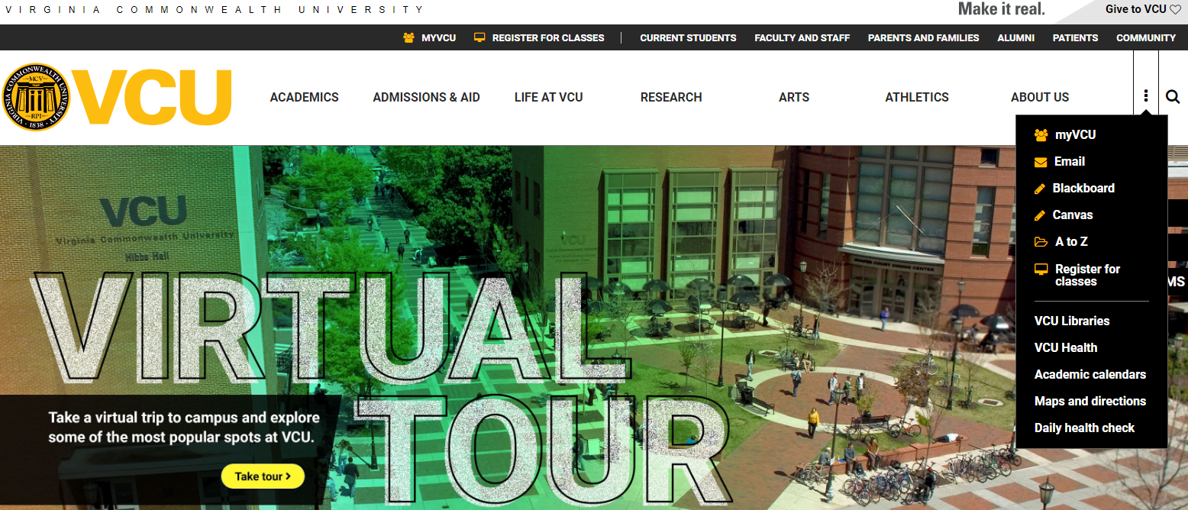

- Click on “eServices/VCU Self Service”.
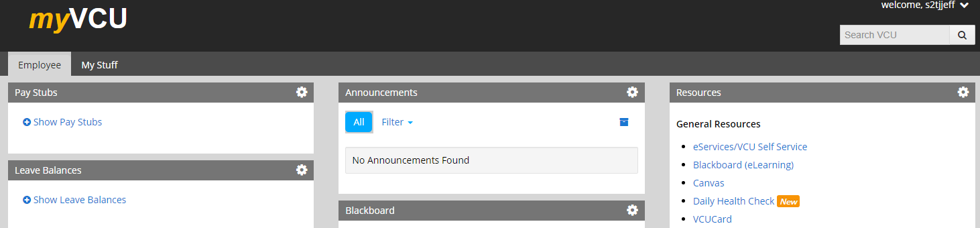

- Navigate to the Finance page using the menu at the top.
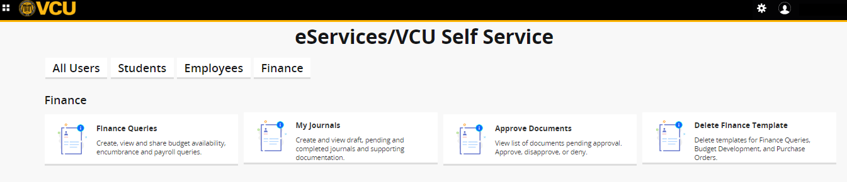
- Click on “Approve Documents”.

- Your “user ID” will populate.
- You do not have to enter a “document number”.
- To see the documents for which you are the next approver, select “user ID is next approver” and click “submit”.
- Tip: If you would like to see all documents that need your approval, select “all documents user may approve” and click “submit”.
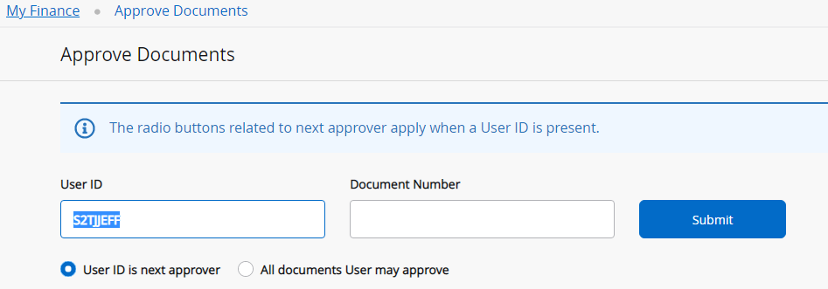

- To view the document detail, click on the document number.
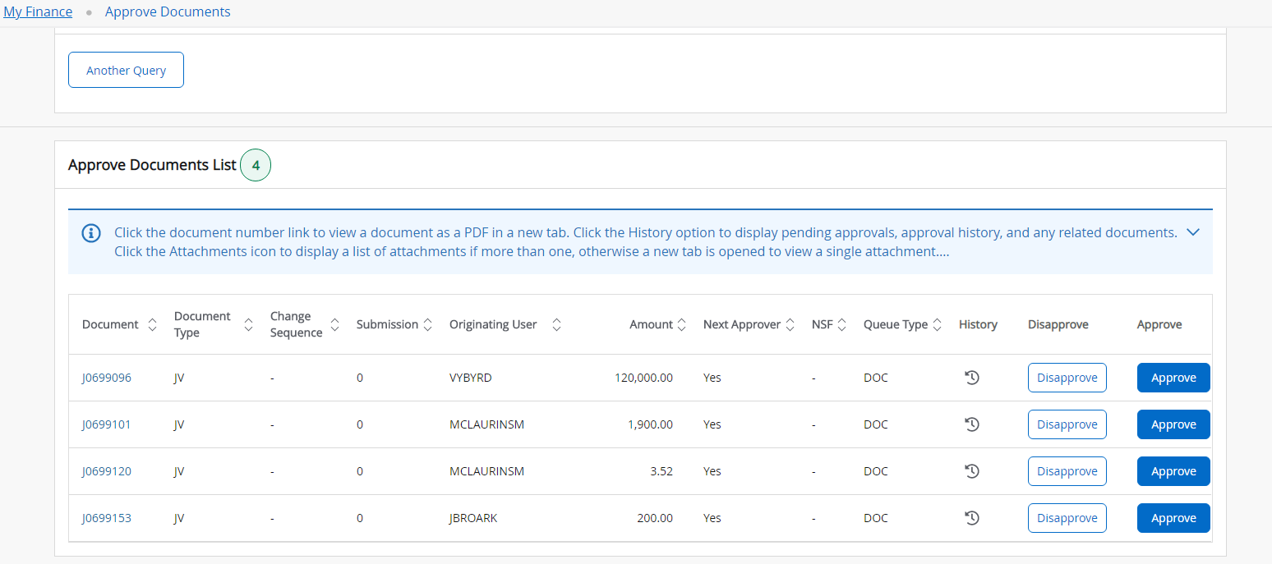

- Review the entire PDF for accuracy.
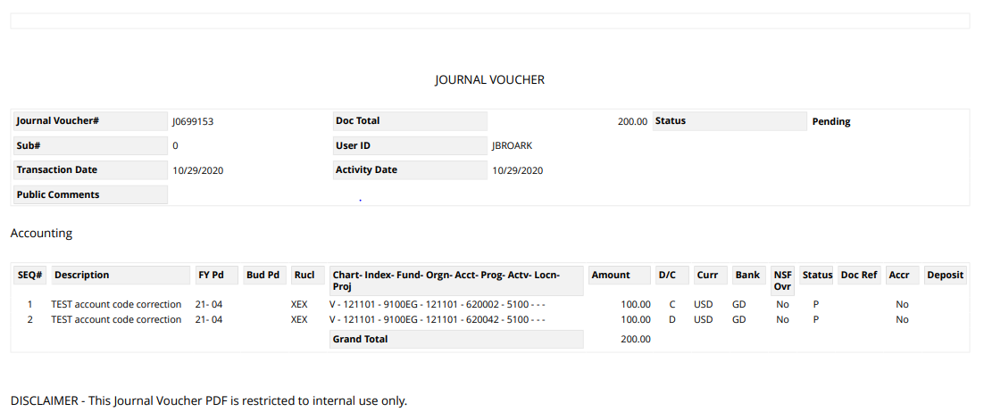
- Close the PDF to return to the “approve documents list” window.

- You can approve or disapprove the document.

- If you need to return from the “approve document” window without approving the document, click “cancel”.
- To approve the document from the “approve document” window, click “approve”.
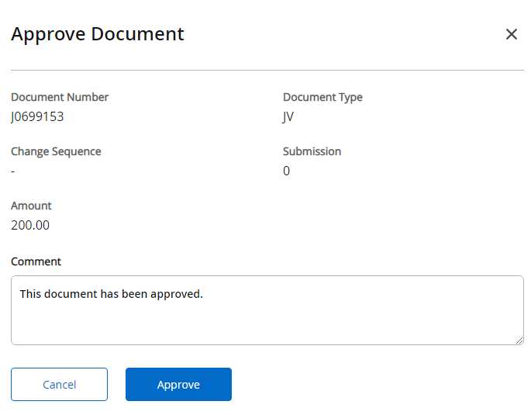

- You will receive a message that indicates the document has been approved.
- To disapprove a document from the “approve document” window, click “disapprove”.
- You will receive a message that indicates the document has been disapproved.
- To approve or disapprove another document, repeat the similar steps above.

