Salary Encumbrances

Banner Finance
University Controller’s Office

Important Items to Remember

• Salary encumbrances do not encumber for hourly employees, including student
workers and work study.
• Salary encumbrance is calculated up to the end of fiscal year or contract date,
whichever is earlier. Multi-year encumbering for grants is not functioning properly.
• The process will run after each payday, so any PHAREDS done after payroll will not be
recognized until the next time the job is submitted (see schedule on page three).
• Payroll in Banner Finance will now post after the process runs, not just twice a month.
• A salary encumbrance report is being created for the Reporting Center.
• Direct any additional questions to the Banner Helpdesk at (804) 828- 0388.

VCU Controller's Office

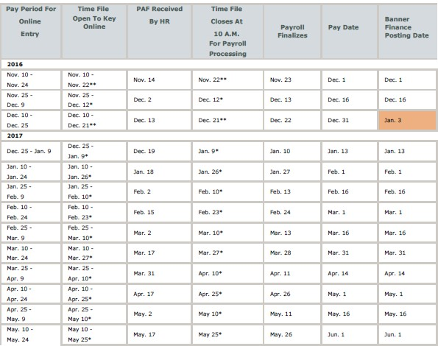Banner Finance Posting Schedule

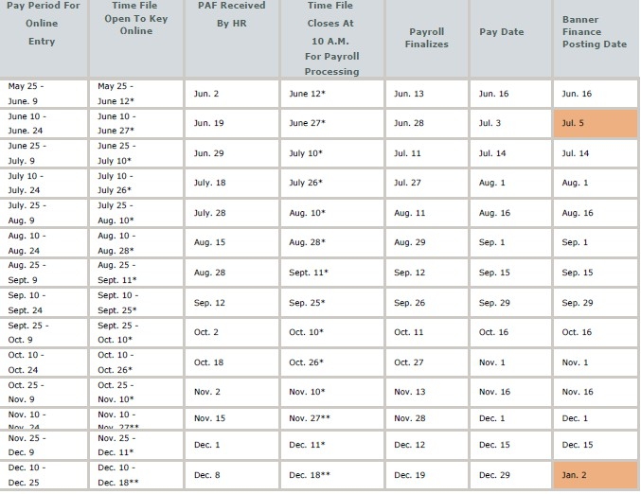

Banner HR Forms NBIJLHS and NHIDIST will show
the salary/fringe encumbrance in the below fields.

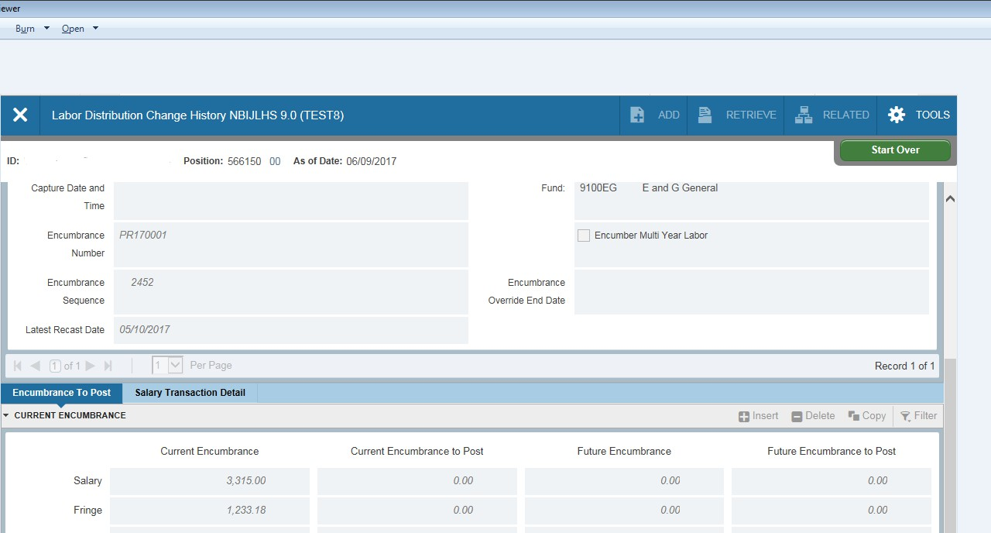NBIJLHS

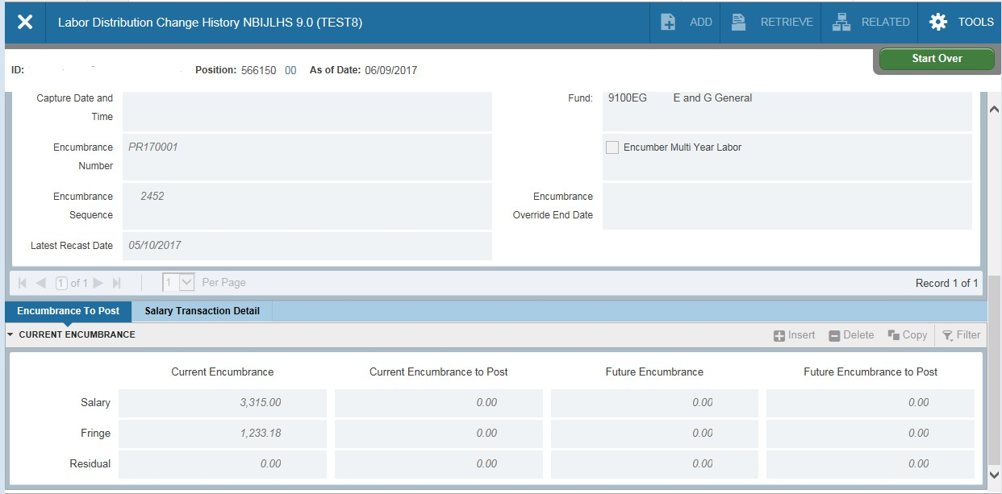NHIDIST

VCU Controller's Office

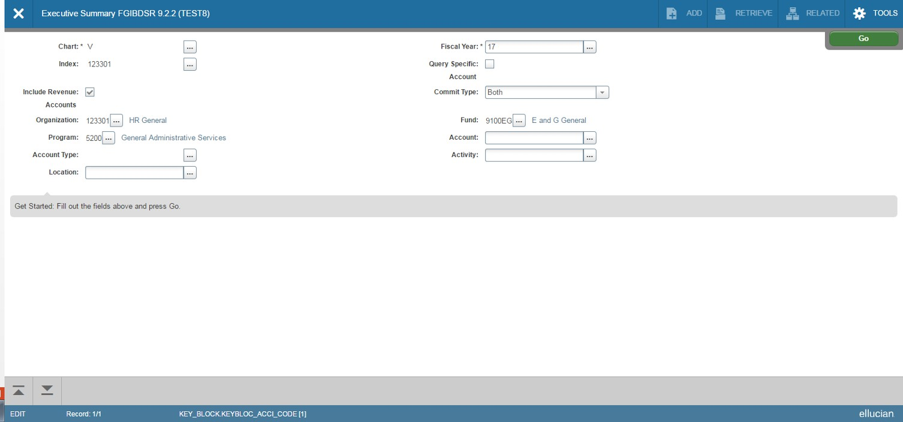FGIBDSR

VCU Controller's Office

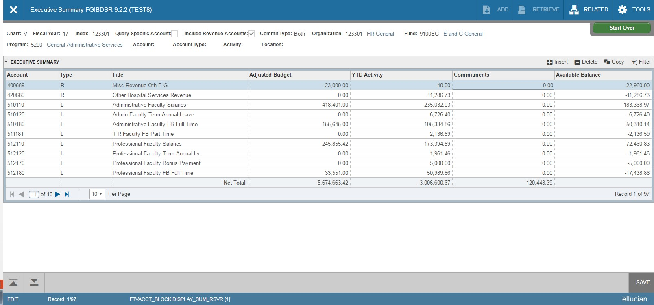FGIBDSR
On Banner Finance Form FGIBDSR, the salary/Fringe commitments appear in the Commitments Column.
VCU Controller's Office

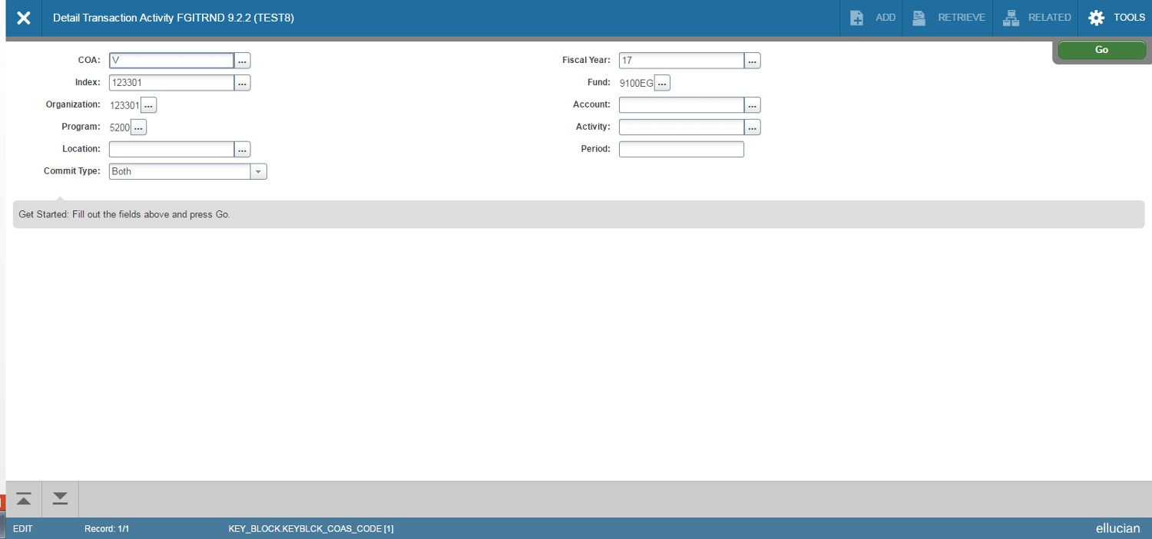FGITRND

VCU Controller's Office

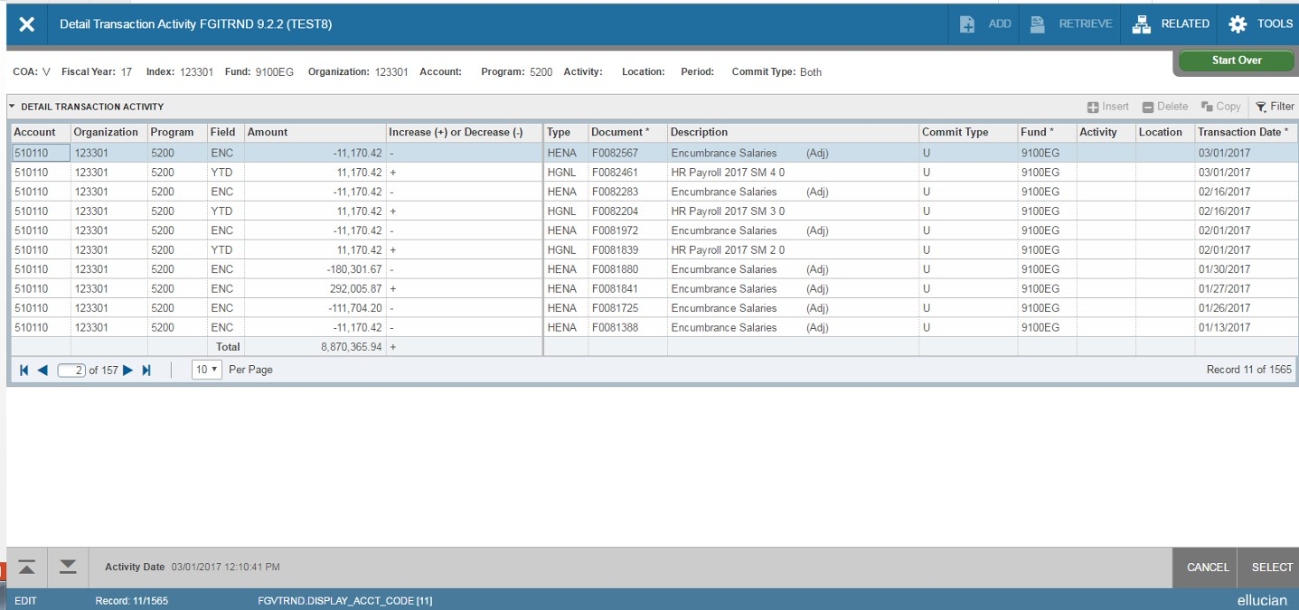FGITRND
Banner Finance Form FGITRND shows the detail for the salary
encumbrance entries.

VCU Controller's Office

