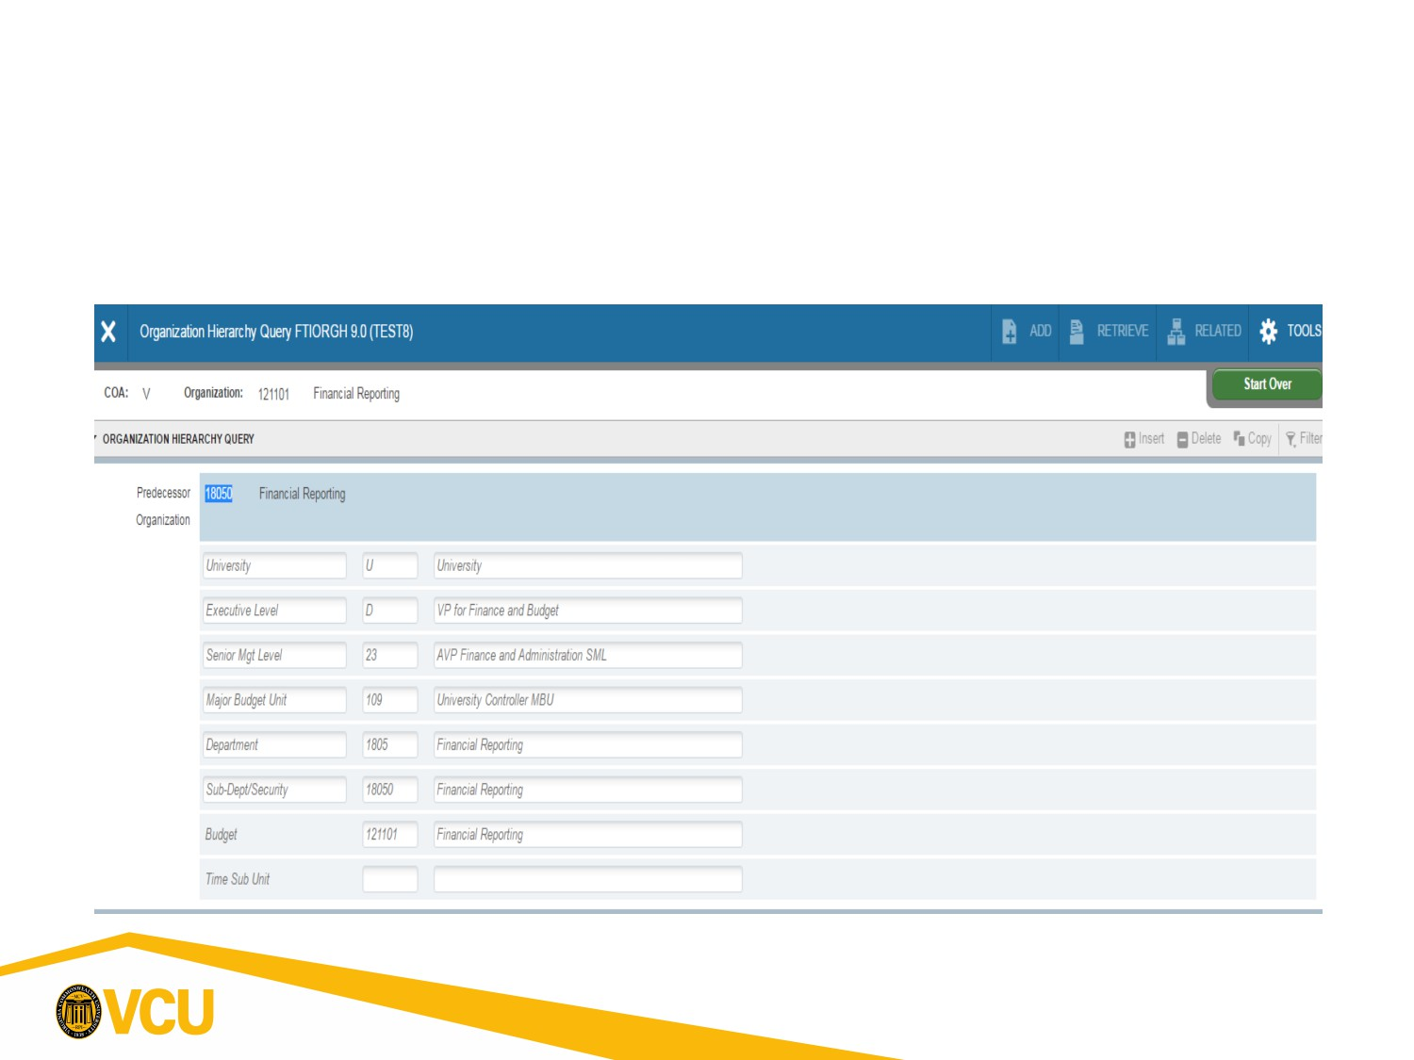FOAPAL-Organization
Banner form FTIORGH shows how an individual 6 digit Organization (org code) rolls up to higher University levels.
1

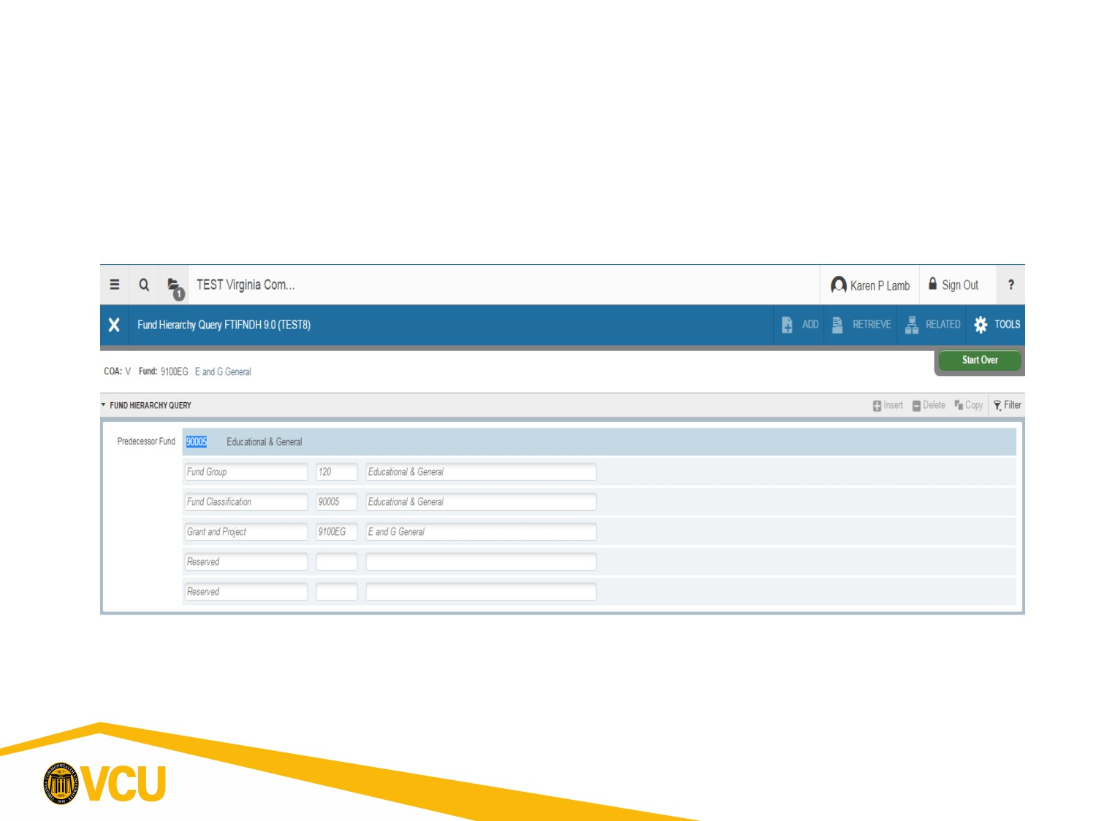FOAPAL-Fund
Banner Form FTIFNDH displays fund hierarchy (how funds roll up to higher
levels). Higher levels have fewer digits and are used for reporting purposes.
2

