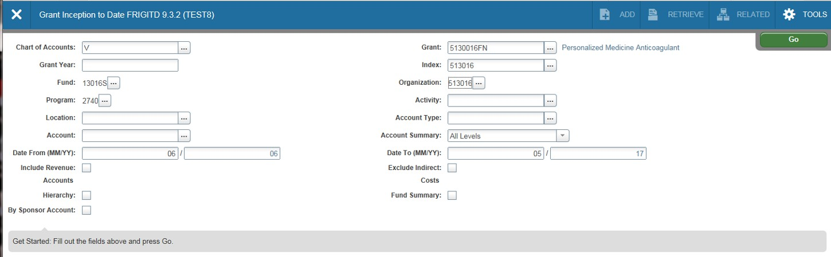FRIGITD (Grant Inception to Date) is a useful page for grant administrators. This page displays activity
for grants or capital outlay projects from the inception date (rather than just fiscal year). It’s a flexible
page with many options. To use this page, you can enter either the Grant ID or the Index code (in which
case the Grant ID will self populate). You can also specify a grant year or leave blank for all years. If the
grant has more than one fund, you can also check Fund Summary to display a summary of each fund.
You may also specify a date range to display or leave blank and the date range will self populate based
on the origination of the grant. After filling in the pertinent information, click on the Go Icon.

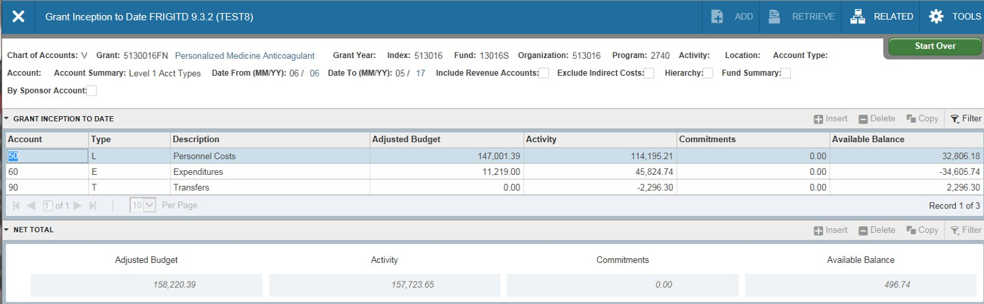FRIGITD (continued)-This page has options for the display of account activity. Level 1 Account Types is a summarized view.

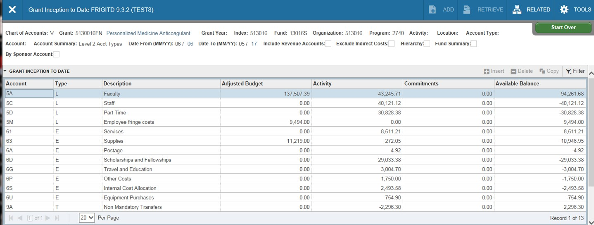FRIGITD (continued)-Level 2 Account Types is summarized by specific areas of activity.

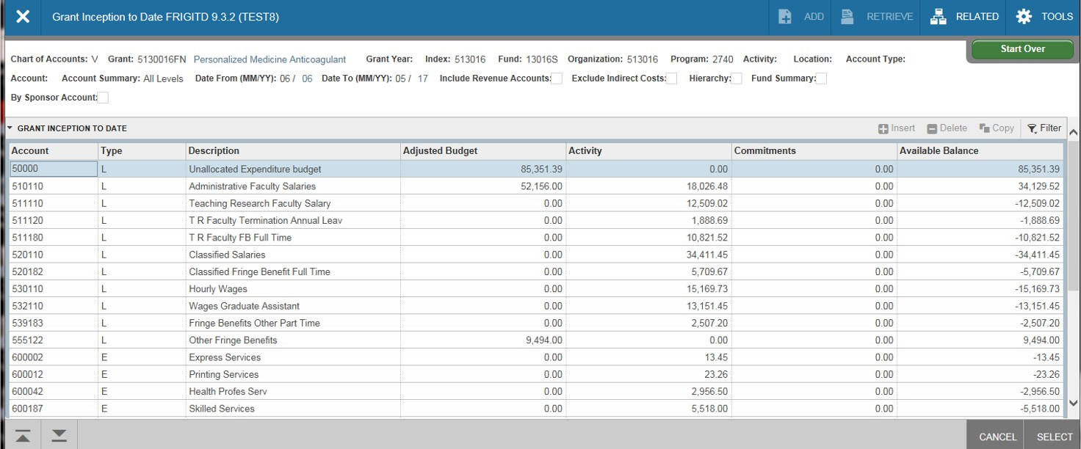FRIGITD (continued)-All levels of Account Summary displays all expenditure
accounts. To view details of an expenditure account, click on the account then choose
the Grant Transaction Detail page under related.

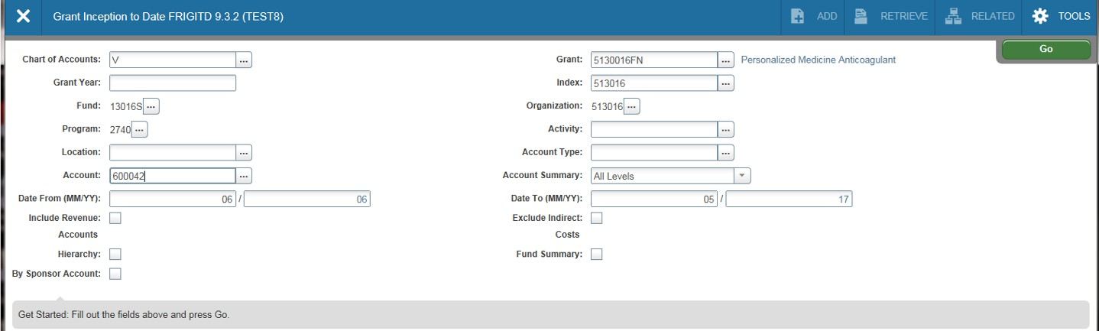FRIGITD (continued)- Another way to view the detail of an expenditure account, enter the account on the criteria selection screen and select the Go icon.

Select an account, then select the Go icon.

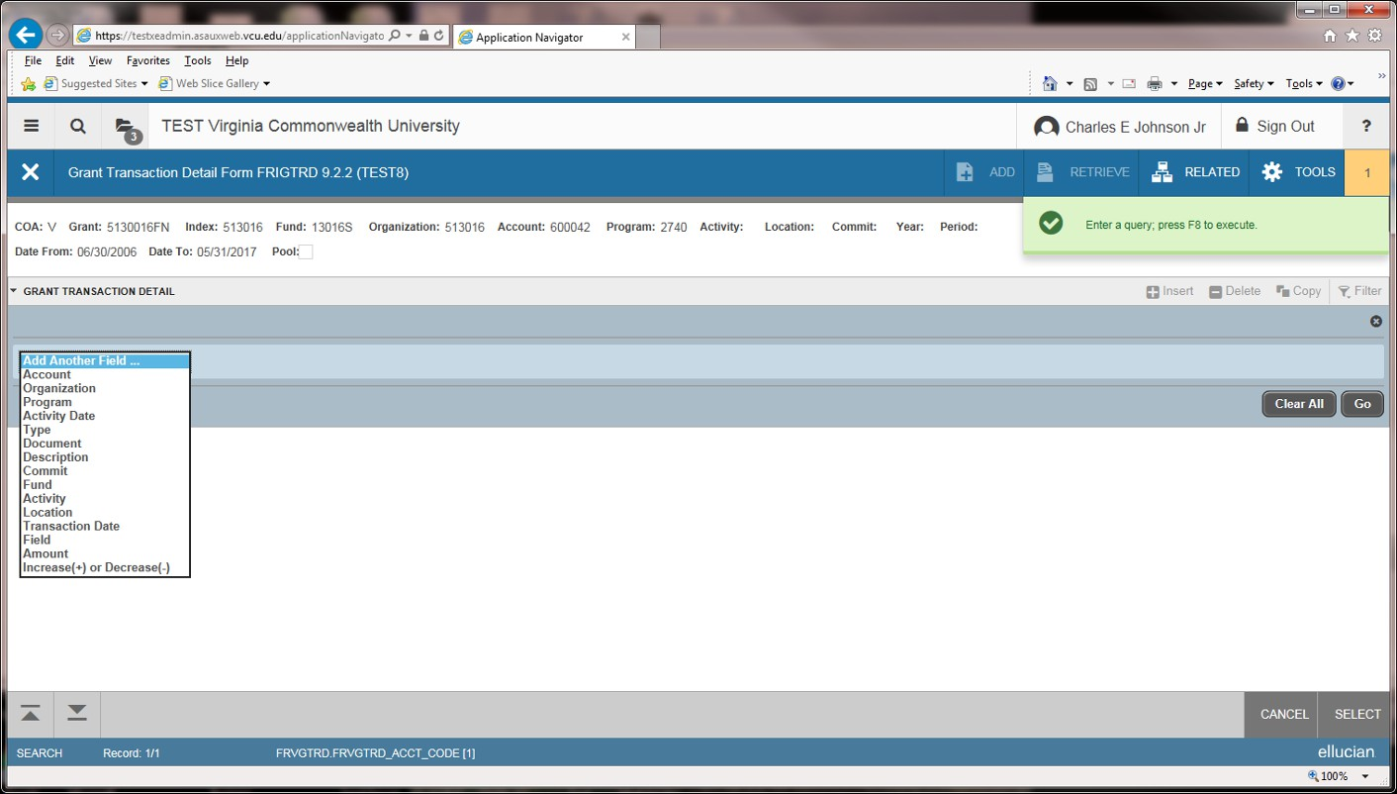FRIGTRD (Grant Transaction Detail) to reveal all transactions that posted to that account. From here the transactions can be queried further using the specific criteria shown.

