What is FACR?
FACR (facilities and administrative cost recoveries) is
the revenue generated from the indirect cost
charged to sponsored programs (grants, contracts
and other sponsored agreements).

VCU earns roughly 32 million in FACR
revenue each year. FACR revenue
directly supports internal research and
research related activities at the
University.

What is indirect cost?
Indirect Cost is an overhead rate that is applied to
the direct costs associated with the administration
of a grant, contract or sponsored agreement.
Overhead costs are associated with the
infrastructure of the institution (buildings,
maintenance, libraries, etc.)

Did you know? VCU is among the top 50 American public research Institutions.

Who decides the indirect cost rate?
Every four years, VCU negotiates with DHHS (Federal
Department of Health and Human Services) to
determine the FACR rate to use for the next four
year period for most awards from federal agencies.

Current and prior year DHHS rate agreements can
be found on our website,
controller.vcu.edu/cost/DHHSrates.htm

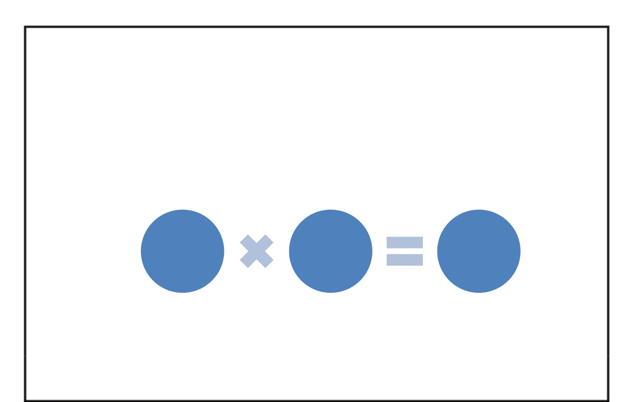
How is the rate applied?
As specified in the State Appropriations Act, VCU is
required to apply the full federally negotiated rate to
ALL grants, contracts and other agreements proposed
and/or accepted unless an exemption has been
granted.

Sponsored
Program
Direct
Costs
Indirect
Cost Rate
%

FACR
Revenue

Exemptions can be found on the Office of Sponsored
Programs website,
research.vcu.edu/osp/costrecoveryguidelines.htm

What is the current rate?
The specific rate applied to a sponsored program
depends on the type of activity (organized research,
instruction or other) and whether it is conducted on
or off-campus.
Current rates range between 26 to 52.5 percent. You
can find the current rates/categories on our website,
controller.vcu.edu/cost/farates.htm
OSP (Office of Sponsored Programs) explains the
categories here, research.vcu.edu/osp/whatrate.htm

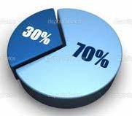
How is FACR revenue distributed?
The State Appropriations Act stipulates that 30% of
the funds recovered from sponsored activity be
transferred to the Educational and General revenues
of the institution and the remaining 70% be used by
the institution to foster, conduct and enhance
research and research related activities. A portion of
the remaining 70% is also used for the principal and
interest on bonds issued by or for the
institution (debt service).

How is FACR distributed?

70% allocation is divided among specific areas:
Academic VPs and Schools generating the income
Research Operation Support (VP Research)
Research Centers and Institutes
Research Park Support
Debt Service related to research space

Graduate Scholarships and Fellowships
Special Allocations & Contingency Funds

70

How is FACR distributed?

30% allocation is used to meet the University’s
administrative/overhead costs associated with
sponsored programs.
30

For more detailed information on how FACR
revenues are utilized at VCU, see the University’s
Budget Plan: budget.vcu.edu/plans.html

FACR allocations to Academic VPs and Schools
Allocations are based on a set percentage of total
indirect costs generated by specific schools and
departments. The academic VPs determine the
percentage share which determines specific
allocations to departments.
The allocations are intended to encourage research
by providing incentives for expanding research in
areas generating the direct Sponsored Programs
activity.

What are depreciation reserves?
Part of the allocation to Academic VPs and schools
includes a component for depreciation reserves.
Depreciation reserves are used to make principal
payments of debt incurred to acquire assets that are
used directly for organized research activities or to
acquire, repair, renovate or improve buildings or
equipment directly used for organized research.
If the building and equipment are not exclusively
used for organized research, only the appropriate
portion can be funded with the reserve.

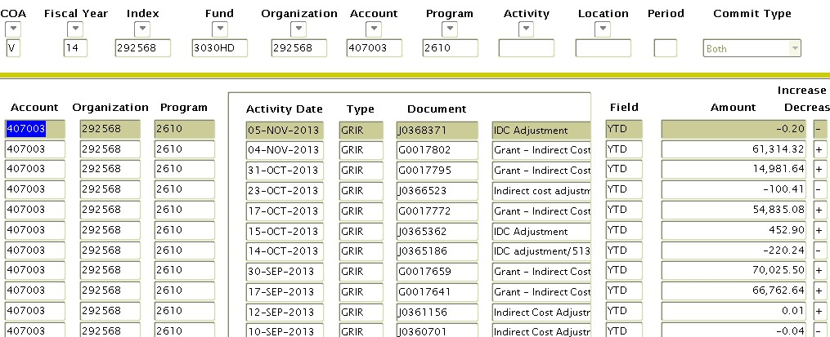
How is FACR recorded in Banner Finance?
Some FACR revenue is processed in Banner automatically and
will post several times a month in 2 ledger Banner orgs using
account 407003.

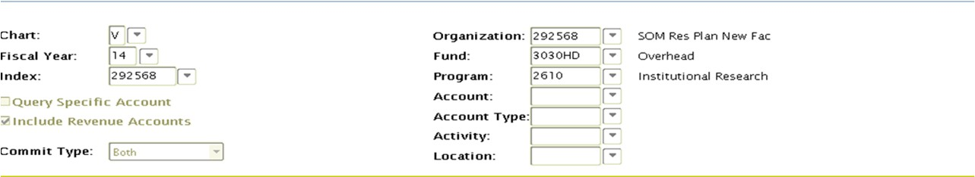
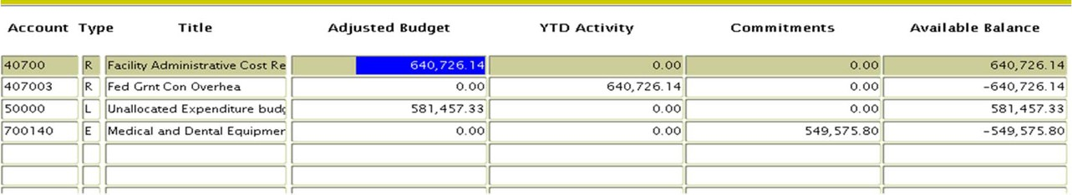
How is FACR recorded in Banner Finance?
This creates revenue and expenditure budget entries
as well as year to date actual revenue.

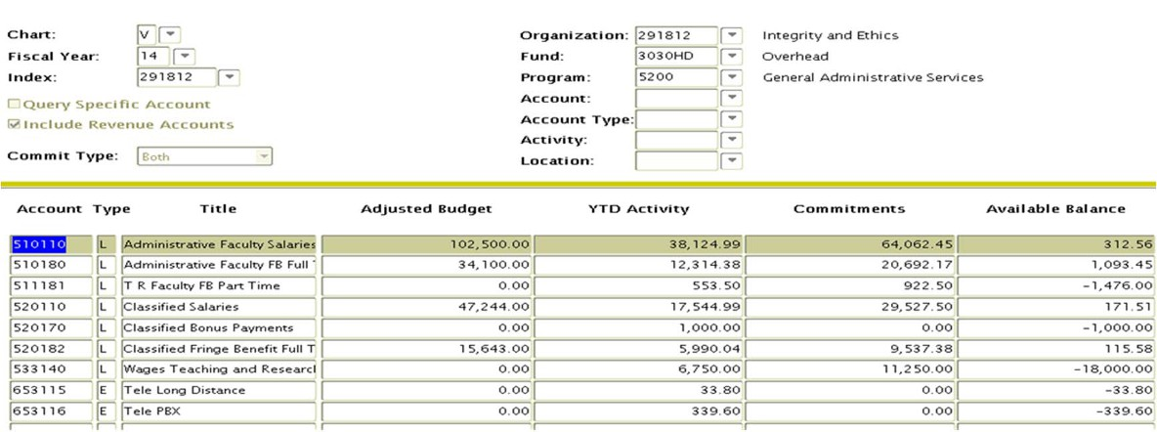
How is FACR recorded in Banner Finance?
Other FACR revenue is budgeted similar to
Educational & General Funds (E&G) with only an
expenditure budget. These orgs are generally for a
specific project.

Departmental FACR funds
FACR orgs (indexes) are treated the same as E&G
and grant funds. The same State rules apply. State
funds may not be used for expenditures such as
gifts, alcohol or social memberships.
It is critical to stay within the adjusted budget.
Unexpended budget balances may carry over to the
next fiscal year, but only at the discretion of the
executive level Vice President.

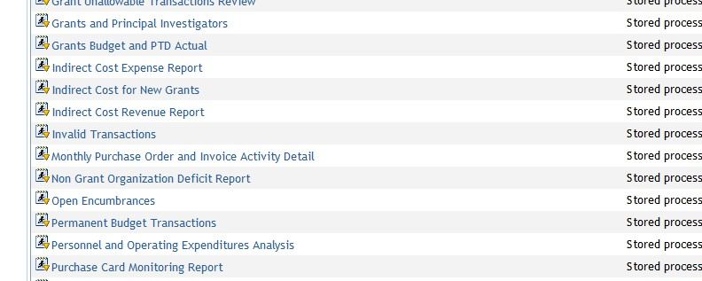
Departmental FACR/Indirect Cost
Information
3 reports on VCU Reporting Center deal with
Indirect Cost and/or FACR revenue.

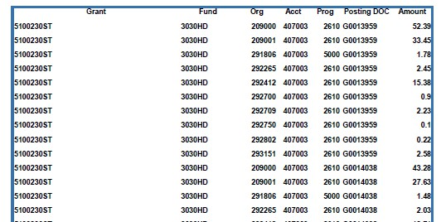
Indirect Cost Expense Report
Provides information on the automatic entries for indirect
cost. Includes the associated grants and expenditures used
for the calculation as well as the orgs used to recover FACR
revenues. Runs by department or sub-department.

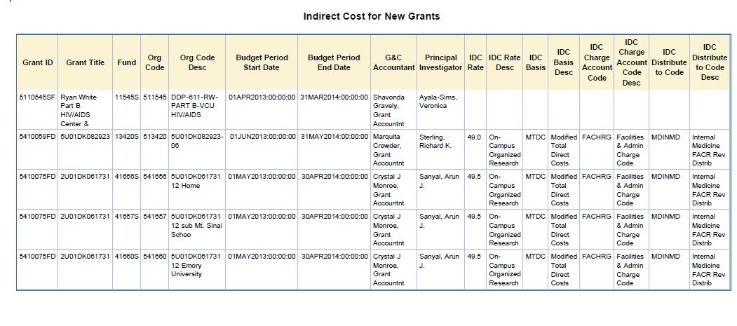
Indirect Cost for New Grants Report
Identifies indirect cost information associated with
new grants. Includes PI and indirect cost rates. Runs
by MBU, department or sub-department.

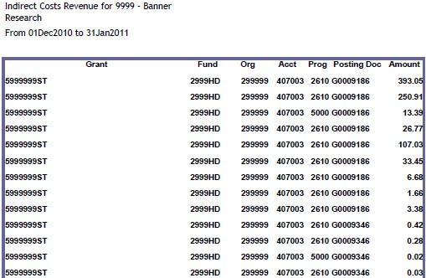
Indirect Cost Revenue Report
Report provides the revenue generated through
indirect cost by grant ID. Does not include expense
detail. Runs by department and sub-department.

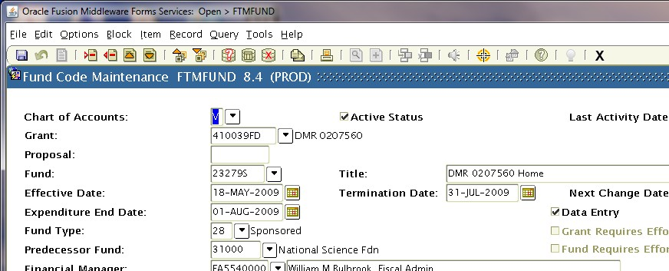
Indirect cost information in Banner
For specific grant information, go to Banner form
FTMFUND. Click on the Enter Query icon on the
toolbar. Type in the Grant number. Click on the
Execute Query icon on the toolbar. Details of grant
will display.

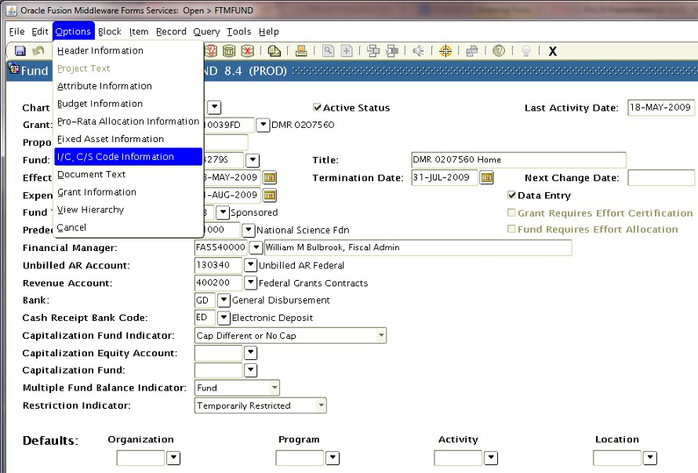
Indirect cost information in Banner
Navigate to FRMFUND by Options>I/C C/S Code Information
on the toolbar.

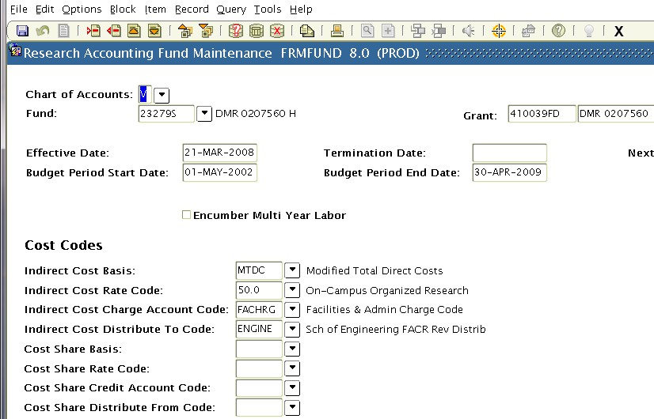
Indirect cost Information in Banner
Displays the budget period and indirect cost setup for the specific grant.

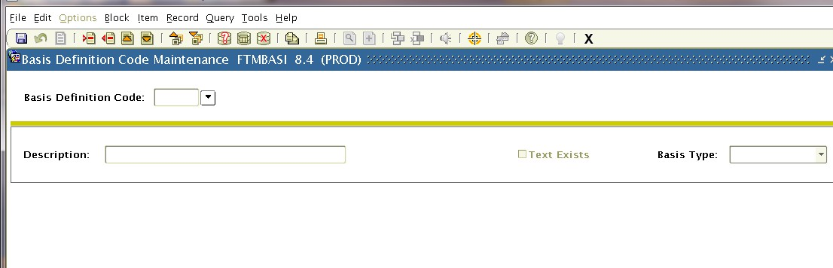
Indirect cost information in Banner
FTMBASI-explains which accounts are used to
determine the indirect cost basis for modified total
direct costs (MTDC). Use the search arrow at the
beginning of form to view the list of codes and
effective dates.

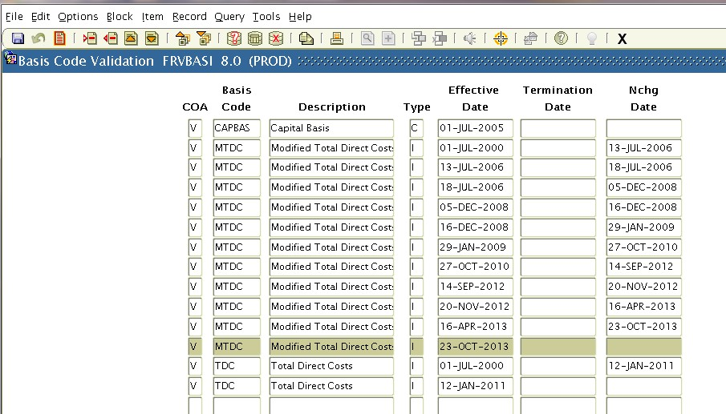
Indirect cost information in Banner
Double click on the basis code you would like to
view. Click on the next block icon.

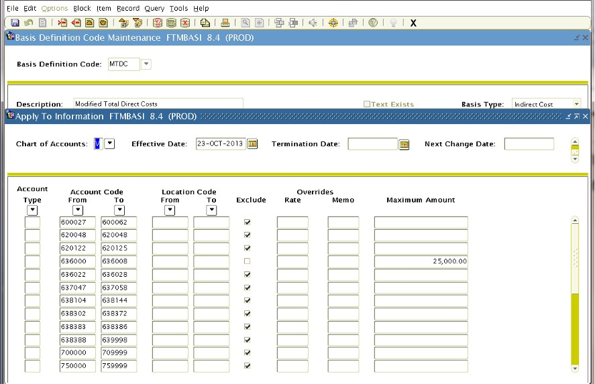
Indirect cost information in Banner
Form displays which accounts are included or
excluded from this definition (MTDC).

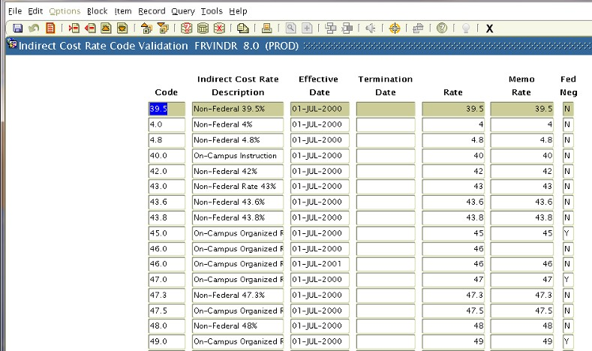
Indirect cost information in Banner
FTMINDR-information on indirect costs rates,
percentages, effective dates and whether rate was
federally negotiated. Navigate the same as FTMBASI:
search arrow, double click rate, next block icon.

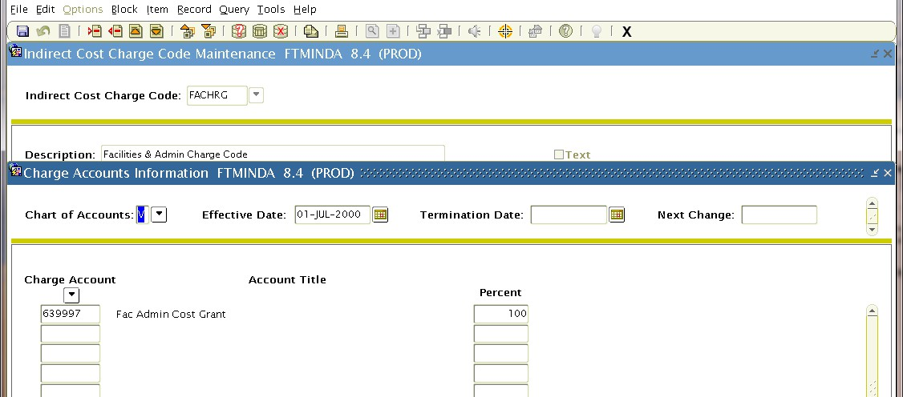
Indirect cost information in Banner
FTMINDA-list of Banner accounts used to charge
indirect cost to orgs (indexes). Search arrow>double
click on code>next block icon.

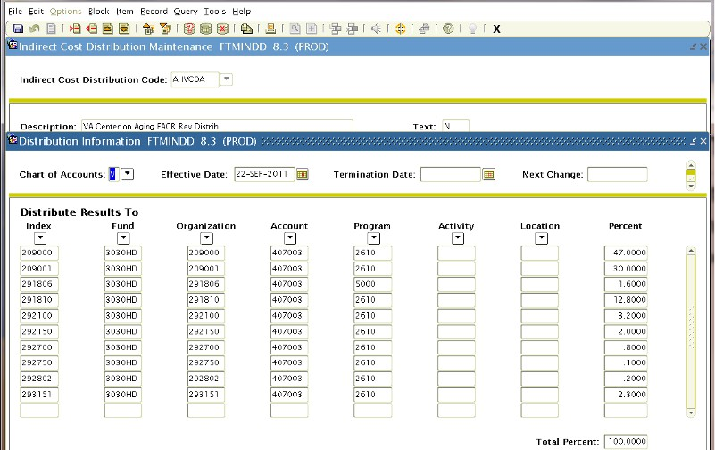
Indirect cost information in Banner
FTMINDD-provides information on Banner orgs
used for indirect cost distribution (FACR revenue).
Search arrow>double click on code/date>next block
icon.

Research Dashboard
Research Dashboard provides investigators and
administrators direct access to financial and
administrative information related to sponsored
awards.
Data in the Dashboard updates nightly and includes
integrated data from Banner Finance, Banner HR and
InfoEd.
Login to the Dashboard through the VCU Reporting
Center.
My VCU>VCU Reporting Center>Research Dashboard
tab.

