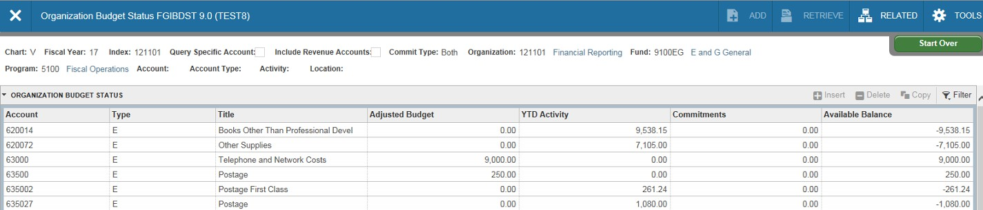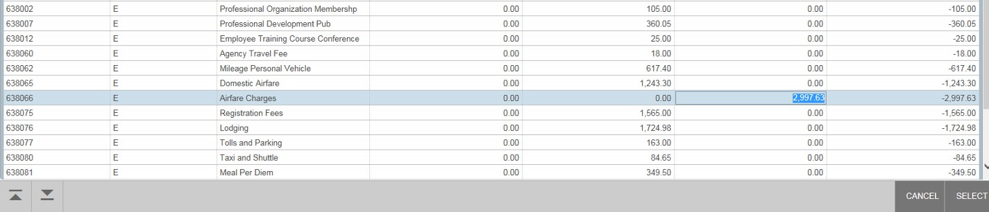
From page FGIBDST you can also view a list of outstanding encumbrances (purchase
commitments) for this org. Click on the specific line item, hit F3 on your keyboard. Select F3 again to drill down further on the specific line item you wish to investigate.

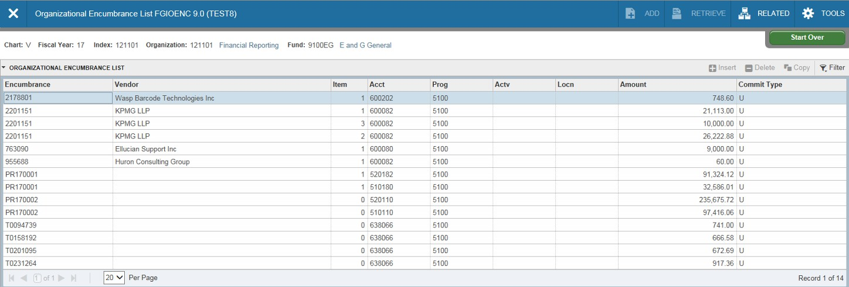FGIOENC (Org Encumbrance) From the Related drop down menu you can select Organization Encumbrances or from the main Banner menu, type FGIOENC and enter the index you wish to
investigate. A list of balances associated with the org will display. The number under Encumbrance is the EP number or the purchase order number. The Amount is the remaining balance of the
purchase order after payments.

Encumbrance and amount

