Type the name of your report in the main menu search box: FGRBDSC (Budget Status Current Period), FGRODTA (Org Detail Activity) or FGRORGH (Organization Hierarchy
Report), Press the enter key on your keyboard. Our example uses FGRBDSC.

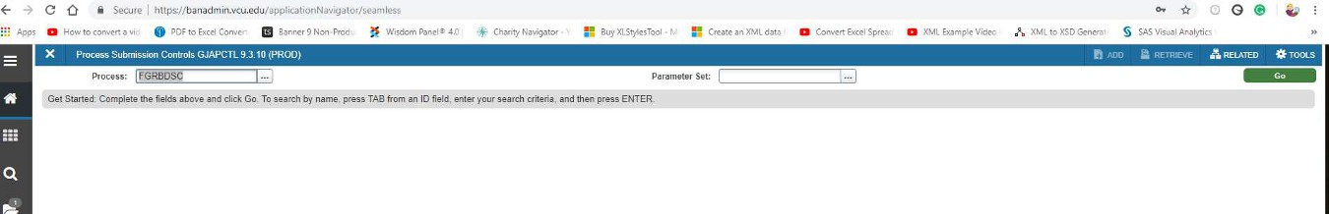
Click on Go.

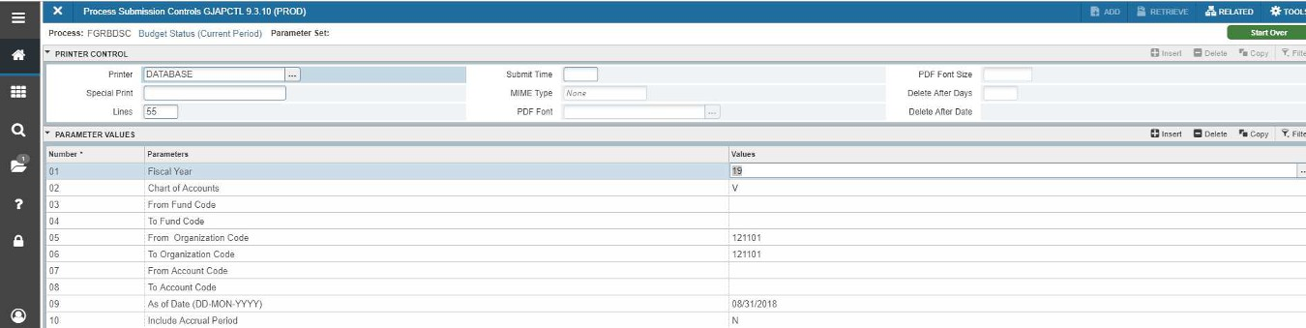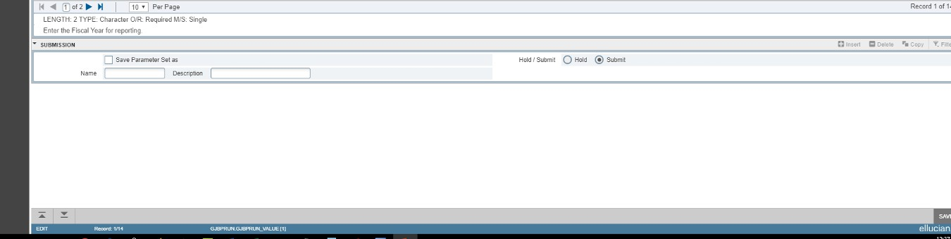Enter the fiscal year with the last two digits of the year. The chart of accounts will
always be equal to V (for VCU). Specify a fund or organization code. You can also specify a range of funds or org codes. In this example, we are specifying one org code,
so we have entered it in both the from and to box.

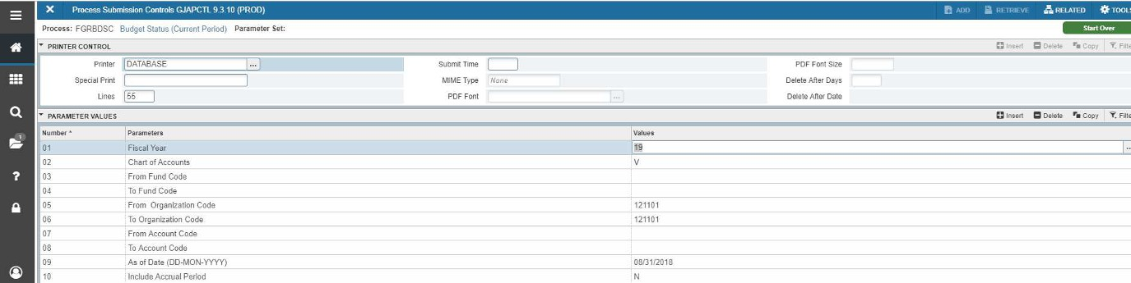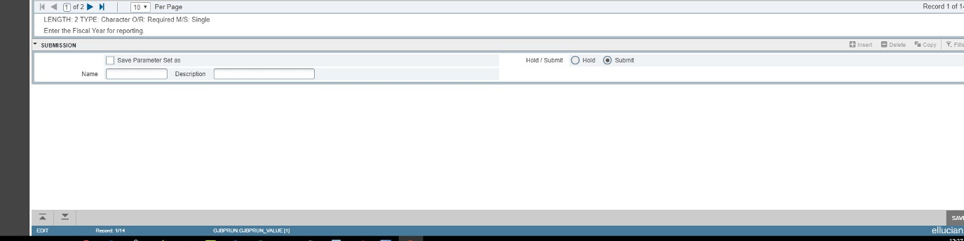Leave From Account Code and To Account Code blank to see all the accounts in the
organization. Enter the As of Date. Enter the As of Date in format 08/31/2018. Enter Y
or N for Include Accrual Period. Click on the next page (page 2) icon. Enter Y or N for
Print Report and Net Totals. Under Commitment Type Indicator, leave the field blank.
VCU does not use this feature. Click on the next selection arrow at the bottom.

Next Page

Next Selection

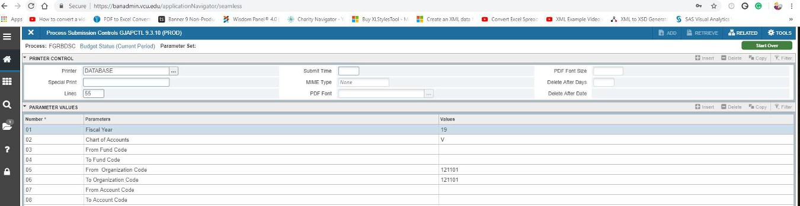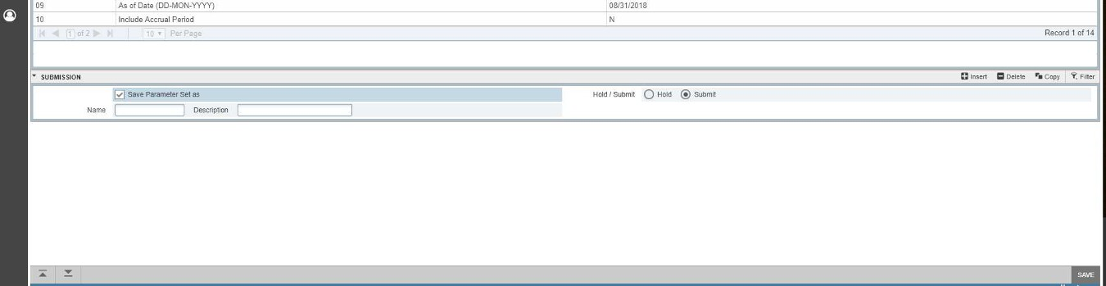
You will enter the Submission key block. Check “Save Parameter Set as”. On to the
toolbar, click on the Save button in bottom right corner.

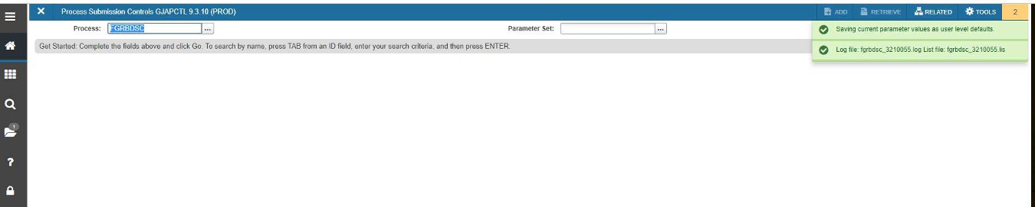
Two pop-up messages will appear.“Saving current parameter values as user level
defaults” and “Log file: fgrbdsc and List file:fgrbdsc”

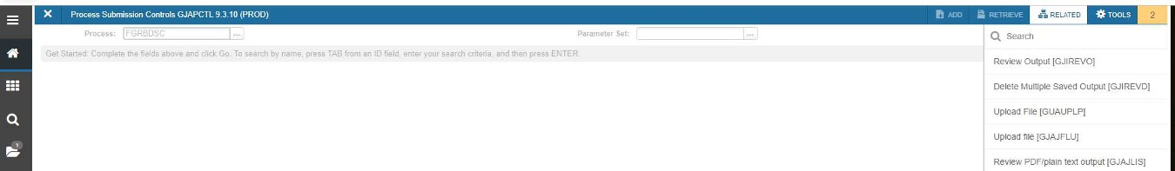
Click on Related>Review Output (GJIREVO).

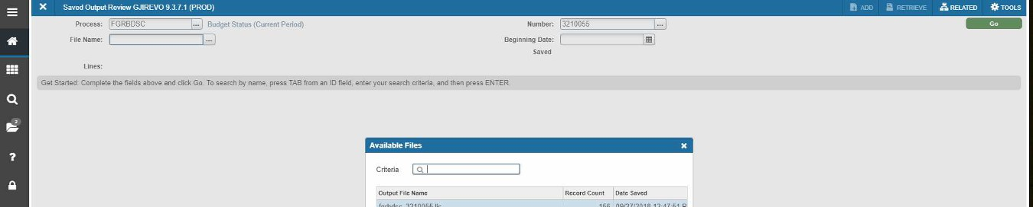
Click on the drop down arrow next to File name and the output files will appear in the
window. The file ending in .lis is the report. Click on that file name. Click OK.

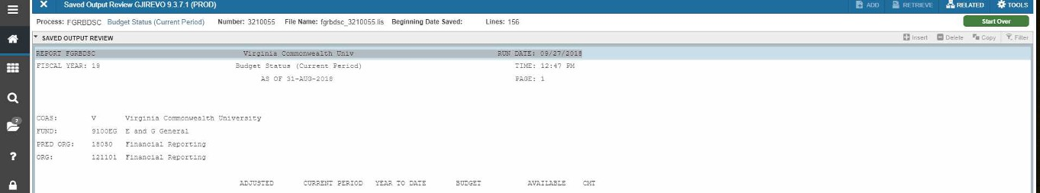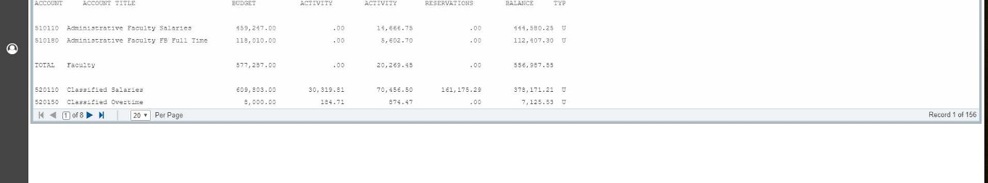
The report will appear in your window.

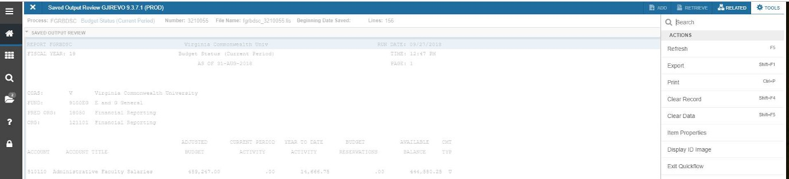
To save the file as text for an Excel spreadsheet, click on Tools, Under Options, select
Show Document (Save and Print File).

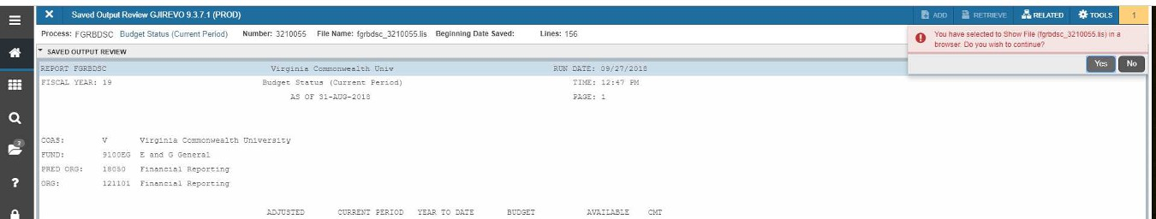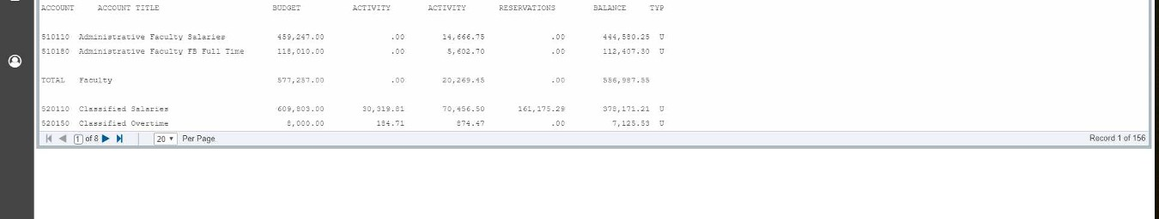
When asked if you would like to continue, click on Yes.

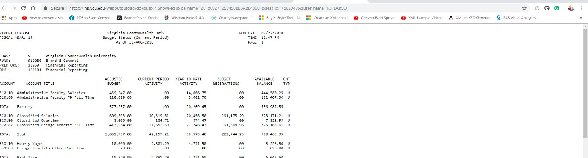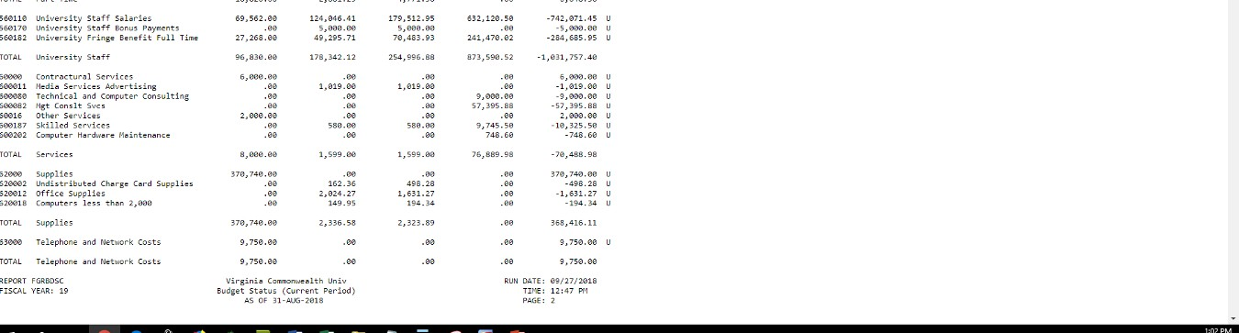
The report will appear in a new browser window. Now you can save the file as text and
import it into Excel. (More Tools>Save Page as).

