Removing a PO Encumbrance
There are instances where an encumbrance (purchase order, manual encumbrance, etc.) needs to be removed manually. For instance, a purchase order may not have liquidated fully.

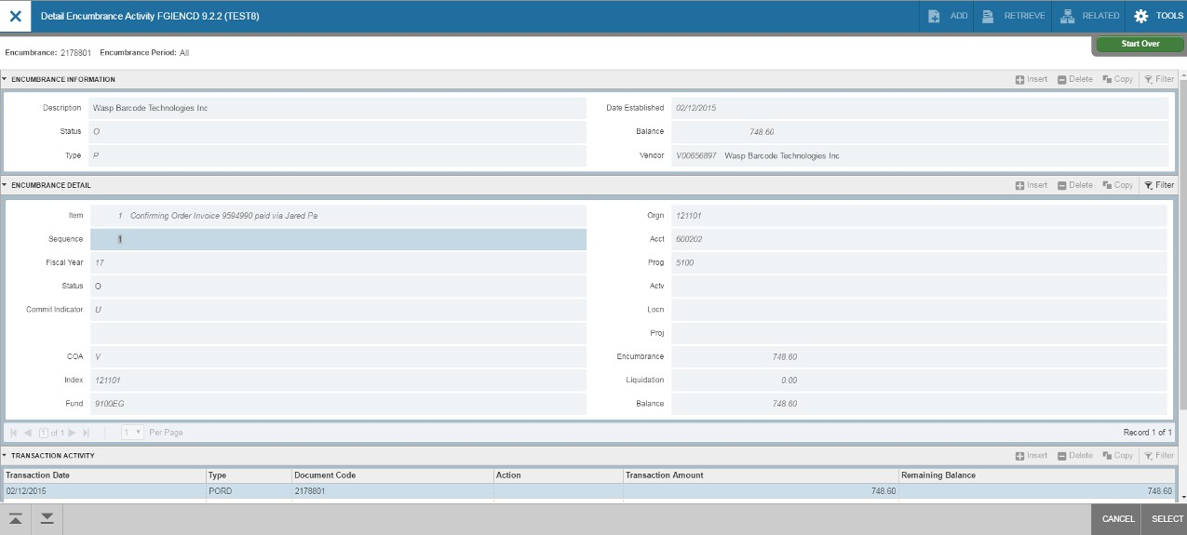First, you will need to find out some specific information about the encumbrance you want to remove. Go to form FGIENCD and enter the PO number. Click on Go.

Removing a PO Encumbrance
From this form, note the Org, item number, sequence number, account, balance and whether the Index field is populated. You’ll need this information to enter on Banner form FGAJVCD (Journal Voucher Entry). This must be done for each line of the encumbrance that needs to be removed. To get this information, check the bottom of the “Encumbrance Detail” section, and hit the right arrow button to view the next record(s).

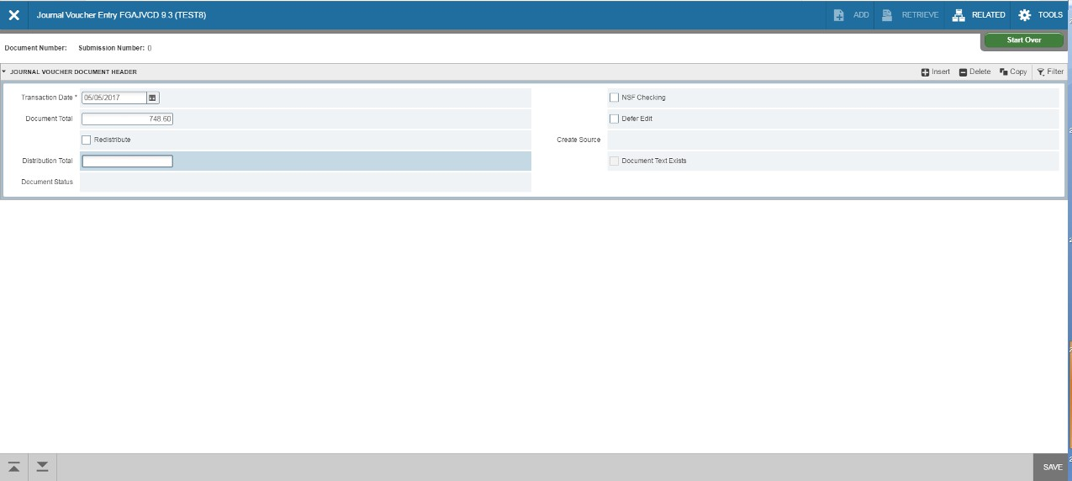Removing a PO Encumbrance

Go to form, FGAJVCD and click on Go. The Document Number will eventually self-populate. The Transaction Date will auto-fill. Enter the Document Total and click on the Next Section down arrow.

Removing a PO Encumbrance

Leave Sequence blank (it will self populate) and tab to Journal Type. Enter E020. The COA
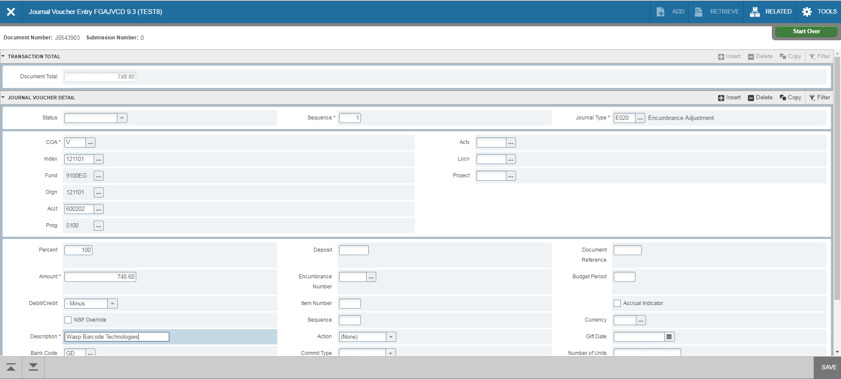 (Chart of Accounts) will self populate with V. Type your index in the Index Field. Fund and Orgn will self populate. Enter the account number in the Acct field. Tab to Percent and enter 100 if removing the entire item (PO line). The amount will self populate. For the Debit/Credit
field, use the minus (-) sign. Tab to Description and enter the Vendor’s name.

Removing a PO Encumbrance
The Bank Code is DB and will self populate. Tab to Encumbrance Number and enter the PO number. Tab to Item Number and enter. Tab to Sequence and enter. Click Save at the bottom right of the screen. Make sure the status field updates to Postable.
- If your purchase order did not have the Index field populated on form
FGIENCD, click in the Index field and delete the Index number (this is necessary as the
accounting must match the purchase order exactly).
- 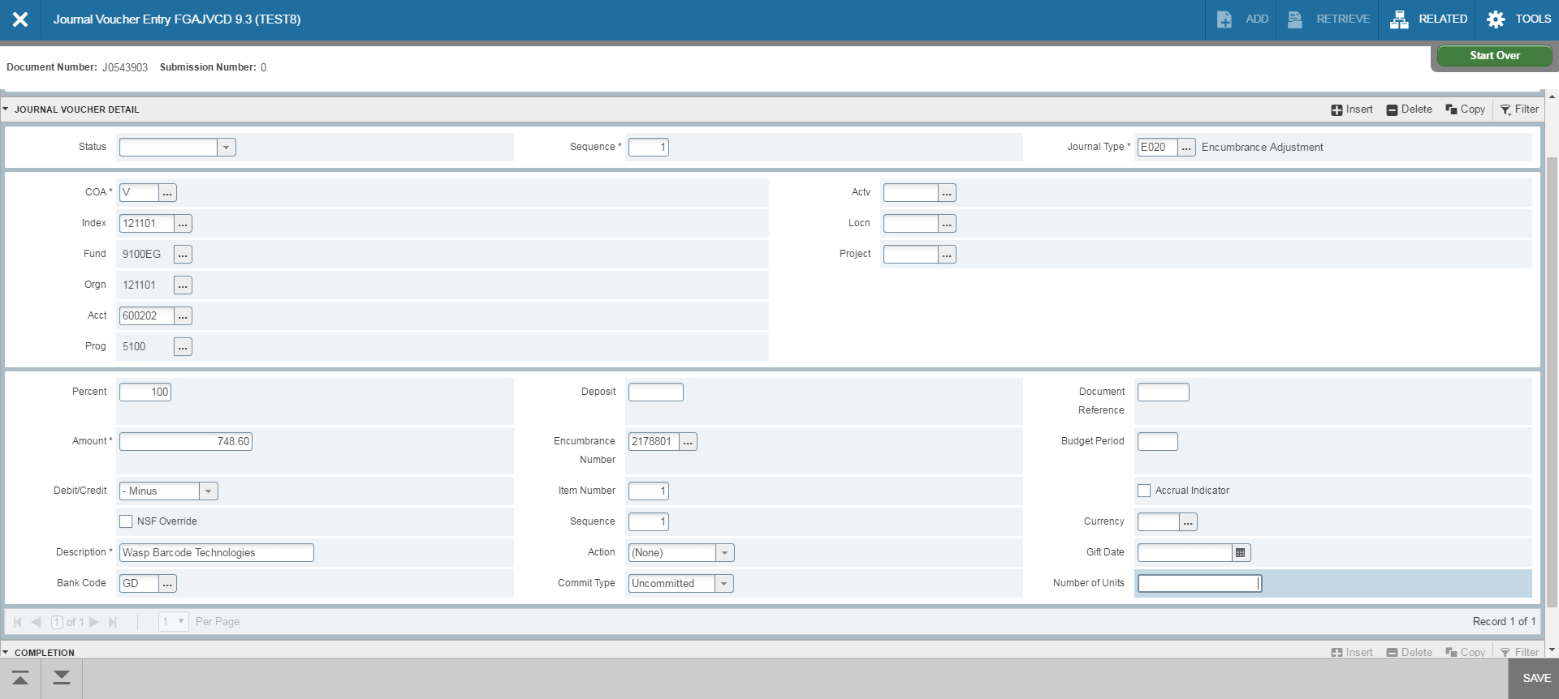 If the encumbrance has multiple lines to be removed, click on Insert to add a line. A
blank form will appear to enter the new line. Follow the same steps to enter the new line.
Removing a PO Encumbrance
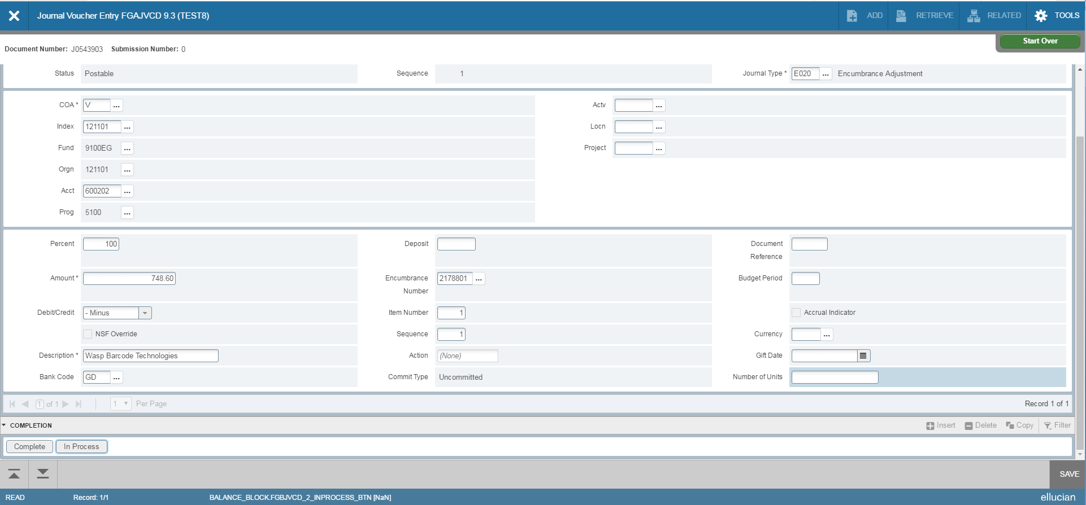After all lines are entered, click on the Next Section down arrow. Click on Complete to forward the entry to the approval queue. After document has been approved, check your Index to see if the encumbrance was removed properly.

