Journal Voucher Rule Classes
- X01 -Journal Entry for Revenue Transfer: For the transfer of revenue from one account to another account. Not for expense or non-mandatory transfers. Restricted to accounts in the 400000 to 499999 range. Must use current fiscal year. Use DB in the Bank field. Budget Period field should be blank. An increase in revenue is a credit entry. A decrease to revenue is a debit entry.
- XEX -Journal Entry for Expense Transfer: For transfer of expenses within orgs and accounts. Not for non-mandatory transfers or internal service charges. Restricted to accounts in the 600000 to 649999 and 700000 to 799999 ranges. Accounts from 650000 to 699999 can not be used. Must use current fiscal year. Use DB in the Bank field. Budget Period field should be blank. An increase to expense is a debit entry. A decrease to expense is a credit entry.
- XIC -Journal Entry for Internal Charge: For original charge or transfers of internal service charges from one unit to another (i.e, Animal Resources, Telecommunications, Physical Plant, Mail Services, etc.). All original charges must be supported by detail work papers that document the actual costs and do not include indirect costs when charged to sponsored programs. Restricted to accounts in the 650000 to 699999 range. Must use current fiscal year. Use DB in the Bank field. Budget Period field should be blank. A charge to a department is a debit entry. A reimbursement to the service department is a credit entry.
- XLF -Journal Entry for Non-Mandatory Transfer: For non-mandatory transfers between local funds. Restricted to accounts in 980035 through 980060, with the exception of 980050, which can not be used for non-mandatory transfers. The organization must be a local organization (index) from 350000 through 699999. XLF can not be used for organizations in the 500000 to 599999 range, for sponsored programs. Use DB in the Bank field. Budget Period field should be blank. A transfer to increase the cash available in a local org is a credit entry. A transfer to decrease the cash in a local org is a debit entry.

University Polices for Journal Vouchers
- Violation of University policies related to journal entries may result in the loss of access to the journal voucher process regardless of job function.
- Attempts to circumvent approval controls are prohibited.
- University policy prohibits using a journal voucher to debit a sponsored program
- organization (orgs in the 5xxxxx range) for an expense that posted to Banner more than 60 days from the month end of the original posting.
- University policy prohibits debiting a state organization and crediting a local organization. For this purpose, local organizations are considered to be orgs in the 400000 to 499999, 600000 to 699999 ranges. All others are considered state organizations. The exception to this policy is the original charges of approved service centers and administrative division units (XIC entry) providing support services to organizations. Expense transfers are allowed that debit a local organization and credit a state organization.
- Charges to sponsored programs (organizations in the 500000 to 599999 range) must be supported by either approved authorized service center rates or documentation to support actual costs. Charges, other than approved authorized service center rates, may only include direct costs that are allowable on the sponsored project if they have been directly charged and may not include any facility, administrative, overhead or processing fee costs or profit.
- No revenue may be transferred to or from organizations in the 200000 to 299999 range from other organizations (ex: can’t move revenue from 1 ledgers to 2 ledgers, or vice versa). Revenue may be transferred between organizations in that range but should also be accompanied by the appropriate budget entries to transfer revenue and expense budget within the 200000-299999. These organizations also may not be utilized for revolving or clearing accounts.

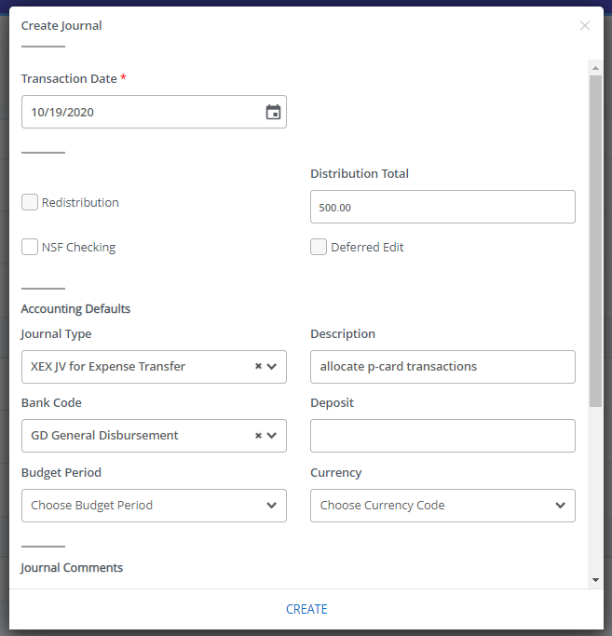
Entering Journal Vouchers in Self Services
- Go to “My Journals” and click on “Create Journal.”
- Transaction Date will auto-fill. Enter the Distribution Total. This is the total of all the transaction lines, so if you move $250.00 from one account to another, the total is $500.00.
4
1
- Enter your Rule Class Type in “Journal Type”: X01, XEX, XIC or XLF. Bank is DB (BoA Disbursement). Type in your description. Budget Period field is blank.
2
- Click on “Create” to move on to the transaction line details.
3

DB BoA Disbursement

Entering Journal Vouchers in Self Services
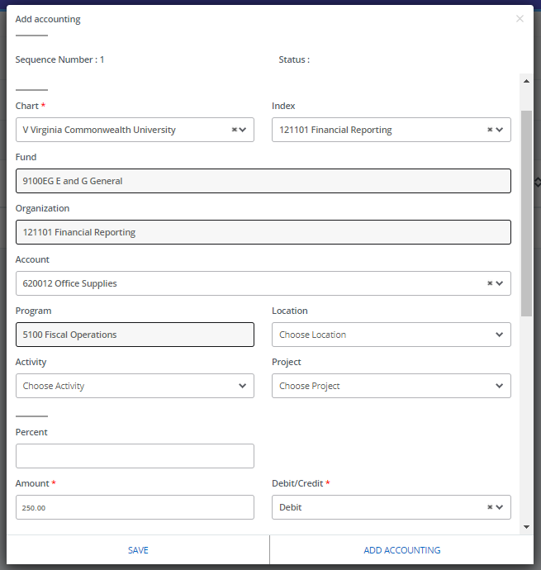
- Enter your index, account, amount, and description.
1

- For Journal vouchers, use the Debit/Credit indicators.

- Click “Add Accounting” to move on to a new transaction line

2
3
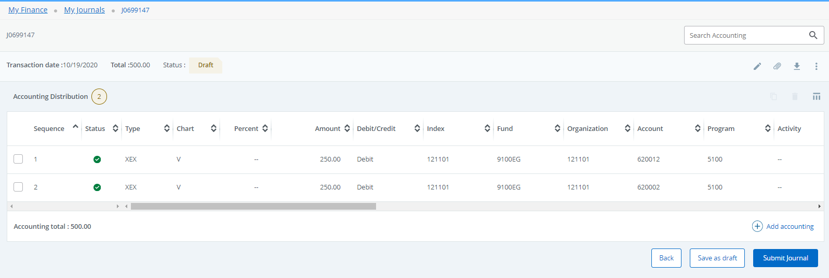
Entering Journal Vouchers in Self Services
3
- After completing all lines, Click “Save.”

- Review the journal summary. Ensure the “Total” in the header agrees to the “Accounting total” of the transactions you entered. Check that the status of each line is a green check mark (i.e., Postable). If necessary, you can edit lines by clicking on them.

- When ready to submit the journal for approval, click “Submit Journal.”

