Budget Queries in Self-Service 9
C Controller’s Office

- Log into Banner 9 Self-Service through “myVCU” found on the VCU homepage. https://www.vcu.edu/

- Click on “eServices/VCU Self Service”.
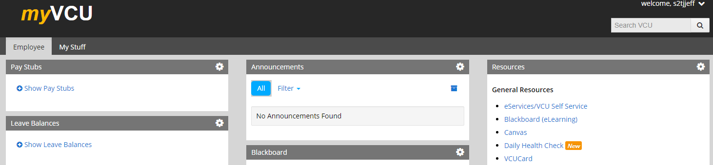

- Navigate to the Finance page using the menu at the top.
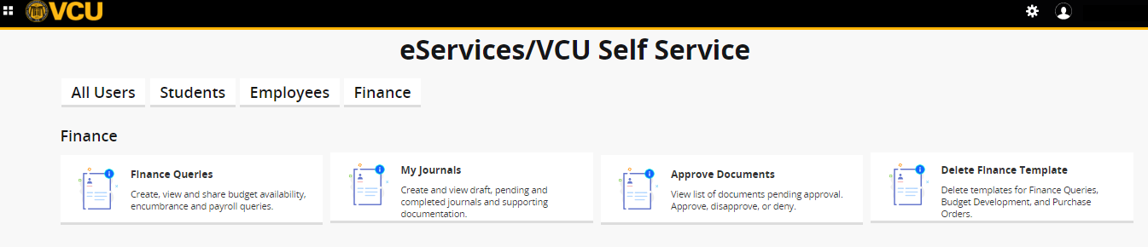
- Click on “Finance Queries”.

Click on New Query.
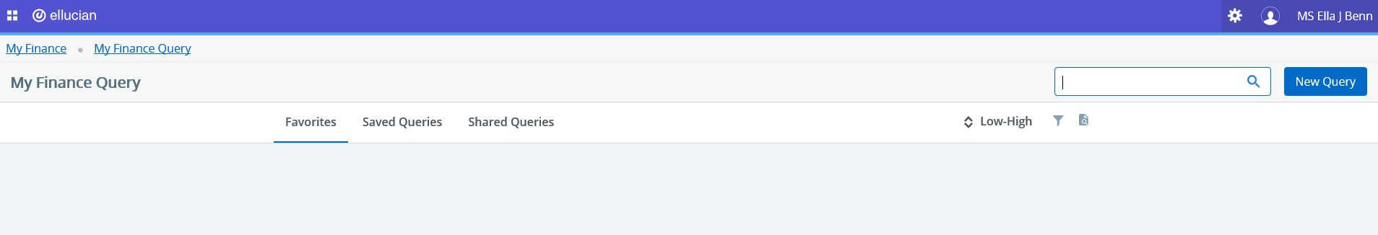

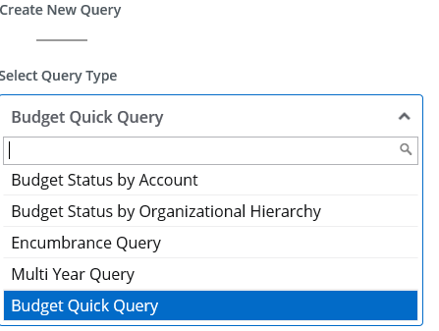

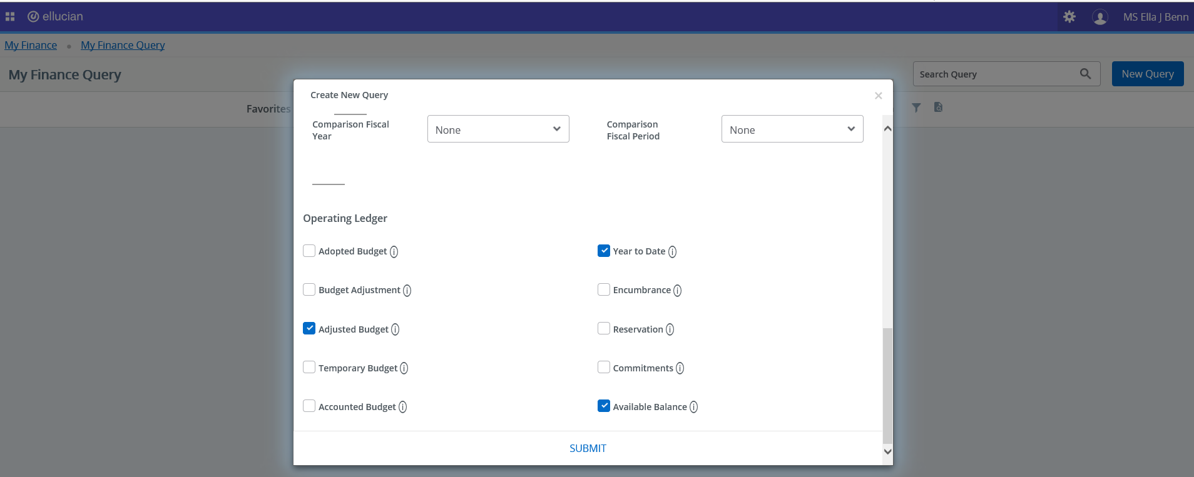
In the VALUES area, select the values and the Operating Ledger columns for which you want to query. Click Submit. Tip: Adjusted Budget is your Current Budget. Year to Date is year to date expenditures.

Specify an account or leave blank to see all accounts. If your org earns revenues, you can check Include Revenue Accounts.
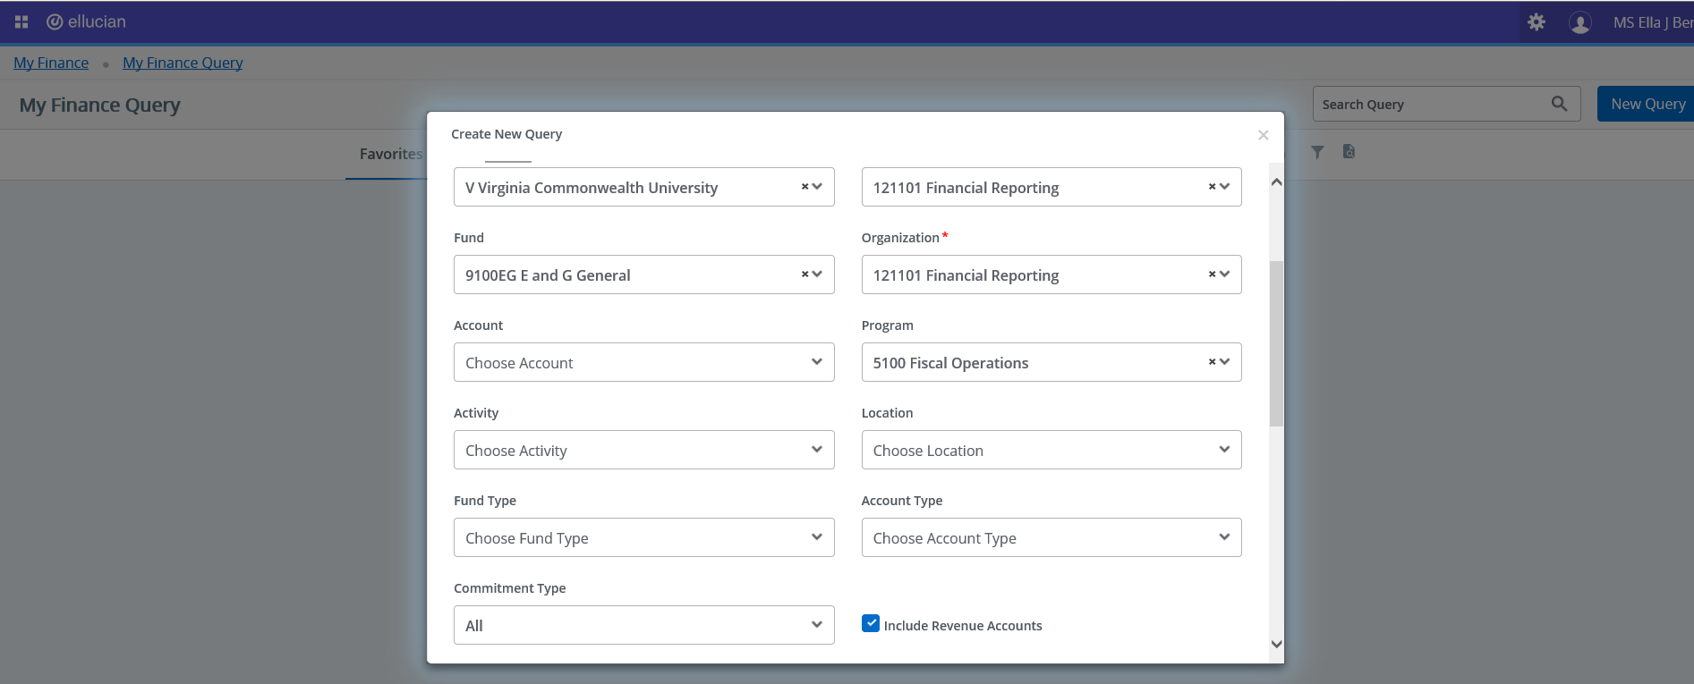

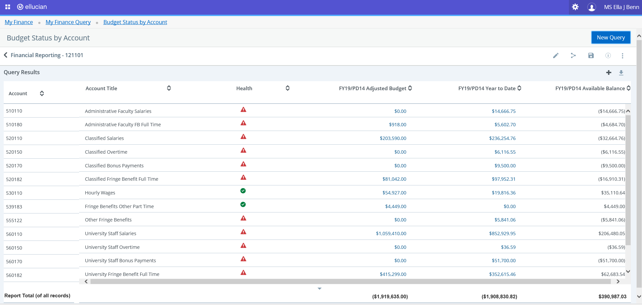
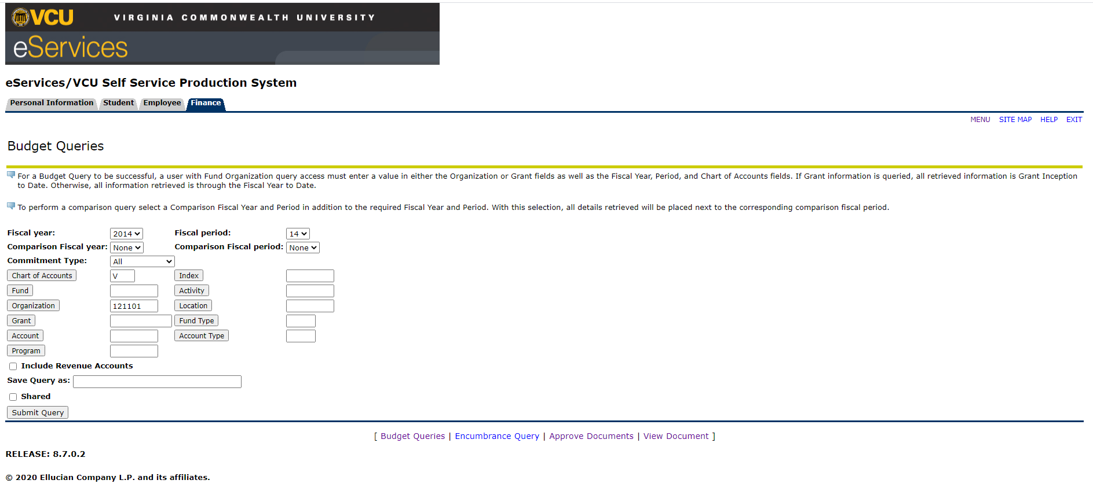
The My Finance Query page appears with query results. Using the available icon buttons, you can edit, share, save, view query parameters, download results to Excel, or view balance, pending documents.
Results will show year to date adjusted budget, expenditures and available balance by each expenditure account. To see further detail, click on any amount listed in the year to date column.

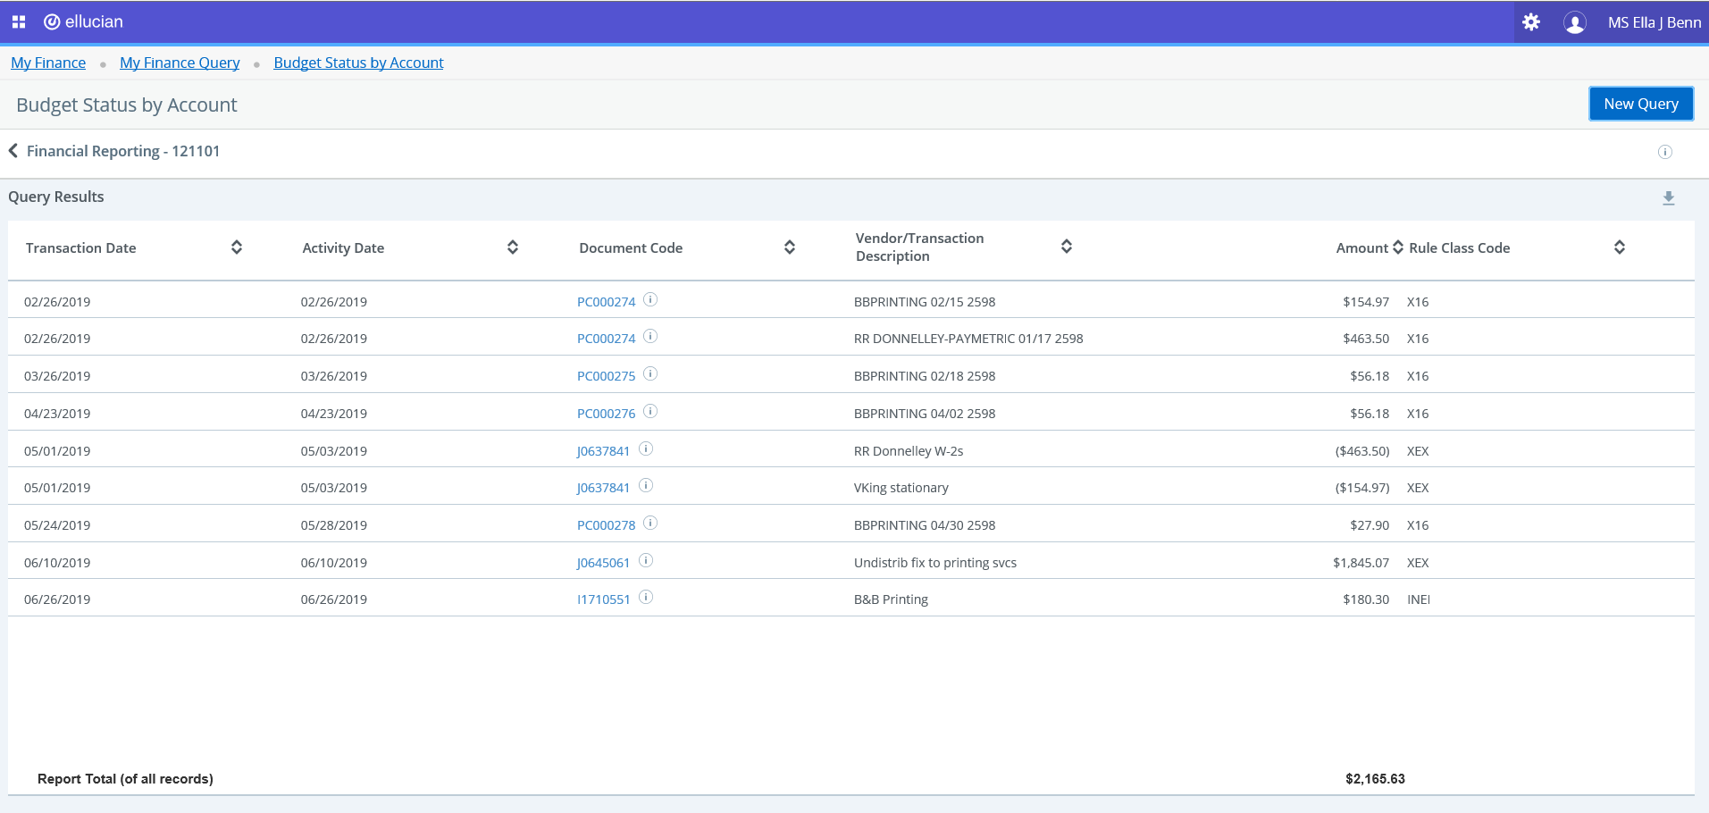
The transactions that make up the expense totals will be displayed. Use your browser’s back button to return to the My Finance Query.

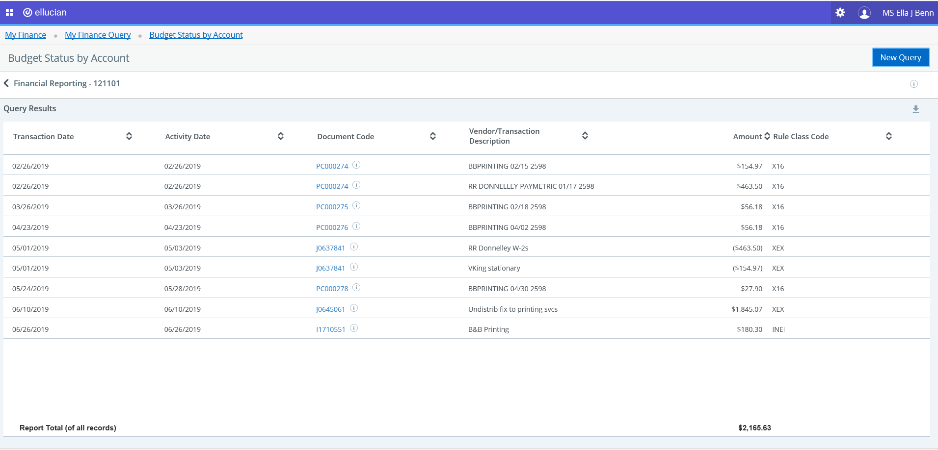
Download a query to Excel.
You can download a query as an Excel spreadsheet.
Click to download the query to the default download location.
Other report options:
Budget Quick Query-does not drill down to transaction level.
Budget Status by Organizational Hierarchy-allows a higher security level view by department or major budget unit.
Encumbrance Query-allows you to search for encumbrance information by specific parameters.
Multi Year Query-supports the current budget status by Grant.

